Ormiston Medical Practice Newsletter
Spring/ Summer 2024
Practice News

Dr. Elizabeth Labaeka and Dr. Michael Ross are GP Trainees that will be working within the Practice. They are fully qualified Doctors training to become GPs.

- Dr. Bolton will be supervising Dr. Ross
- Dr. Stevens will be supervising Dr. Labaeka

Their usual working week will be Monday, Tuesday all day and Thursday, Friday all day.

Dr Labaeka will be leaving in February 2024 and Dr Ross will be leaving in August 2024.

Ormiston Medical Practice will celebrate the 10 year anniversary since moving Surgeries. From Sprinty Drive to our purposely built surgery at Tynemount Road on 1st September 2024.

Practice Closures

Monday 6th May 2024
During this time please call 111 for urgent care or 999 in an emergency.

Opening Hours

8.00 a.m. - 6.00 p.m. Monday to Friday

Wednesdays we are closed 12.30 pm – 1.30 pm then reopen until 6.00pm. This is for regular in-house training and tutorials.

Appointments

We have improved our GP appointment availability – we have lots of pre-bookable appointments.

Only medical emergencies will be seen on the day.

Appointments can be face to face, telephone or via video call. Please advise us of your preference when booking.

You will now receive a reminder text message from the Practice 2 days before your appointment.
If you no longer need your appointment, please contact us to cancel, so this may be offered to other patients.



Prescription Requests

We ask that all patients order their prescriptions 7-10 days in advance as a Medication reviews may be required.

There are several ways to order:

- Online via Ormiston Medical Practice website
- Telephone between 10am-4pm
- Hand in request to Reception or post in black box to Left of doors.
- Set up with a Pharmacy, for them to order your prescription every 2 months.
- Post it with pre-paid envelope attached.

If you run out of medication, please inform a Pharmacy and they can issue an emergency supply.

What the Practice did February-April

February Patients seen = 1291
Did not attend = 48

March Patients seen = 1324
Did not attend = 62

April Patients seen = 1453
Did not attend = 50

Thank you

We would like to say a big thank you to Ormiston Blooms Together for the beautiful flower boxes at the front of the Practice.
And a thank you to all patients who bring in all kinds of treats for the staff.
Both are greatly appreciated.

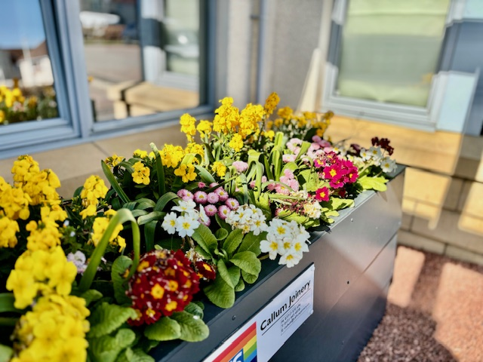
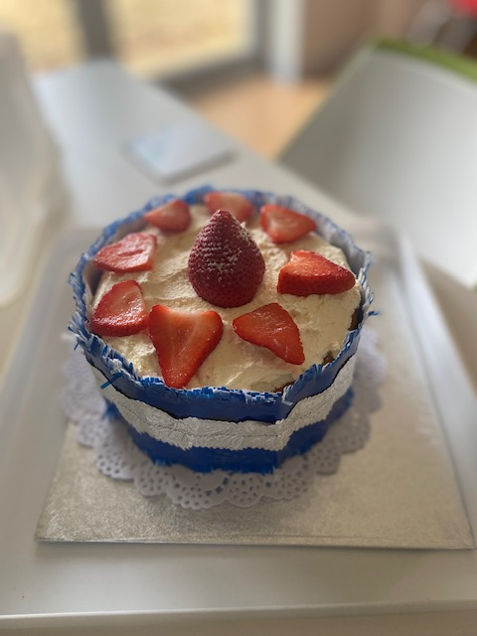

Ormiston Library

Ormiston Library offer various events every week. One includes A brew and a blether, every Wednesday.

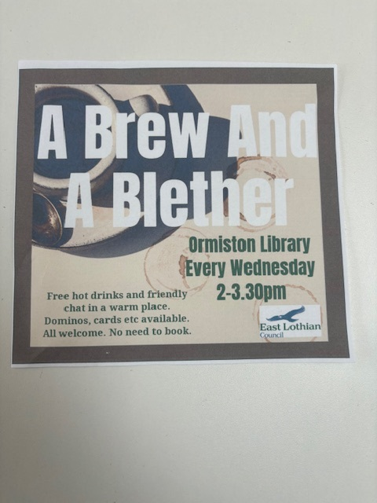

Medication Reviews
To make sure you’re on the best medicine for your needs, we undertake regular medication reviews. After a medication review, we may suggest changes to your medication to keep up with the latest guidance or advice.

- Ensuring Safety
- Effectiveness
- Side Effects
- Change of medication/ doses

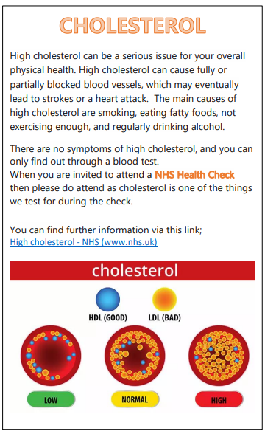
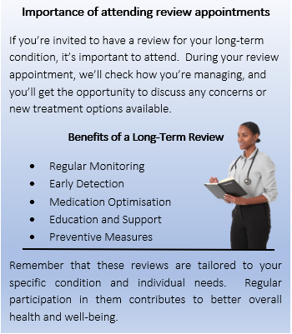

East Lothian Council – Ageing Well
Much has been done in recent years to get East Lothian more active, but the number of adults meeting physical activity recommendations declines sharply with age. Physical activity helps prevent and manage a wide range of health conditions, including diabetes, heart and lung conditions and osteoporosis. But did you know that less than a third of people in Scotland aged over 55 are active enough for health?
The Ageing Well project promotes healthy lifestyles for people over 50 in East Lothian. The project is a partnership between NHS Lothian and East Lothian Council.
The Ageing Well project aims to maintain and promote the physical and mental health, well being and quality of life for people over 50 in East Lothian through a list of activities.
Some ways Ageing Well can help are:
- Set up new activities where there is a demand or a gap
- Help sign post you to activities in your area
- Help you stay healthy and active for longer
There are also opportunities to volunteer for the Ageing Well Project.
For more information contact:
Ageing Well Coordinator
Email: ageingwell@eastlothian.gov.uk
Tel: 07718 117585

Visit the Ageing Well website to see the full list of the activities available
