
Issue 45 – October 2022

Welcome Back
This is our first newsletter in a while so we have a lot of news to get through!
There has been a lot of staffing changes over the past couple of years so below is a current overview of our management / clinical staff:
- Practice Manager – Emma Middleton (has been in the role for just over a year now)
- Office Manager – Carol Smith
- Deputy Office Manager – Lucy Tipton (been in role for approx. 1 year now)
- GPs
  - Dr Khaja, Dr Woo Ling, Dr Ross, Dr Woodhouse
  - Dr Tade (male) joined the practice in August as a salaried GP
  - We currently have 4 GP registrars at the practice – Dr Pilmore (female), Dr Johnson (male), Dr Richards (female), Dr Hameed (male).
  - Dr Pilmore will be joining us permanently as a salaried GP later this month.
- Nursing Staff
  - Nurse Practitioner – Rebecca (joined us in August)
  - Practice Nurse – Ann
  - Practice Nurse – Lisa (joined the practice Oct 21)
  - Healthcare Assistants – Judith, Caitlin, Liza (Liza joined us in Oct 21).
- Pharmacist – Lynzie – (joined the team last year)
We have also had changes and new staff to reception and admin teams over the last 2 years so there will be plenty of new faces around.
We would like to welcome everyone to the team!

Practice Pharmacist
We have a practice based clinical pharmacist (Lynzie) who holds regular face to face and telephone clinics to help with general medication queries and reviews.
Our pharmacist can also help with mental health conditions, initiating of new medication from secondary care and medication reductions.



Failing to attend / failing to cancel unwanted appointments

From May 2022 to the end of September 2022 609 appointments were wasted due to patients failing to attend / failing to cancel their appointment – see breakdown:

Please always cancel unwanted appointments as they can be used by other patients who need to see a GP/Nurse.

Clinician Type: | No. of appointments:
GP | 72 appointments
Nurse Practitioner | 36 appointments
Practice Nurse | 251 appointments
Healthcare Assistant | 250 appointments

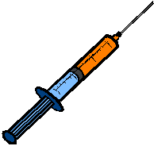
FLU TIME!

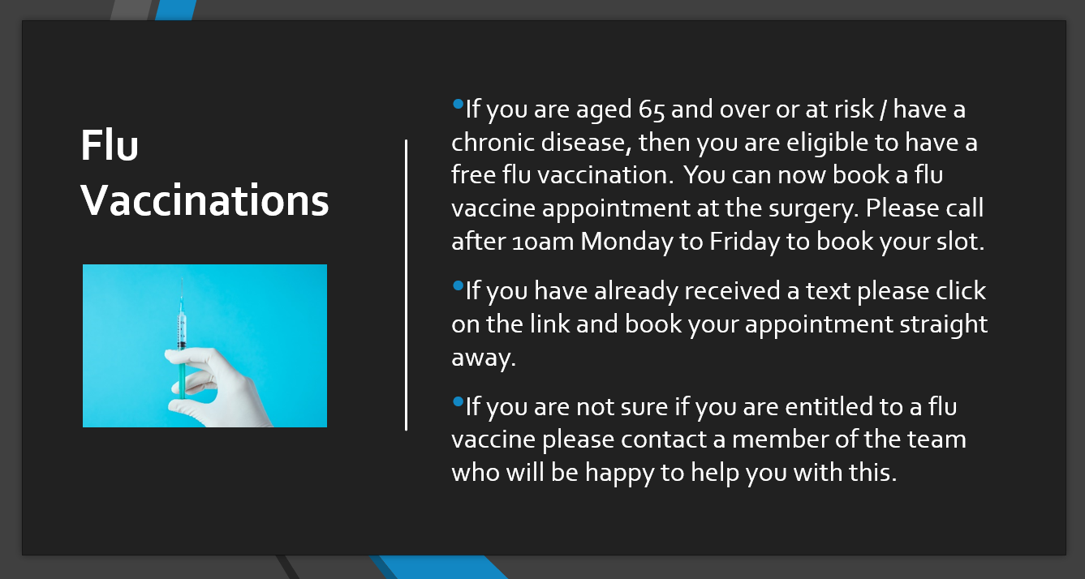

Did you know?
-Symptoms of flu can include: high temperature, tiredness, sore throat and general aches and pains. Symptoms tend to be much more severe than a bad cold and also last longer. Flu spreads easily by coughing, sneezing and talking and also by touching contaminated surfaces. According to the World Health Organisation (WHO) vaccination is the most effective way to prevent infection and protect against the consequences of flu.

-The flu virus changes every year (and so does the vaccine). So the vaccine you had last year may not contain the strains which circulate this year. So it is important to book in for your vaccine at Hetton Group Practice as soon as you can.

-Having flu in the past does not make you immune. As mentioned above, the strains change each year so you do not develop immunity.

-It is a myth that the flu vaccine can give you flu! It does not contain an active virus.

Are your contact details up to date?

If you have changed your telephone number, your address, or your name, please make sure you inform us.

If you want your medical record to be updated with an emergency contact / next of kin details, please speak to a member of the team who will ask you to complete a form and update this for you.

Useful Links

- Surgery website – http://www.hettongp.nhs.uk/
- Practice Facebook information page - Just search for Hetton Group Practice
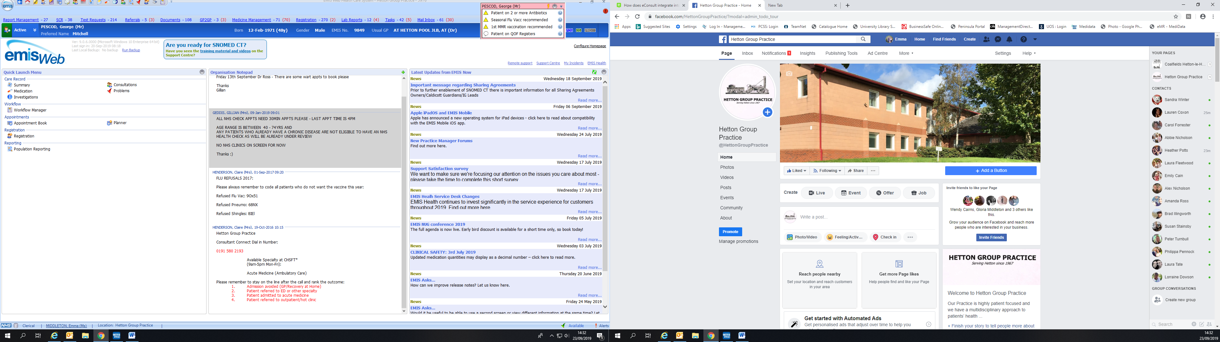

ATTENTION PARENTS

- Is your child over 3 and a half?
- If so, please ensure they attend for their “pre school booster”.

YOUR CHILD IS AT RISK IF THEY DO NOT COMPLETE THEIR FULL VACCINATION SCHEDULE

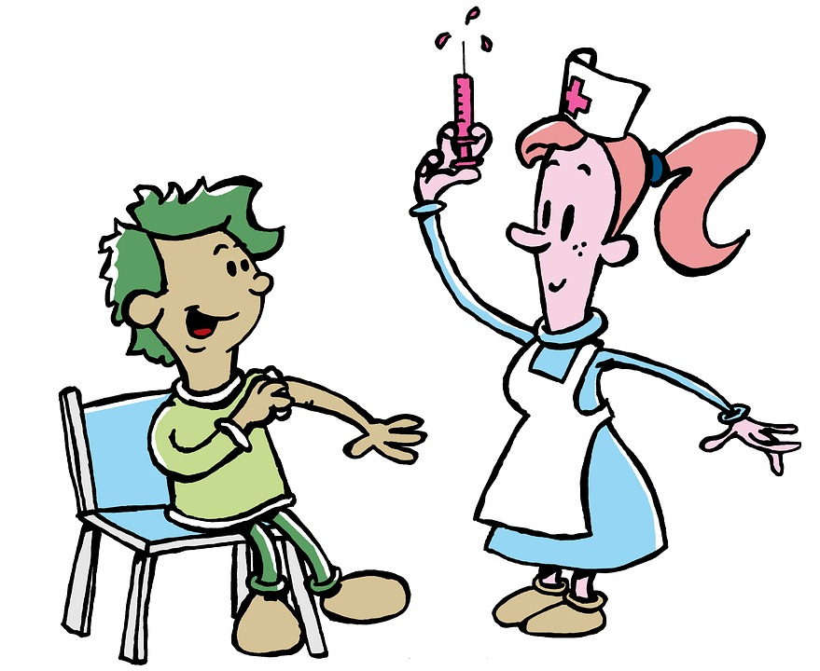
Childhood Vaccinations & Immunisations
It is important that your child/children’s vaccinations are kept up to date – so please attend these appointments.

The surgery is closed every Wednesday 1-2 and will also be closed on the following dates:

Wednesday 23rd November 2022 - PM
Monday 26th Decemeber 2022 - All day
Tuesday 27th December 2022 - All day
Monday 2nd January 2023 - All day
Wednesday 15th February - 2023 PM
Wednesday 15th March - 2023 PM
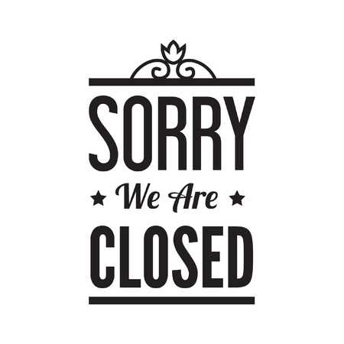


NHS Health checks

We are currently undertaking a campaign to assess the risk of heart disease, stroke, diabetes and kidney disease. We are looking at our patient’s 40 - 74years who may be at risk of developing any of these conditions.
If you are in this age range – please ring the surgery to speak with a Health Care Assistant to see if you are eligible.
The check will consist of a small finger prick blood sample, questionnaire, blood pressure check etc.

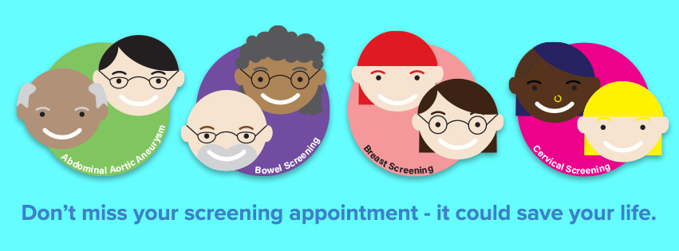


FUNDRAISING 2022

This year’s charity is: BREAST CANCER
We have been raising money by: dress down days, book sales, donations etc.
Other monies raised were:
Dress Down Jubilee Date £20.50
Dress Down Wembley Day £24.50
Jeans for Genes Day £50.83
Pink Day £57.50
Book sales towards Breast Cancer £80
Future fundraising days for 2022: Children in Need – November, Elf Day and other dress down days – December.

Last year we raised £150 for Stroke Association
Children in Need £65 + Gift Aid
Wear it Pink £100
Jeans for Genes Day £29
Christmas Jumper Day £35.05
Elf Day – Alzheimer's Society £43.40
Thank you to all patients who donated towards these charities.





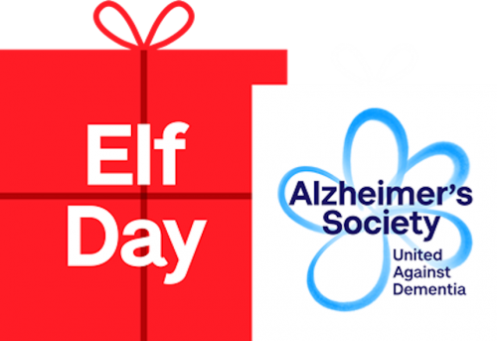
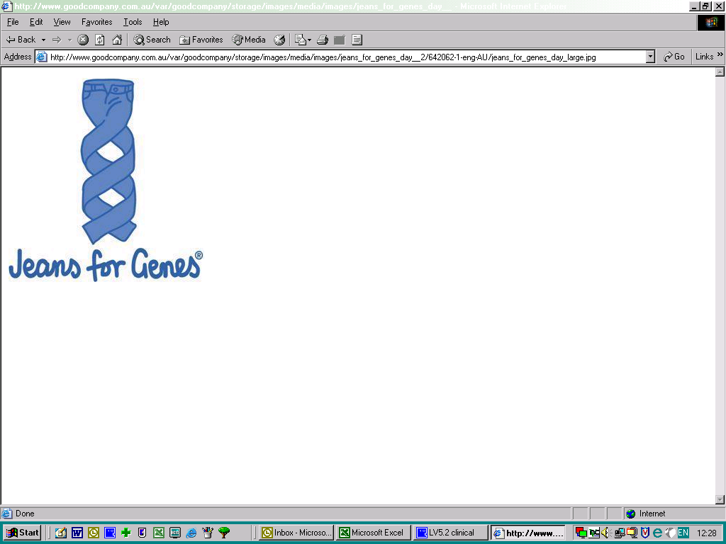

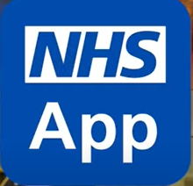
NHS APP

- Order repeat prescriptions
- View GP appointments
- Get your COVID pass
- Get health advice using the Health A-Z
- Register as an organ doner

The NHS App is available on iOS and Android


NHS HEALTHIER TOGETHER APP

A mobile app to reduce anxiety/worry for

parents and care givers of young children to

avoid unnecessary A&E and GP visits

The NHS Healthier Together app has been designed to allow you to access
care for your child much more easily. If your child is unwell and needs to be seen by a healthcare professional, instead of having to call your GP surgery, your surgery may offer you the option to use the app to directly inform them about your child’s symptoms. They will then contact you to decide what needs to be done. And if you are seeking help when your GP surgery is shut, it will direct you to NHS 111.

Available to download on iOS and Android

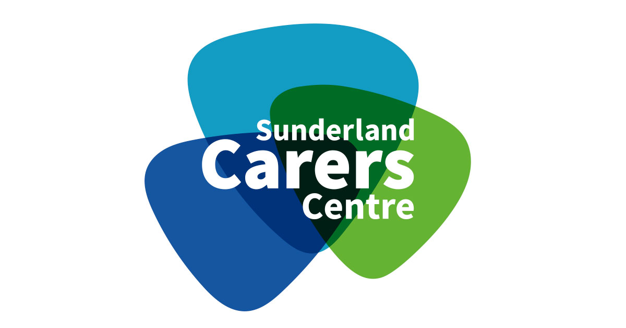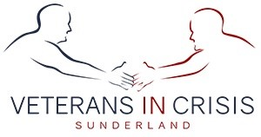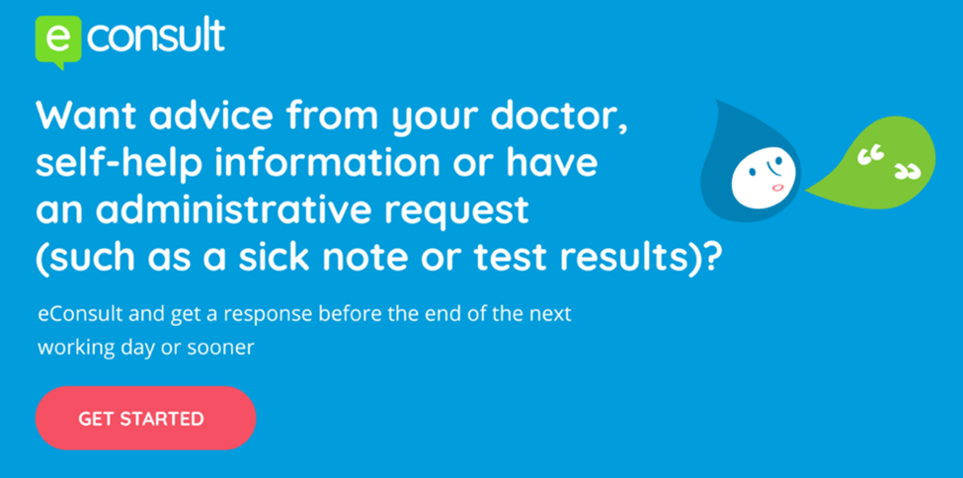
Warm Spaces Sunderland

Please visit www.sunderland.gov.uk/warm-spaces for details of Warm Spaces being provided across Sunderland over the winter period. The spaces have been put in place across the community to support residents in accessing a warm, safe and welcoming space as well as an opportunity to enjoy some company and possibly hot drinks.

Interested in
Stopping Smoking?

If you are a smoker and are interested in quitting, we have smoking cessation clinics here at the surgery with our healthcare assistants. Make an appointment if you are interested.

Sunderland GP Enhanced Access Service

Require an appointment out of hours?
Clinics run Monday to Friday 6pm to 8pm, Saturday 9am to 5pm and Sunday 10am-3pm at the Houghton Primary Care Centre.

Appointments are for things such as minor ailments and not ongoing problems that need continuity from their own GP.

Appointments available:
GP face to face and telephone, Advanced nurse practitioner, Phlebotomy, BP/Height/Weight, Smear and Pill checks.
Are you a carer?
Sunderland Carers Centre offers a confidential information, advice and support service to carers.
If you are a carer please let us know.

http://www.sunderlandcarers.co.uk

If you are a veteran in Sunderland and you need help, call us! We can help you with housing, employment, drug, alcohol and mental health issues, reintegration to society and much more - www.veteransincrisis.co.uk
Econsult is available 24/7.
To use this service please visit our web page http://hettongp.nhs.uk
A pop up box will appear for you to complete, once completed this will be emailed to the surgery and we will aim to deal with this query by 6pm the next working day.

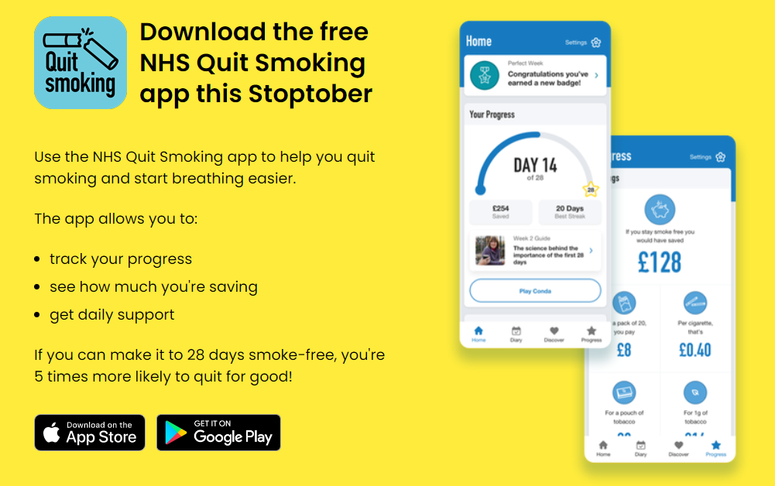




There is a NHS Zero tolerance policy against shouting, swearing, or threatening behaviour, and these will not be tolerated under any circumstances Our staff are here to help you and will always be as polite and as helpful as possible even during difficult times and patients who are threatening or abusive towards our staff may be asked to leave our practice.

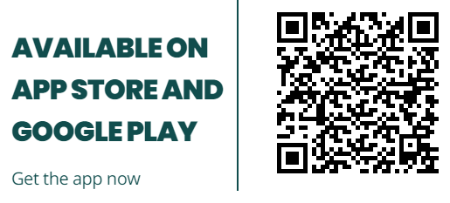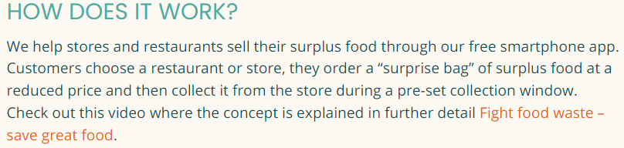 311
Grocery stores, Bakeries and Restaurants that use Too Good To Go are Greggs, Dickinson's, Starbucks, Morrisons, Subway, Toby Carvery, local takeaways and more.

