HETTON  GROUP  PRACTICE |   Issue 46 – January 2023 | NEWSLETTER


Happy New Year!



We would like to say a very big thank you to all of our patients for the kind gifts and cards you have sent us over the Christmas period.



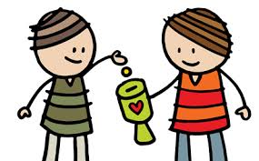

Fundraising


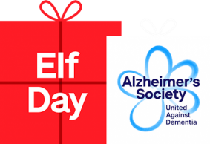



This year’s charity is: Washington Mind
We will be raising money by: dress down days, book sales, donations etc.

Last year we raised:

Breast Cancer £302.11
Children in Need £61.90 + Gift Aid
Wear it Pink £57.80
Jeans for Genes £50.83
Christmas Jumper Day £23.50
Eld Day – Alzheimer's Society £48.55
Loaves and Fishes £68

Thank you to all patients who donated towards these charities.

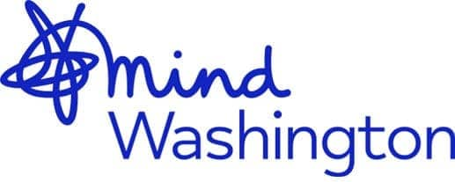

Failing to attend / failing to cancel unwanted appointments

From November 2022 to the end of January 2023 387 appointments were wasted due to patients failing to attend / failing to cancel their appointment – see breakdown:

Please always cancel unwanted appointments as they can be used by other patients who need to see a GP/Nurse.

Clinician Type: | No. of appointments:
GP | 64 appointments
Nurse Practitioner | 15 appointments
Practice Nurse | 150 appointments
Healthcare Assistant | 158 appointments

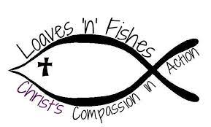
All donations welcome to go to Loaves 'n' Fishes Food Bank. Please see reception for more details.

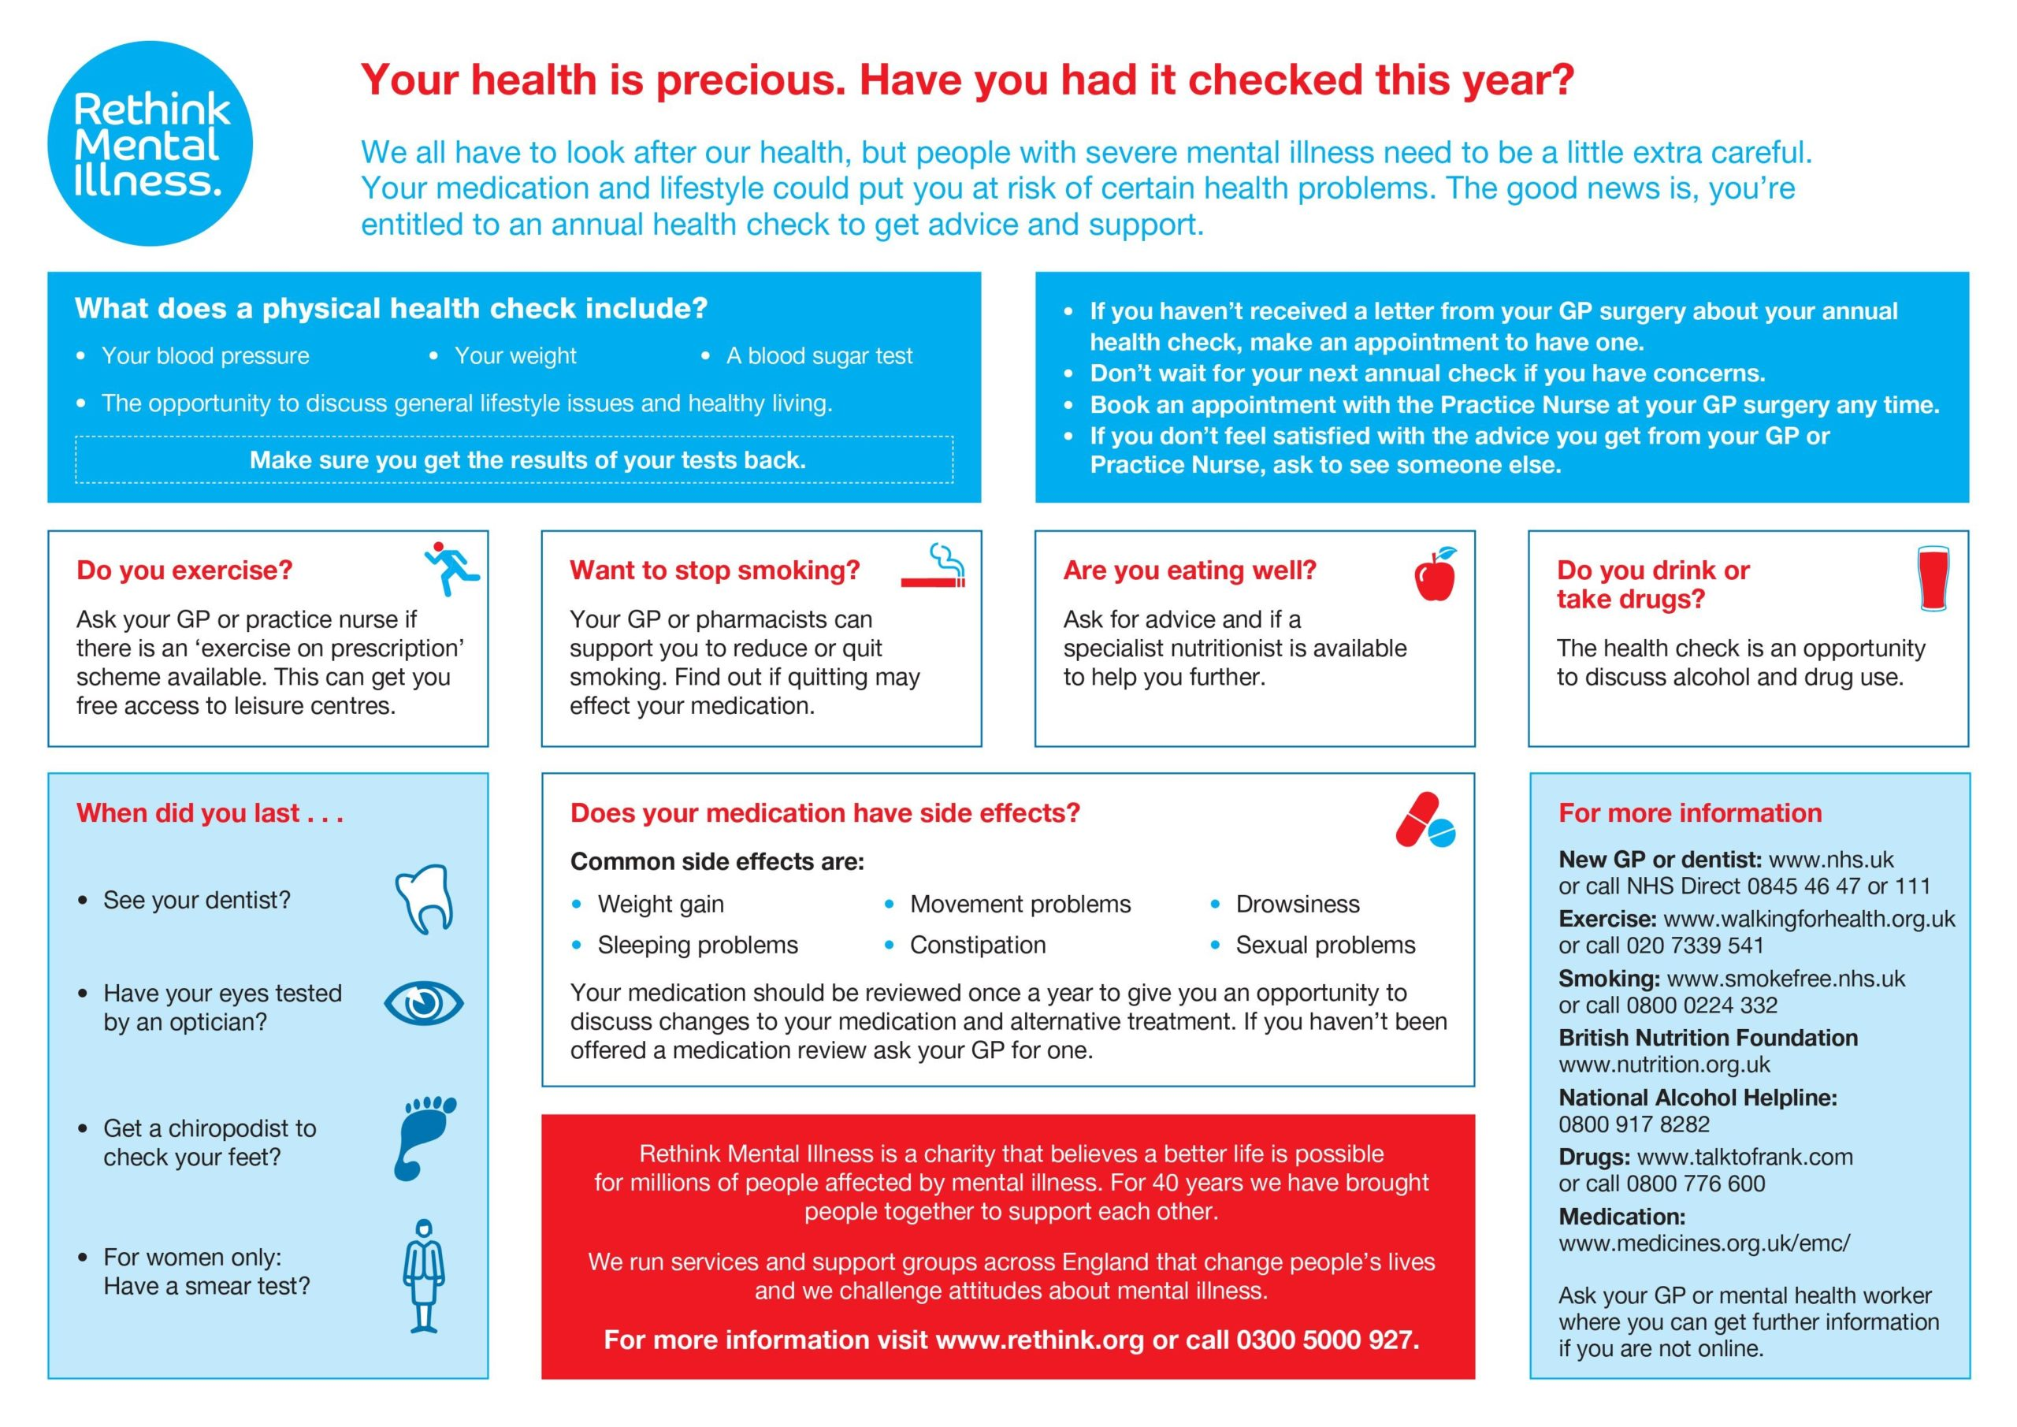


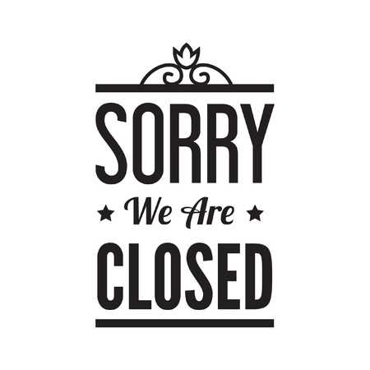
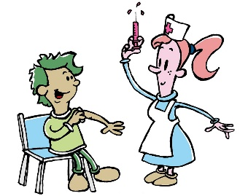

Useful Links

- Surgery website – http://www.hettongp.nhs.uk/
- Practice Facebook information page - Just search for Hetton Group Practice
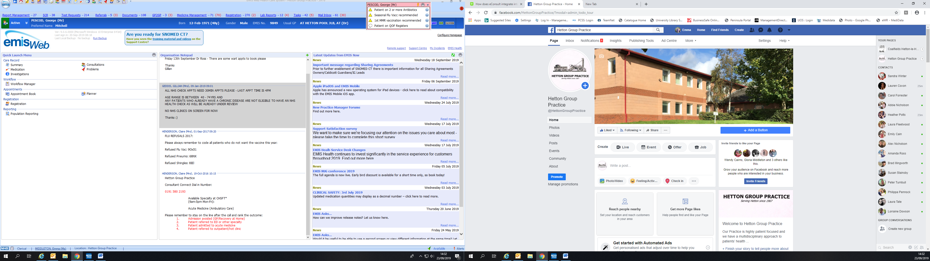
ATTENTION PARENTS

Any new patients registering with the practice that have moved to the UK, please could you bring a copy of your vaccinations into the surgery so we can update your records.
The surgery is closed every Wednesday 1-2 and will also be closed on the following dates:

Wednesday 22nd March - PM
Wednesday 17th May - PM
Childhood Vaccinations & Immunisations
It is important that your child/children’s vaccinations are kept up to date – so please attend these appointments.

- Is your child over 3 and a half?
- If so, please ensure they attend for their “pre school booster”.

YOUR CHILD IS AT RISK IF THEY DO NOT COMPLETE THEIR FULL VACCINATION SCHEDULE

NHS Health checks

We are currently undertaking a campaign to assess the risk of heart disease, stroke, diabetes and kidney disease. We are looking at our patient’s 40 - 74years who may be at risk of developing any of these conditions.
If you are in this age range – please ring the surgery to speak with a Health Care Assistant to see if you are eligible.
The check will consist of a small finger prick blood sample, questionnaire, blood pressure check etc.
There is a NHS Zero tolerance policy against shouting, swearing, or threatening behaviour, and these will not be tolerated under any circumstances Our staff are here to help you and will always be as polite and as helpful as possible even during difficult times and patients who are threatening or abusive towards our staff may be asked to leave our practice.

Cost of Living

Here at the practice, we are aware that the rise in cost of living is something that will affect many of our patients, their friends, family and loved ones that is struggling to come and speak with one of the team as we would like to offer support in any which way we can. You may want help be it emotionally, financially, or support accessing the internet to complete forms, or support in completing forms.

We know it can be daunting to try and find out what support is available, and we want to help. Some of you may find yourself in a position that you never thought you would be in.
Please find below some useful links which may help you, your family and friends.

Energy saving advice
Worried about Energy Costs? Call NEAL now!
Northeast Energy Advice Line
The Advice Service is:
• Independent
• Free
• Confidential
• Impartial
Call us now and we will:
• telephone you back with free and independent advice
• make an appointment for you to see an Energy Adviser if necessary
Energy costs have gone up a lot this year, and with other prices going up as well, making sure you can stay warm and manage your energy and other bills is more important than ever.
To Help, Citizens Advice in the North East have set up a new Telephone Advice Service to give you specialist and independent advice. The North East Energy Advice Line can give you free, independent and up-to-date advice on:
- how to minimise your fuel costs
- dealing with problems with your energy supplier
- welfare benefits and grants you may be entitled to
- Warm Home Discount and Cold Weather Payments
- improving energy efficiency in the home
- Priority Services Register and other support and much, much more
Call NEAL now on 01642 626106
For further advice https://www.citizensadvice.org.uk/consumer/energy/energy-supply/get-a-better-energy-deal/choosing-energy-tariff/
Ask CPAG | Fuel Rights Handbook 20th edition

Food Banks

The practice works with Sunderland Foodbank we are able to issue vouchers if you need support, please just give us a ring or call into practice.

For further information regarding foodbanks:
https://www.citizensadvice.org.uk/debt-and-money/using-a-food-bank/
Sunderland Foodbank https://www.sunderland.foodbnk.org.uk
Email: coordinator@sunderlandfoodbank.org.uk
Further information regarding food banks and parcels can be found at Sunderland Information Point Food banks and parcels - Sunderland Information Point https://www.sunderlandinformationpoint.co.uk/kb5/sunderland/directory/results.page?adultchannel=6_4

If you are a veteran in Sunderland and you need help, call us! We can help you with housing, employment, drug, alcohol and mental health issues, reintegration to society and much more - www.veteransincrisis.co.uk
Econsult is available 24/7.
To use this service please visit our web page http://hettongp.nhs.uk
A pop up box will appear for you to complete, once completed this will be emailed to the surgery and we will aim to deal with this query by 6pm the next working day.
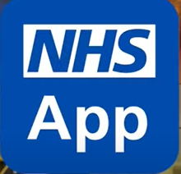


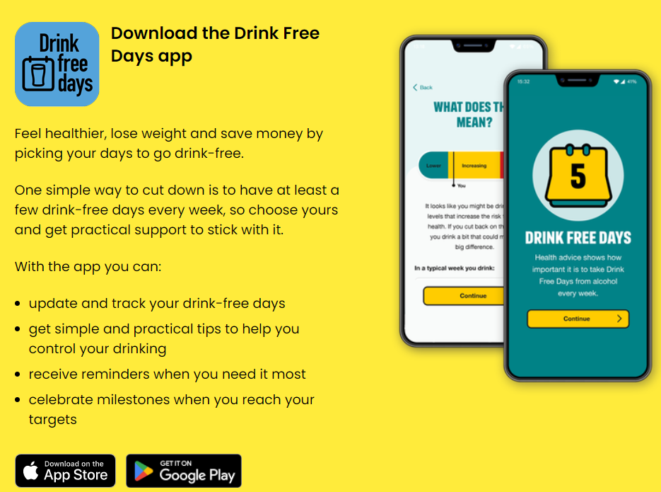
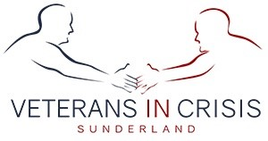
NHS APP

- Order repeat prescriptions
- View GP appointments
- Get your COVID pass
- Get health advice using the Health A-Z
- Register as an organ doner

The NHS App is available on iOS and Android


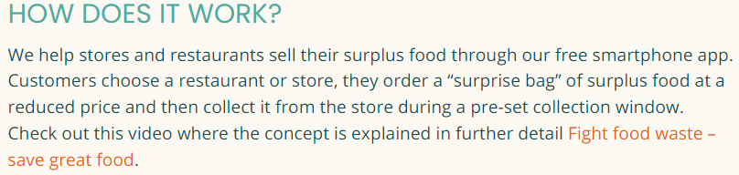

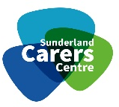
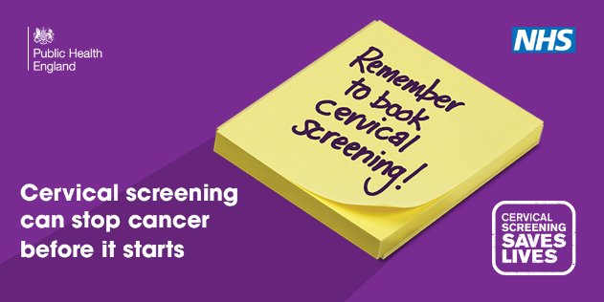
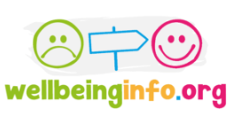
Grocery stores, Bakeries and Restaurants that use Too Good To Go are Greggs, Dickinson's, Starbucks, Morrisons, Subway, Toby Carvery, local takeaways and more.
Interested in
Stopping Smoking?

If you are a smoker and are interested in quitting, we have smoking cessation clinics here at the surgery with our healthcare assistants. Make an appointment if you are interested.

Are you a carer?
Sunderland Carers Centre offers a confidential information, advice and support service to carers.
If you are a carer please let us know.

http://www.sunderlandcarers.co.uk
Warm Spaces Sunderland

Please visit www.sunderland.gov.uk/warm-spaces for details of Warm Spaces being provided across Sunderland over the winter period. The spaces have been put in place across the community to support residents in accessing a warm, safe and welcoming space as well as an opportunity to enjoy some company and possibly hot drinks.

If you are looking to improve your health and wellbeing, or want to help a friend, colleague or family member? But don’t know where to start then Wellbeinginfo.org is the site for you. They offer:

- Local training
- Volunteering
- Youth wellbeing info
- Skill building
- Local events
- Mental health support
- Wellbeing resources
- Physical health resources
- Financial wellbeing resources
- Support, info and advice

