HETTON  GROUP  PRACTICE |   Issue 47 – May 2023 | NEWSLETTER
&



We would like to wish Dr Ross good luck with his next adventure. He has been with the practice for the last ten years and will be greatly missed!

We would like to welcome our new Nurse Practitioner Sally who joined the team in April.



The surgery is closed every Wednesday 1-2 and will also be closed on the following dates:

Wednesday 17th May – PM
Monday 29th May – Bank Holiday
Wednesday 21st June – PM
Wednesday 19th July – PM

Spring COVID Boosters
The spring COVID Boosters are now getting done at the surgery. We will contact you either by telephone or we will send you a text message with a self book link so you can book your own appointment.


Chronic Diseases

We are changing the way we invite patients in for their yearly health checks. All patients will now be invited in for their checks in their birth month. This may mean you might be invited slightly earlier or later than normal.

Failing to attend / failing to cancel unwanted appointments

From February 2023 to the end of April 2023 326 appointments were wasted due to patients failing to attend / failing to cancel their appointment – see breakdown:

Please always cancel unwanted appointments as they can be used by other patients who need to see a GP/Nurse.

Clinician Type: | No. of appointments:
GP | 39 appointments
Nurse Practitioner | 6 appointments
Practice Nurse | 109 appointments
Healthcare Assistant | 172 appointments

Useful Links

- Surgery website – http://www.hettongp.nhs.uk/
- Practice Facebook information page - Just search for Hetton Group Practice
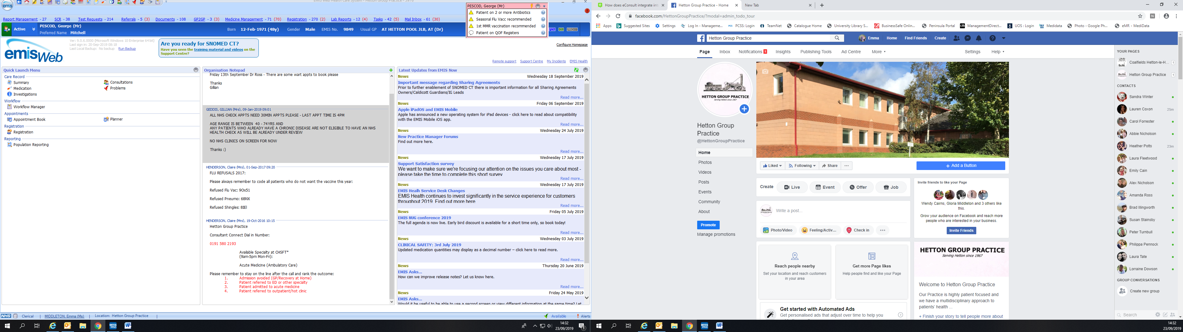
Any new patients registering with the practice that have moved to the UK, please could you bring a copy of your vaccinations into the surgery so we can update your records.





NHS Health checks

We are currently undertaking a campaign to assess the risk of heart disease, stroke, diabetes and kidney disease. We are looking at our patient’s 40 - 74years who may be at risk of developing any of these conditions.
If you are in this age range – please ring the surgery to speak with a Health Care Assistant to see if you are eligible.
The check will consist of a small finger prick blood sample, questionnaire, blood pressure check etc.

Please keep your details up to date and inform the surgery of a change of address or a new telephone number so that we always have the correct details.

Some of you may have seen we have new doors please press the button to enter and exit the surgery.

ATTENTION PARENTS

- Is your child over 3 and a half?
- If so, please ensure they attend for their “pre school booster”.

YOUR CHILD IS AT RISK IF THEY DO NOT COMPLETE THEIR FULL VACCINATION SCHEDULE

Childhood Vaccinations & Immunisations
It is important that your child/children’s vaccinations are kept up to date – so please attend these appointments.

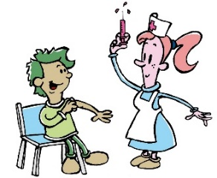
Econsult is available 24/7.
To use this service please visit our web page http://hettongp.nhs.uk
A pop up box will appear for you to complete, once completed this will be emailed to the surgery and we will aim to deal with this query by 6pm the next working day.



There is a NHS Zero tolerance policy against shouting, swearing, or threatening behaviour, and these will not be tolerated under any circumstances Our staff are here to help you and will always be as polite and as helpful as possible even during difficult times and patients who are threatening or abusive towards our staff may be asked to leave our practice.

Are you a carer?
Sunderland Carers Centre offers a confidential information, advice and support service to carers.
If you are a carer please let us know.

http://www.sunderlandcarers.co.uk



NHS APP

- Order repeat prescriptions
- View GP appointments
- Get your COVID pass
- Get health advice using the Health A-Z
- Register as an organ doner

The NHS App is available on iOS and Android




Interested in
Stopping Smoking?

If you are a smoker and are interested in quitting, we have smoking cessation clinics here at the surgery with our healthcare assistants. Make an appointment if you are interested.



Cost of Living

Here at the practice, we are aware that the rise in cost of living is something that will affect many of our patients, their friends, family and loved ones that is struggling to come and speak with one of the team as we would like to offer support in any which way we can. You may want help be it emotionally, financially, or support accessing the internet to complete forms, or support in completing forms.

We know it can be daunting to try and find out what support is available, and we want to help. Some of you may find yourself in a position that you never thought you would be in.
Please find below some useful links which may help you, your family and friends.

The North east Energy Advice Line can give you free, independent and up-to-date advice on:
- How to minimise your fuel costs
- Dealing with problems with your energy supplier
- Welfare benefits and grants you may be entitled to
- Warm home discount and cold weather payments
- Improving energy efficiency in the home
- Priority services register and other support
Call NEAL now on 01642 626106

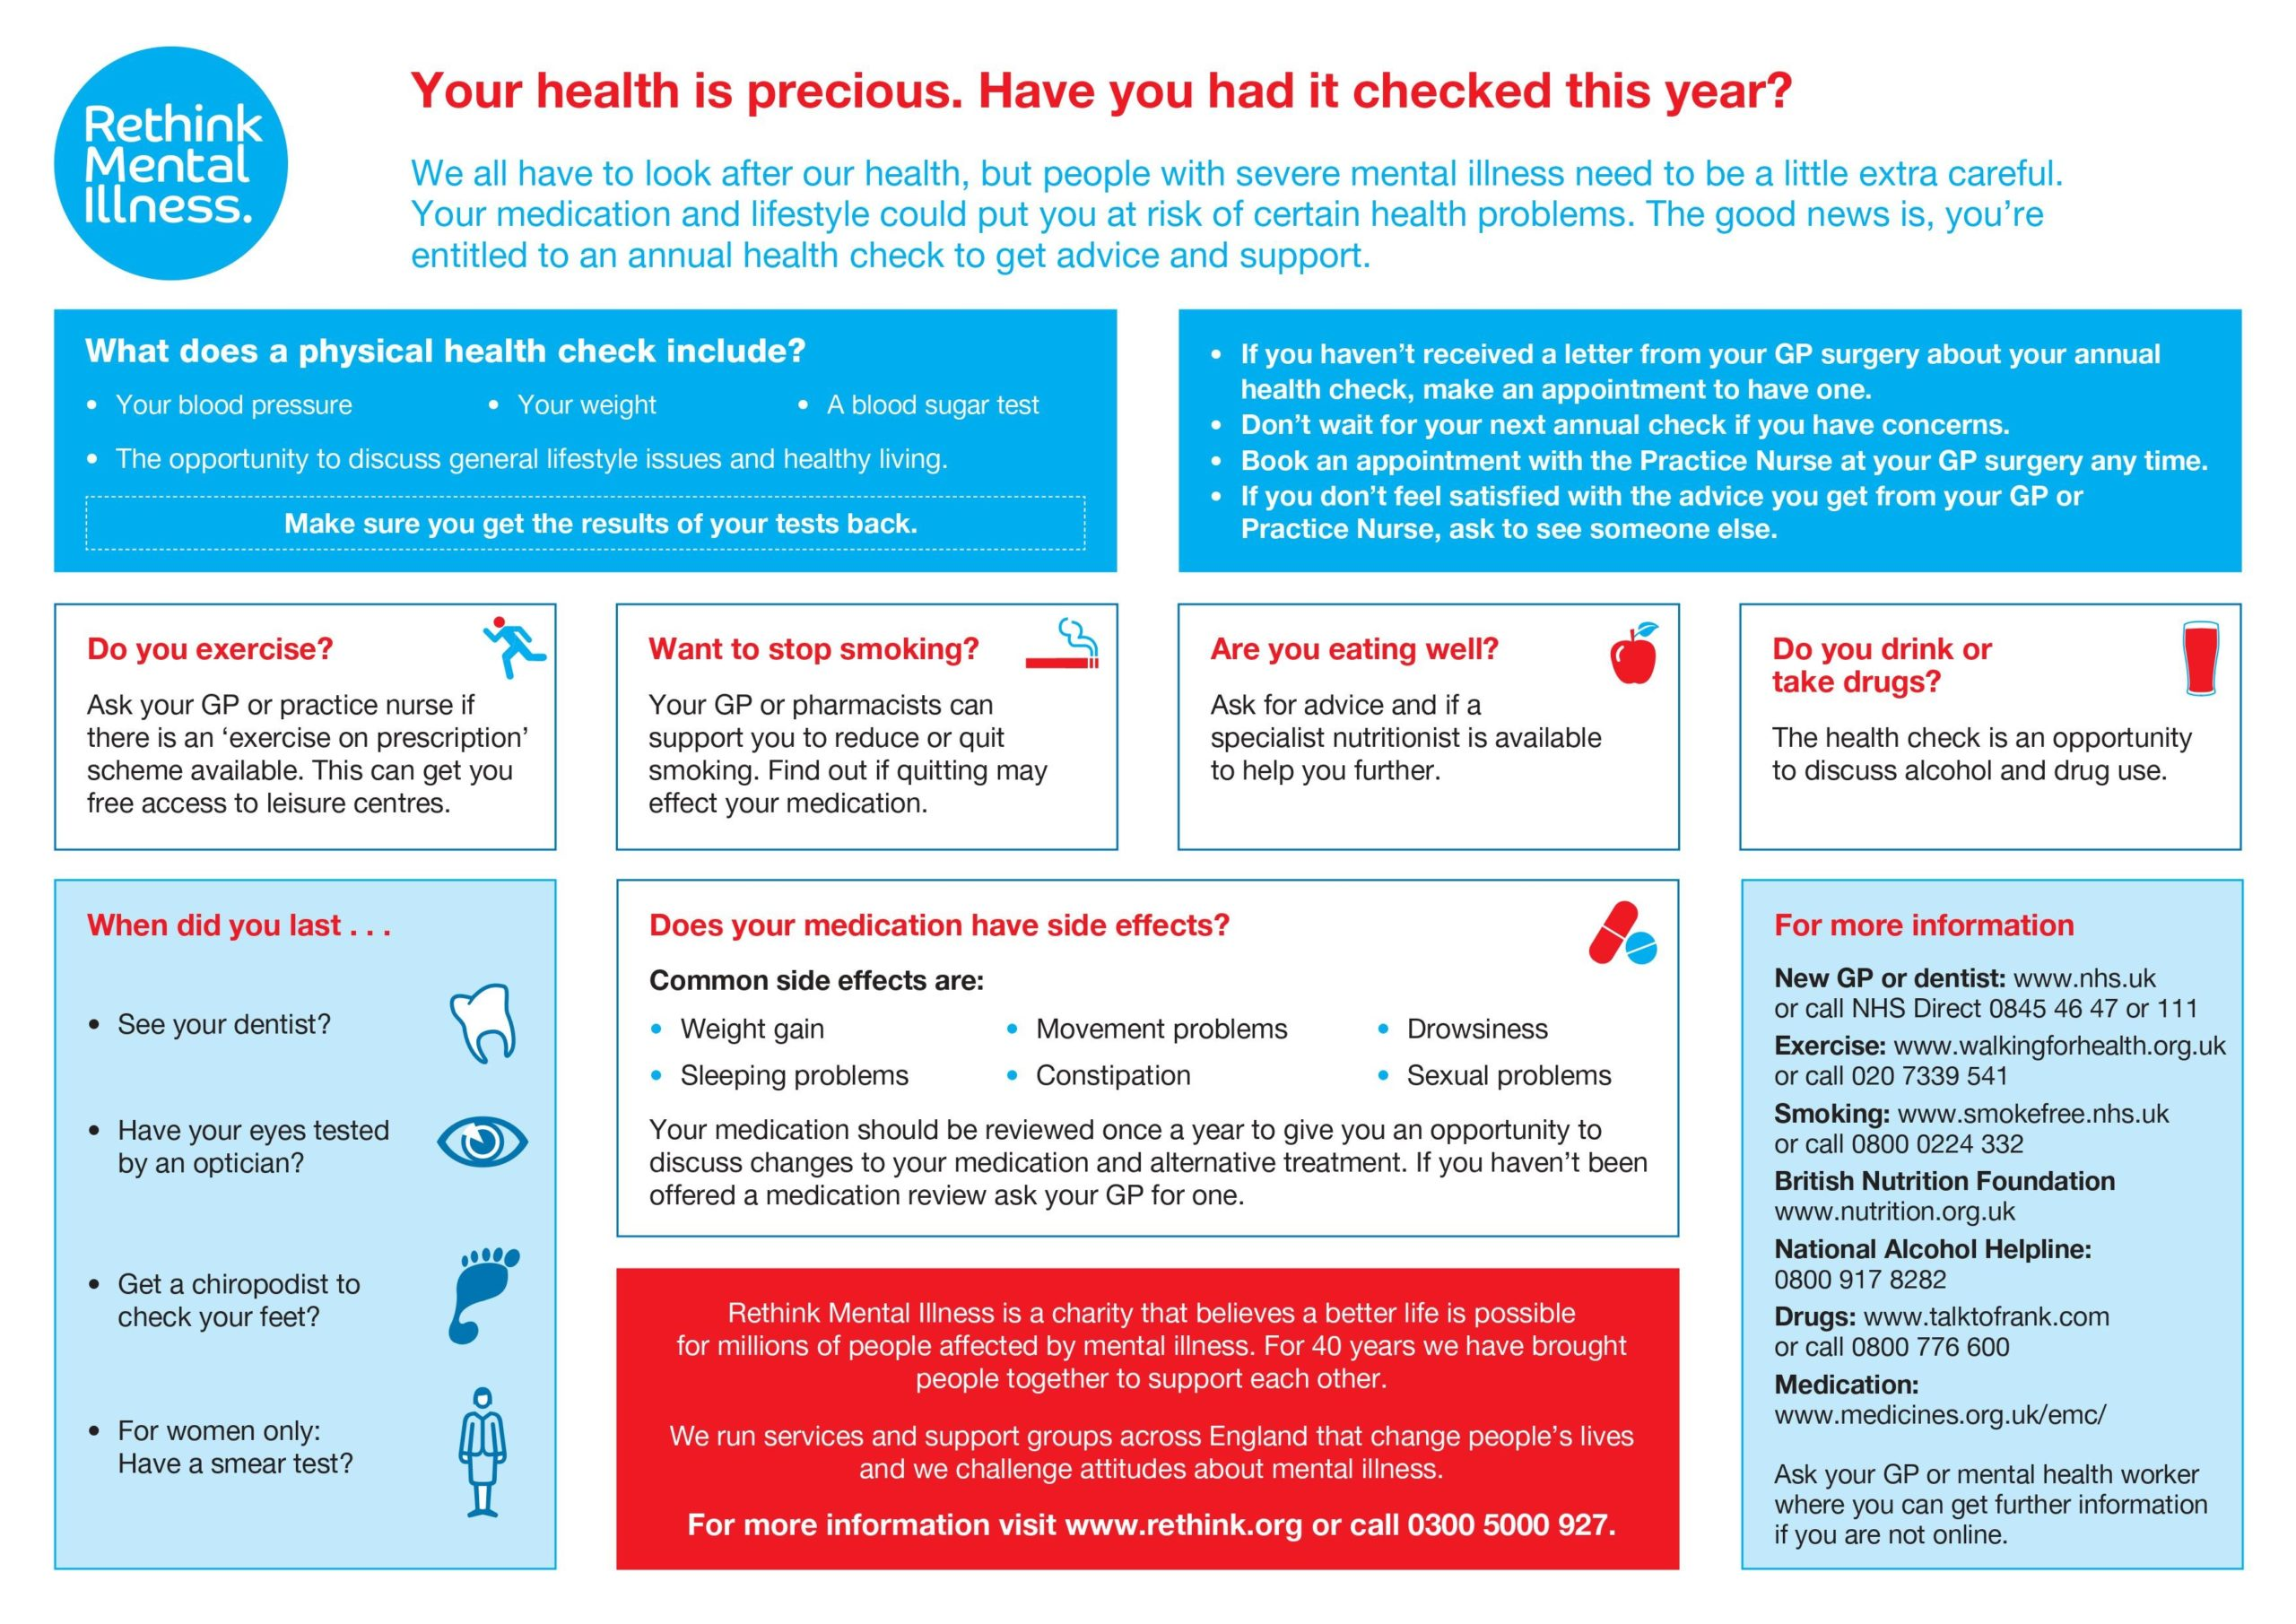



www.sunderlandhealthandwellnesshub.nhs.uk
This website has been built by local healthcare professionals. You can use it to find more information about local health and care services across Sunderland.

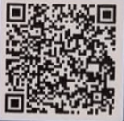
Social Prescribing

Many things can affect your health and wellbeing, we know that it can take more than medicine to help you get better. The Sunderland Social Prescribing Service will work with you to find out 'what matters to you.' The team will then support you in your own community.

They can support you with:
- Loneliness
- Emotional wellbeing
- Money worries
- Housing worries
- Healthy lifestyle choices
- Managing long-term health conditions

Ask you GP to refer you to this service or you can self-refer by scanning the QR code with your mobile phone.

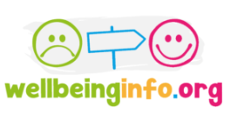

If you are looking to improve your health and wellbeing, or want to help a friend, colleague or family member? But don’t know where to start then Wellbeinginfo.org is the site for you. They offer:

- Local training
- Volunteering
- Youth wellbeing info
- Skill building
- Local events
- Mental health support
- Wellbeing resources
- Physical health resources
- Financial wellbeing resources
- Support, info and advice


