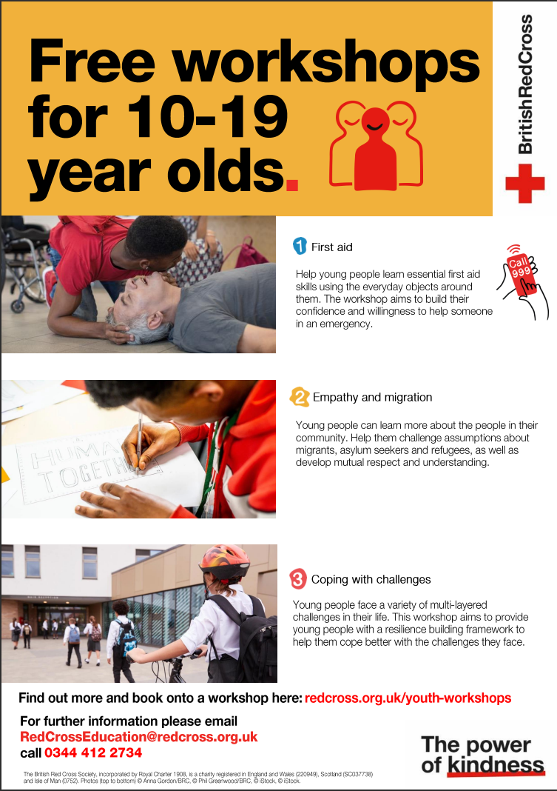



Your local coordinator is: Gordon Chalk
Email: gordonchalk@redcross.org.uk
Phone: 07714159035

