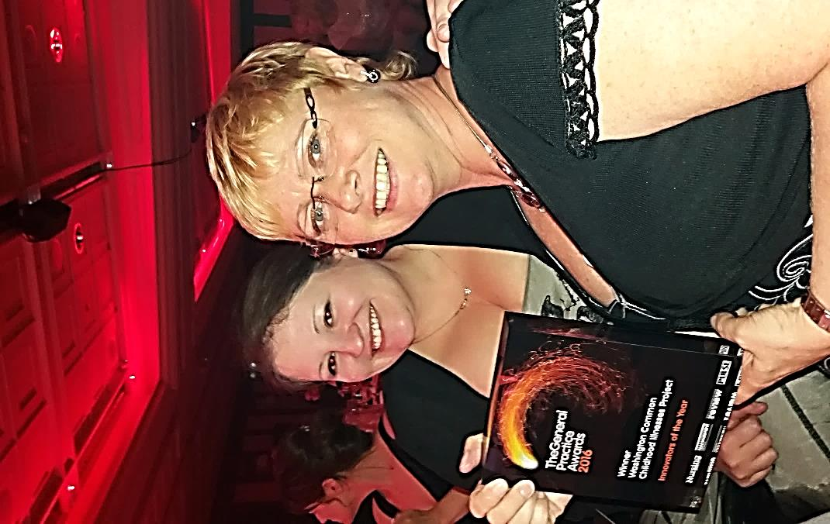
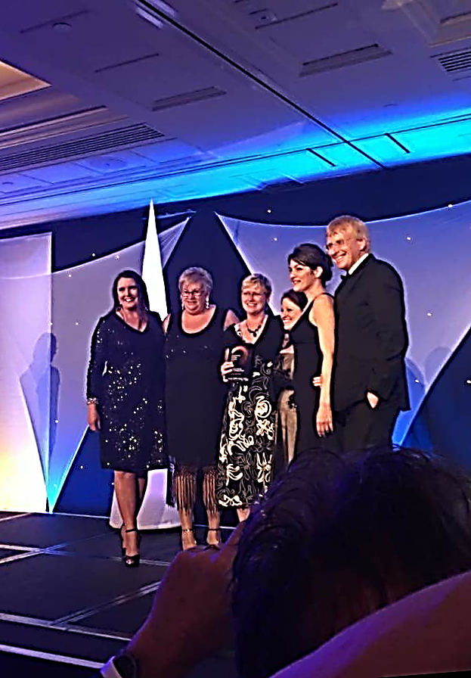
GENERAL PRACTICE AWARDS 2016

We are proud to announce that the Washington Locality scooped the ‘Innovator of the Year’ award this year for our Common Childhood Illness Booklet and App.

The awards were held at the Lancaster London Hotel in London on Thursday 24th November 2016. There were 17 nominations in this category and the awards are nationwide, so Washington has done really well.

We were also a finalist in the Clinical Group – Paediatrics for this work.

The Coalfields also won an award for the Young Persons Sexual Health Clinic and the Sunderland GP Alliance won Commissioner of the Year.

This has put Sunderland well and truly on the map.

