Save the planet and save some money

Visit the energysavingtrust.org.uk

  Switch off standby – Almost all electrical appliances can be turned off at the plug without upsetting their programming. You might be able to save up to £40 a year by doing this. |   Draught proof your house - Unless your home is very new, you will lose some heat through draughts around doors and windows, floors or through the chimney. If you have an open chimney, try an inflatable chimney sock.
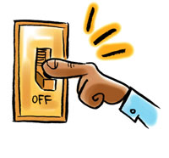  Turn off lights - when you’re not using them or when you leave a room. This will save you around £14 a year on your annual energy bills.  Replacing all the lights in your home with LED bulbs could also help reduce the amount you spend on energy. | 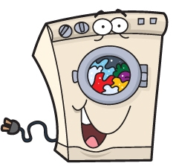  Think about your washing and drying habits - You can save money on your energy bill by using a 30-degree cycle instead of higher temperatures. Avoid using a tumble dryer for your clothes dry clothes on racks inside where possible or outside in warmer weather and you might save up to £40 a year.
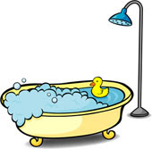  In the bathroom - keeping your shower time to just 4 minutes could save a typical household £45 a year on energy bills. Swapping just one bath a week with a 4-minute shower could save you £7 a year on your energy bills. |   In the kitchen - kettles are one of the most used appliances but many of us boil the kettle with more water than we’re going to use. Avoid overfilling the kettle and you could save £8 a year on your electricity bill.

