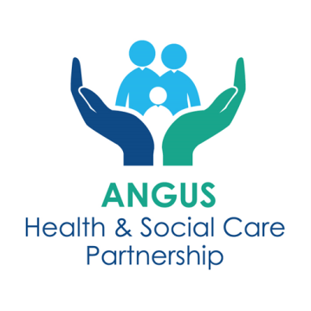
South East Angus ECS Mental Health and Wellbeing Hub
Self-Referral Form

Who is this service for?

Any person (16+) who is registered at a GP Practice in Arbroath, presenting with mental health and wellbeing needs, or substance use needs. The Hub will also accept referrals for 11-16 year olds of high school age but only for the Young People’s Peer Support Worker and for those young people with less complex mental health and well-being challenges. Following completion of this form, please email to tay.southeastangushub@nhs.scot or hand into your practice receptionist. Once the referral has been received it will be screened by the ECS mental health and wellbeing hub.

Date: _______________________________

GP Practice Name: ______________________________

Please tick box if form completed by GP Practice Staff on behalf of the patient

PERSONAL DETAILS
Name: __________________________ DOB: ____________
Address: ____________________________________________________
Postcode: _______________________________
Mobile: __________________ House Phone: ____________________________
Are you involved with any other services now or in the past?
E.g. CMHT, Penumbra, AIDARS, Tayside Council on Alcohol, Peer Support, Psychology.

Brief summary of the support/help you need?
Please describe the issues effecting your mental health and wellbeing e.g. stress, low mood, anxious, bereavement

