**Welcome to the Christmas edition of the Glebe House Surgery Newsletter.**

**Surgery news:**

You may have noticed some staff in Christmas jumpers. This is because we are supporting Save the Children Christmas Jumper appeal.

Did you know we have a Facebook page? Have a look at it – Glebe House Surgery.

Information about the surgery can be found on the surgery's website: [www.glebhousesurgery@nhs.net](http://www.glebhousesurgery@nhs.net).

**Pharmacy news:**

Knight Mills would like to remind patients that it takes 7 days from ordering a prescription to them being able to supply it to you.

**Patient participation Group news:**

This is now up and running again and we have had two meetings. We are still looking for more volunteers to join us. We meet every three months with the next meeting scheduled for Tuesday 6 February at 17.30. If you are interested in joining us or have any comments you wish to raise, then email [hnyicb-ny.b82066ppg@nhs.net](mailto:hnyicb-ny.b82066ppg@nhs.net).

**Christmas tips:**

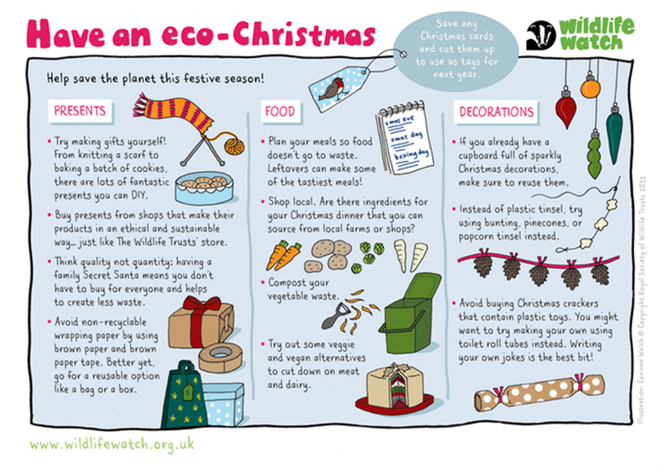

**Self care:**

Five things for your medicine cabinet:

1. Pain relief – paracetamol, ibuprofen and aspirin to help relieve minor aches and pains, as well as symptoms of minor illnesses.
2. Oral rehydration salts – a high temperature, diarrhoea and being sick can cause you to become dehydrated by losing water and essential minerals. Oral rehydration salts help restore your body’s natural balance of fluid and minerals.
3. Anti-diarrhoea tablets – diarrhoea can be caused by food poisoning or a stomach virus and can happen without warning. Anti-diarrhoea remedies may not deal with underlying cause but can help control the symptoms.
4. Indigestion treatment – antacids can reduce stomach acidity and bring relief to stomach ache or heartburn.
5. A full first aid kit – this should include bandages, plasters, a thermometer, antiseptic, eyewash solution, sterile dressings, medical tape and tweezers.

**Forthcoming health promotions:**

**January**

* Veganuary www. veganuary.com

Thinking of try Vegan? Veganuary inspires and supports people all over the world to try vegan for January and beyond.

* Dry January - https://alcoholchange.org.uk/help-and-support/managing-your-drinking/dry-january

Take on 31 days alcohol-free with Alcohol Change UK for a total body and mind reset. From better sleep and a mental health boost, to saving money and time - there's a whole lot to gain this Dry January.

**Useful Information**

**Opening times:**

|  |  |  |  |
| --- | --- | --- | --- |
|  | **Glebe House Surgery** | **Knights Mills pharmacy** | **Rowlands pharmacy** |
| Monday | 8 – 18.30 | 9 – 17.30 | 9 – 17.30 |
| Tuesday | 8 – 18.30 | 9 – 17.30 | 9 – 17.30 |
| Wednesday | 8 – 18.30 | 9 – 17.30 | 9 – 17.30 |
| Thursday | 8 – 18.30 | 9 – 17.30 | 9 – 17.30 |
| Friday | 8 – 18.30 | 9 – 17.30 | 9 – 17.30 |
| Saturday | Closed | 9 – 13.00 | 9 – 12.00 |
| Telephone no. | 01677 422616 | 01677 422878 | 01677 422835 |

**(We are all closed on 25 and 26 December and then again on 1 January 2024).**

**Merry Christmas and a Happy New Year to you all!**