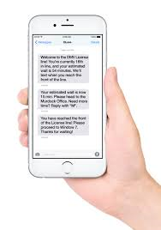

YES PLEASE REGISTER ME FOR YOUR TEXT MESSAGING SERVICE:

Name:

Date of Birth: Mobile Number:

TEXT MESSAGING SERVICE:

Did you know you can register your mobile phone number at Wilsden or Cullingworth surgery and we can then text you appointment confirmations and reminders and even messages re test results?

Why wait, register today – drop in to reception or call our team on 01535 273227