GRANGE PPG MEETING MINUTES
16 January 2024 (5:00 pm – 6:00 pm)
Attendees:
- PPG members: Matin (Chair), Noelle, Sue Caselton, Phil Gibbins, Adrian Abel, Wyn Barron, Cath Bottomley, Mohammad Naeem
- Grange: Dr. Kumar, Dav (Practice Manager), Vedikka, Zunera (Minutes)
Apologies:
Amanda Cllr Pinnock, Patricia (Pat Bell)
Welcome and Introductions:
All attendees introduced themselves and their respective roles.
5:05–5:10 pm - Action from Previous Minutes (21 November 2023)
Attendees confirmed agreement with the actions outlined in the previous minutes, requiring no further discussion.
5:10–5:15 pm – Appointments, Access, Capacity, and Monthly Figures
Dav provided updates on the ARI Hub (respiratory clinic) and discussed the effective utilization of clinics during the winter months. The Grange hosts the ARI clinic hub every Wednesday, catering to children and adults with respiratory infections. These are appointments additional to our core offering at the Practice.
Regarding flu/Covid clinics, Dav informed about the completion of Covid/flu vaccination clinics in January. Whilst the covid vaccination “season” (Autumn boosters) has finished, flu vaccinations are likely to be available until the end of March. Notably, there were fewer Covid vaccine uptakes compared to flu vaccines this year. Strategies to promote vaccinations were discussed, including weekend clinics and targeted promotions. The Practice hopes to offer the covid vaccinations from The Grange in future “seasonal” campaigns, and it is hoped this will improve access for local patients and encourage uptake of the vaccine.
Martin requested previous years' data for comparison, to which an action was assigned to send Adrian Covid/Flu data.
Action :- Send Adrian Covid/Flu data
Appointment System
Dav introduced the implementation of PATCHS to optimise and prioritise appointment requests, transitioning from traditional methods to a more efficient online system. Concerns regarding accessibility for patients lacking technology access were raised, emphasizing the importance of maintaining phone-based communication options. Dav reassured the patient group that traditional access routes were still available but explained capturing the relevant information at time of request – online, by phone or in person is important in helping us prioritise the most urgent cases and optimising our capacity.
Extended Access Appointments
Queries regarding extended access appointments were addressed, clarifying the shared resource model within the primary care network (PCN). Extended access appointments are available Mon-Thurs until 8pm at The Grange, and our patients can also access Saturday appointments across Huddersfield.
Practice Updates/Recruitments
Updates on attracting new doctors and integrating additional roles such as pharmacists and physiotherapists were provided, indicating a positive trend for the Grange. We have successfully recruited 2 GPs, a male and a female GP to replace Dr Solomon, who will leave us at the end of February to take control of his own Practice in Barnsley.
Buildings and Estates
Updates on renovations at the Grange and discussions with NHS Property Services regarding the reopening of Keldergate were shared. Patient preferences for accessible locations were highlighted, and the patient group recommended the Practice work towards reopening Keldregate or offering services from another site close to that area. It was noted there were a lot of elderly and infirm patients there, who depended on the Keldregate site as their local GP surgery.
AOB
Discussions included increasing participation among PPG members, dissemination of information, and potential impacts of junior doctors' disputes on practice services. We were delighted to acknowledge the introduction of several new members over the past 6 months, and further recruitment should continue to increase diversity, views and suggestions within the Patient Group.
Data Analysis and Trends Discussion
Adrian Abel presented data analysis findings, addressing trends in home visits, medication issuance, and consultation requests. Concerns over response times and COVID-related data anomalies were discussed.
Adrian used graphical representations to enhance his presentation, particularly showcasing several slides that effectively explain the operational efficiency of Grange Group practice.
The below graph illustrates a steady upward trend in call volumes commencing from 2022, with figures starting at 6,851 and concluding at 8,181 by the end of December 2023.

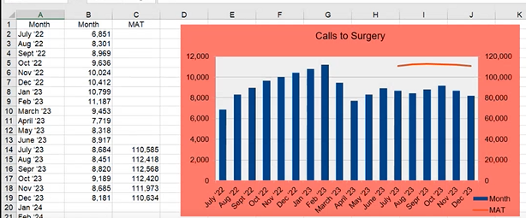

The following slide presents a graphical representation explaining the trajectory of online appointment requests between 2022 and 2023, emphasizing the proficient adoption of technology by patients affiliated with Grange.
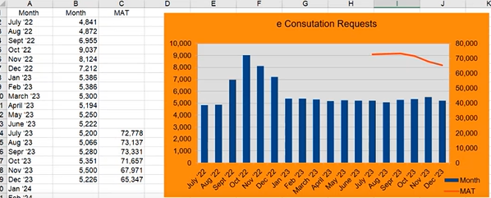
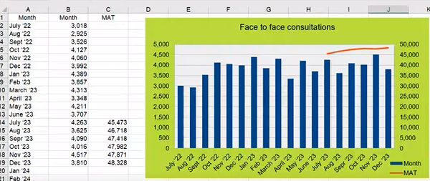

The preceding slide outlines the face-to-face appointments offered by Grange, emphasizing our organisation commitment to providing optimal care to its patients.
Conclusion
The meeting concluded with gratitude expressed to all attendees. Future meeting arrangements, including virtual and in-person options, were discussed and delegated for organization.
Action Items:
- Zunera to organize future meetings considering virtual and in-person formats.
- Next Meeting: March 19th, 5:00 pm-6:00 pm (Location: To be confirmed)
- Copy of the notes to be confirmed and then shared on the Patient Group section of the website.

