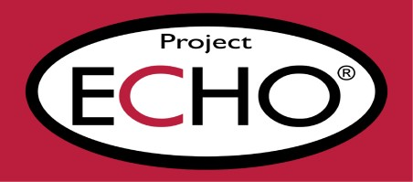

Extension

for

Community

Healthcare

Outcomes

Awareness Training NHS Screening Programmes

open to all staff, family members and carers in all care service areas
Working in partnership to increase the uptake of NHS Screening Programmes for people with a learning disability, autistic people, and people with a severe mental illness
This 90-minute session aims to increase knowledge and understanding of the 3 NHS
Cancer Screening Programmes (Bowel, Breast and Cervical) and Abdominal Aortic
Aneurysm (AAA) and Diabetic Eye Screening and the importance of them. By the end of the session, you will be able to identify opportunities where you can support reducing inequalities in uptake of screening programmes

Available Dates
Friday 15 November 2024, 10.00 am to 11.30 am To book a place follow the link
https://stlukes.accessplanit.com/accessplan/checkout/AddItems?coursedateid=12663
Monday 10 February 2025, 1.00 pm to 2.30 pm To book a place follow the link
https://stlukes.accessplanit.com/accessplan/checkout/AddItems?coursedateid=12664
Tuesday 4 March 2025, 1.00 pm to 2.30 pm To book a place follow the link
https://stlukes.accessplanit.com/accessplan/checkout/AddItems?coursedateid=12669
If you experience any difficulty booking onto any of these sessions, please email: echo@hospicesheffield.co.uk
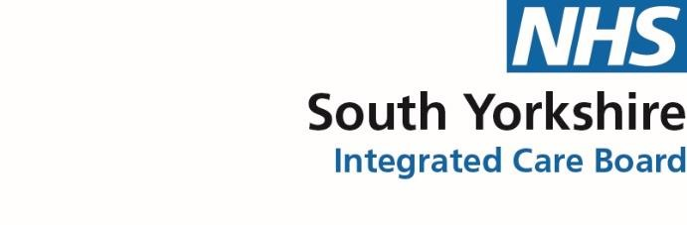
1

