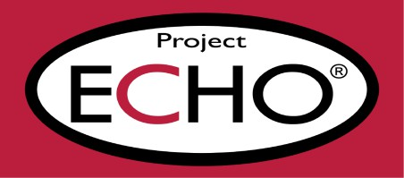
Extension for Community Healthcare Outcomes

Oral Health Awareness Training
open to all anyone in a caring role, paid or unpaid who are supporting people with a learning disability, mental health needs or autistic people
This 90-minute session aims to increase knowledge and understanding of oral health care.
The session will be delivered by:
Emily Grayson, Dental Nurse and Oral Health Advisor & Joanne Charlesworth, Oral Health Promotion Manager
Session aims:
- To recognise the difference between a healthy and unhealthy mouth
- Recognise how diet affects dental health
- Carry out an effective tooth brushing technique
- Care for dentures and the mouth
- Show a knowledge signs and symptoms of the mouth and the appropriate care

Day | Date | Booking Link
Tuesday  Tuesday  Tuesday | 13th August 2024  24th September 2024  22nd October 2024 | https://stlukes.accessplanit.com/accessplan/checkout/AddItems?coursedateid=12334  https://stlukes.accessplanit.com/accessplan/checkout/AddItems?coursedateid=12335  https://stlukes.accessplanit.com/accessplan/checkout/AddItems?coursedateid=12336
Tuesday | 26th November 2024 | https://stlukes.accessplanit.com/accessplan/checkout/AddItems?coursedateid=12337
If you have any issues registering, please contact: echo@hospicesheffield.co.uk



