**Lofthouse Surgery and The Manse Surgery**

**A GUIDE TO:**

**YOUR DOCTORS SURGERY**

**The Lofthouse Surgery**

2 Church Farm Close

Lofthouse

Wakefield

WF3 3SA

Tel: 01924 822 273

www.lofthousesurgery.co.uk

**The Manse Surgery**

4 Marsh Street

Rothwell

Leeds

LS26 0AE

Tel: 0113 282 3390

www.themansesurgery.co.uk

**Contents:**

|  |  |
| --- | --- |
| 3. | Welcome and Practice History |
| 4. | The Practice Team |
| 5. | The Practice Team Continued |
| 6. | Appointment System Overview |
| 7. | Doctors Appointment Guide |
| 8. | Out of Hours GP Appointments |
| 9. | Nursing Team Appointments Booking Guide |
| 10 -11. | Nursing Team Appointment Information |
| 12. | Travel Vaccination Services |
| 13. | Contraception and Sexual Health Services |
| 14 – 16. | Additional Information and Services |
| 17. | Prescription Requests |
| 18. | Patient Online Services |
| 19. | Our Responsibilities to You |
| 20. | Your Responsibilities to Us |
| 21. | Compliments, Comments and Complaints |
| 22. | Our Locations |
| 23. | Freedom of Information & Zero Tolerance Policy |
| 24. | Useful Telephone Numbers |

|  |
| --- |
|  |

**Welcome to Lofthouse and The Manse Surgery**

**Practice History:**

We currently have two surgery buildings, The Lofthouse Practice in Lofthouse and The Manse Surgery in Rothwell.

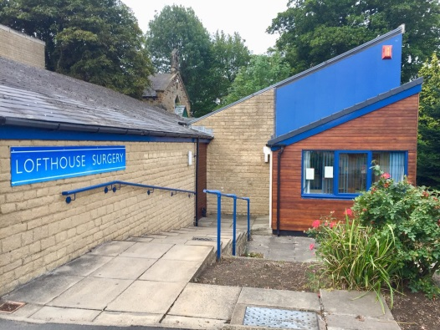

**Lofthouse Surgery**

**Lofthouse Opening Times**

|  |  |
| --- | --- |
| Monday | 8.00am - 6.00pm |
| Tuesday | 8.00am - 6.00pm |
| Wednesday | 8.00am - 6.00pm |
| Thursday | 8.00am - 6.00pm |
| Friday | 8.00am - 6.00pm |

**PLEASE NOTE:** The surgery will be closed one afternoon each month for staff training. The dates are advertised in surgery and on the practice website. If you need medical attention on these afternoons please ring **111** or **in an emergency 999.**

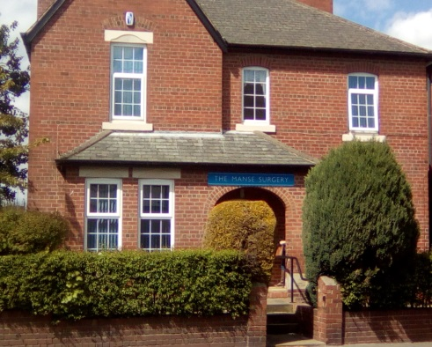

**The Manse Surgery**

**The Manse Opening Times**

|  |  |  |
| --- | --- | --- |
|  | Monday | 8.00am - 6.00pm |
|  | Tuesday | 8.00am - 6.00pm |
|  | Wednesday | 8.00am - 6.00pm |
|  | Thursday | 8.00am - 6.00pm |
|  | Friday | 8.00am - 6.00pm |

**The Practice Team:**

**Practice Manager**

**Mrs Karen Nicholson BA(Hons)**

**The General Practitioners (GPs) Partnership**

* Dr Benjamin Browning
* Dr Ian Sanderson
* Dr Philippa Barnes
* Dr Anna Tarr
* Dr Amjid Khan
* Dr Katie Lummis

**Salaried GPs**

* Dr Maryam Ageni-Yusuf
* Dr Babundo Okwechime

**Practice Nurses**

* Maxine Grimbley *– Lead Nurse*
* Angela Hainsworth
* Rebecca Parkin

**Healthcare Assistants**

* Joanne Moon
* Sarah Jowsey
* Susie Oakes
* Lisa Dowd – *Phlebotomist*

**The Practice Team:**

**Business Administration Team**

Anna Kiernan, Claire Lightowler, Emily Lunn

**Administration Team**

Sandra Bedford – *Administration Team Leader*

Christine Saunders, Karen Smith, Jill Lampe,

Martine Rees, Emma Smith

**Reception Team**

Elizabeth Walton – *Operations Supervisor*

Gemma West, Joanne Wadworth

Lucy Duncan, Michelle Marshall, Jessica Taylor

Katie Flanagan, Natalie Appleby

**Prescription Team**

Jacqueline Firth, Sharon Richman, Tracy Schofield

**Appointments**

We are constantly reviewing our appointments to ensure they meet the patient’s needs. As a result we feel that not only does the system benefit the patient fairly, but also ensures that the patient is able to obtain an appointment in a timely manner which suits the urgency of your needs. On the next page we have listed the appointments we offer, what needs these are best suited to and the process of booking these appointments.

**Please note** whilst each patient has the right to express a preference to see a particular practitioner, this may delay the time in which you are able to book an appointment. The practice will always endeavour to comply with the patient’s request, but in some circumstances this may not be possible, in this event an explanation will be offered.



**GP Appointment Booking Guide**

**7 Day & 14 Day GP Appointments**

7 day & 14 day GP appointments are designed for non-urgent needs but the patient feels that they need to see a doctor soon. The slots are released at the start of the day and allow the patient to book an appointment for one weeks’ time for the 7 day appointments and two weeks’ time for the 14 day appointments. Please refer to the practice opening times on page 3 for specific times. The patient is able to request a specific GP, and whilst we will always try to fulfil this request we cannot guarantee that there will be availability. **PLEASE NOTE*:*** *7 day & 14 day appointments are given on a first come, first serve basis. The appointment may be at an alternative surgery to your normal choice.*

**Urgent Same Day GP Appointments**

For patients who require urgent medical attention the surgery releases a fixed amount of urgent appointments every day. The appointments become available at the start of the day. Please refer to the practice opening times on page 3 for specific times. **PLEASE NOTE*:*** *Urgent same day appointments are given on a first come, first serve basis. The appointment may be at an alternative surgery to your normal choice and unfortunately,* ***we are not able to offer a choice of GP****.*

*When booking this appointment you will be asked by the receptionist to confirm that it is indeed an urgent appointment.* ***Please do not abuse this system as these appointments are for patients who need to be seen ASAP.***

**Out of Hours GP Appointments**

We are happy to announce that as part of the NHS Primary Care Extended Access Scheme we are now able to offer a selection of weekend and evening appointments for both GPs and Nursing.

These appointments are great for our patients who work within normal practice hours, or for patients who feel they need to be seen sooner than the next available appointment the practice is able to offer.

**Please note:**

* These appointments are held at St George’s Centre in Middleton and New Cross Surgery in Rothwell.
* We are not able to offer a choice of GP as they are GP’s from the whole of Leeds, and it will vary each day to who is available.
* These appointments are for ACUTE problems only. If an appointment for a recent ongoing issue is required, then a slot with a GP at the practice will be required.



**Nurse and Healthcare Assistant Appointments Booking Guide**

The practice nurse and healthcare assistant team are available at both sites to throughout the day. Below is a list of services they are able to provide.

Please be aware when booking the appointment our receptionists will ask why the appointment is required. This is to ensure we book our patients in with the correct staff member and for the appropriate amount of time.

**Nursing Team Services List**

|  |  |
| --- | --- |
| * Routine Blood Tests | * Blood pressure check |
| * Routine Health Checks | * Wound Care |
| * B12 Injections | * ECG’s |
|  |  |
| * Immunisations – including Child and Travel | * Ear Syringing |
| * 24hr Blood Pressure Monitoring | * Weight, Cholesterol and Life Style Advice |

We also have nurse led clinics for Long Term Conditions Care including Respiratory, Diabetes and Cardiovascular conditions

**Nurse Appointment Information**

* **Wound Dressing**

Wound care is provided by the practice nurses, some basic dressings, stitches and clip removal maybe carried out by trained health care assistants.

* **Leg Ulcer Management**

Some practice nurses are specially trained to manage leg ulcers and perform Doppler assessments.

* **Blood testing**

We have bookable blood clinics available throughout the week. Please contact the surgery for the latest clinic times. Please be aware the latest appointment we can offer is 3:50pm as our samples are collected for the lab at 4pm every day.

* **Smoking cessation advice**

We offer basic smoking cessation advice and make referrals for patients wishing to give smoking.

* **Sexual Health Advice**

All GP’s and Practice Nurses are trained to provide sexual health advice. We offer routine sexual health screening. For contraception other than the pill the patient may be advised to attend the sexual health clinic in Leeds or Wakefield.

* **Long Term Conditions**

In addition to general medical consultations we are pleased to be able to provide specialist clinics and services covering Asthma, COPD, Coronary Heart Disease, Diabetes and Cardiovascular conditions.

**Travel Vaccinations and Immunisations**

Travel and other vaccinations are by appointment with the practice nurse only. For travel vaccinations the patient is required to complete a travel assessment form (6 weeks before travel). This assessment will be completed within 10 working days. After this time period the patient needs to contact the surgery after 1pm to get the results from our reception team who will then book an appointment with the nursing team if necessary. Please allow time for the assessment at busy periods.

* **Please note:** *Some vaccinations are not available on the NHS and you may be referred to a private travel clinic for these.*
* *If you are due to go on holiday sooner than six weeks you will need to contact a local travel clinic. We have provided some contact details below*

***Super Travel Clinic***

*Tel: 03 333 111 007*

***Woodhouse Medical Practice***

*Address: Cambridge Road, Leeds, LS6 2SF*

*Tel: 0113 221 3533*

*Website:* [*www.woodhousemedicalpractice.nhs.net*](http://www.woodhousemedicalpractice.nhs.net)

* **Electrocardiography (ECG)**

All practice nurses and healthcare assistants are trained to perform ECG’s on request from a GP or Nurse.

* **Health Checks**

Depending on the age of a patient and whether they suffer from any long term Conditions, the surgery offers a range of health checks which can benefit the wellbeing of a person. In most cases we will make contact with the individual when they become eligible for the check. For more information please see [www.nhs.uk](http://www.nhs.uk).

* **Spirometry Test**

Most of the nurses are trained to perform a spirometry test after referral from a GP or Nurse.

* **Blood Pressure Monitoring**

We now have 24hr BP monitoring after referral from a Nurse or GP

.

**Cervical Screening**

* **Cervical Screening**
* Women aged 25-49 require a routine smear test every three years.
* Women aged 50-64 require a routine smear every five years.

The patient will receive a notification letter in the post inviting them to book an appointment with a practice nurse.

**PLEASE NOTE:**

Trans patients may not be invited to routine screenings and can miss out on important health checks.

Please ask a doctor or nurse to see if you’re due a screening and book an appointment to discuss how we can make your screening most comfortable for you

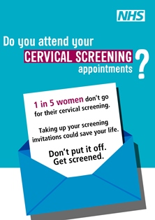

**Contraceptive and Sexual Health Services**

Advice is available from all GPs, and practice nurses; however, unfortunately at the moment we are unable to prescribe any contraception other than oral contraceptives.

Below are the contact details of other sexual health services in the area who offer this service.

Wakefield Spectrum Healthcare Clinic – Reproductive Health Clinic

Address: Trinity Walk Clinic, 9333 Craven St, Trinity Walk Shopping Centre, Wakefield WF1 1QS

Tel: 01924 846 628

Website: [www.spectrumhealth.org.uk](http://www.spectrumhealth.org.uk)

Leeds Sexual Health Clinic

Address: [Unit 44 50 Merrion Centre Merrion Way, Leeds LS2 8NG](https://www.bing.com/local?lid=YN1029x13610972948569576945&id=YN1029x13610972948569576945&q=Leeds+Sexual+Health&name=Leeds+Sexual+Health&cp=53.801517486572266%7e-1.5439218282699585&ppois=53.801517486572266_-1.5439218282699585_Leeds+Sexual+Health)

Tel: 0113 392 0333

Website: [www.leedssexualhealth.com](http://www.leedssexualhealth.com)

For advice, information, live chat, local service help and the option to book an appointment at your local sexual health clinic.

**Additional information and Services We Offer**

**Home Visits**

The surgery offers a home visit service; however, these appointments are strictly for patients who cannot attend surgery because of medical issues, i.e. housebound. Where ever possible please call the surgery before 10am to request a home visit. The receptionist will ask why the visit is required; this is so the GP is able to deem whether a visit is necessary. Please be aware we are not able to guarantee which GP visits as the visits are designated on an availability basis. Visits are generally done over lunch time hours. If medical attention is required later in the day please contact 111 for clinical advice first.

**Maternity Service**

Our midwifery team offer appointments at both sites depending on the day. These clinics usually run on a Tuesday and Thursday at Lofthouse Surgery, and on a Wednesday at The Manse Surgery. Appointments are limited so we suggest where ever possible booking well in advance.

For an initial appointment we ask that the patient wait until they are between 8 and 10 weeks pregnant before seeing the midwife. When booking this appointment the receptionist will ask which hospital the patient plans to give birth at. We need to know this so that your midwife can create the pregnancy pack. The initial appointment is 60 minutes long; any appointment thereafter will usually be 30 minutes.

**Minor Surgery Clinics**

Removal of moles, cysts, lesions and ingrowing toenails can be performed at the surgery. We also offer cortisone injections for certain musculoskeletal problems. To arrange a minor surgery appointment we ask a GP appointment is arranged first. The only exception to this is if we receive a referral from another outside medical source such as a hospital. Please be aware we only offer minor surgery at Lofthouse Surgery late morning with specific GP’s. Please allow time for busy periods.

**Child Health Surveillance**

We hold baby immunisation clinics at both Lofthouse Surgery and The Manse Surgery. We receive monthly lists of which children are due for their vaccinations from which we will send out an appointment letter to the parents or guardians. If this appointment is inconvenient then please contact the practice to rearrange. When attending this appointment we ask all parents to bring their child’s red book to the appointment.

**Outside Practice Hours**

If medical help is needed outside of surgery opening hours please use the NHS 111 service by calling 111. NHS 111 is available 24 hours a day, 365 days a year. Calls are free from landlines and mobile phones. You can also visit their website ([www.nhs.uk/111](http://www.nhs.uk/111)) for more information.

**Test Results**

Please ring the surgery **after 1.00pm** for results of blood tests, X-rays etc. This leaves the line free during the morning for patients booking appointments and requesting home visits.

**GP Private Work**

The partners are happy to complete private work from the patients including (but not limited to):

* To Whom It May Concern Letter
* Consent Forms and Declarations
* Pre-employment Reports
* Medical Examinations such as HGV Licensing and adoption.
* Insurance Forms such as holiday cancellation

Please be aware we require adequate and reasonable notice when requesting any private work done, and there will be a charge for the work. **Any private work must be discussed with a GP and a charge agreed before the work can be completed.**

**Prescriptions**

If a patient has regular medication they need then they can ask to be given a repeat prescription. We provide this service in two ways:

1. Paper - This is printed by the computer where unless otherwise organised with your pharmacy we will keep it secure in surgery where you can collect it.
2. Electronically – We can now send most of our prescriptions directly to a selected pharmacy making it more convenient for the patient. The patient will need to contact their surgery or chemist to register their interest and preference. Please note: Certain medicines such as controlled drugs are unable to be sent via this system for patient welfare reasons.

Please allow **48 working hours** for any prescription to be prepared before collection. If a prescription requires posting then please include a stamped addressed envelope.  
  
We consider it unsafe to issue prescriptions without production of a repeat certificate.

We also take prescription requests via our patient online system. For more information please see page 18.

**We do not take repeat prescription requests over the telephone.**

**Patient Online Services**

We now offer a patient online service via the internet which allows the patients to book appointments, request repeat prescriptions and view medical records or results.

To register for this service please fill in a Patient Online Services Registration form. This can be found at reception in surgery, or is available for download on the practice website. To fully complete the registration process we need the patient to provide us with ID.

Once registered, a username and password will be sent out in the post. This service can be accessed by either logging in via our website by clicking on the icon below, or using the app which can be downloaded to any smart phone for easier accessibility.

Please see the front page for website details.



**Our Responsibility to you**

**Practice Charter Standards:**

These are the local standards set within this practice for the benefit of our patients. It is our job to give you the best treatment and advice. Following a discussion, you will receive the most appropriate care given by suitably qualified people. No care or treatment will be given without your consent. In the interest of your health it is important for you to understand all the information given to you. Please ask questions if you are unsure of anything.

**Names**

People involved in your care will give you their names and ensure that you know how to contact them. The surgery should be well sign posted with doctors’ or nurses’ names indicated on their surgery doors.

**Waiting Time**

We run an appointment system in this practice. You will be given a time at which the doctor or nurse aims to see you. You should not wait more than 20 minutes in the waiting room without receiving an explanation for the delay.

**Respect**

Patients will be treated as individuals and partners in their health care, irrespective of their ethnic origin or religious and cultural beliefs.

**Health Promotion**

The practice will offer patients advice and information on:

• Steps they can take to promote good health and avoid illness

• Self-help for minor illnesses which can be undertaken without doctors

**Your Responsibility to us**

**Help us to help you**

* Please let us know if you change your name, address or telephone number.
* Please do everything you can to keep appointments. Tell us as soon as possible if you cannot make it. Otherwise, other patients may have to wait longer.
* We need help too. Please ask for a home visit by the doctor only if you’re too ill to visit the surgery.
* Please keep your phone calls brief and avoid calling during peak morning time for non-urgent matters.
* Test results take time to reach us, so please do not ring before you have been asked to do so.
* Information requests about tests ordered by the hospital should be directed to the hospital, not the practice.
* We ask that you treat the doctors and the practice staff with courtesy and respect.
* Please read this guide. This will help you to get the best out of the service we offer. It is important that you understand the information given to you.
* Ask questions if you are unsure of anything.
* Remember, you are responsible for your own health and the health of your children. We will give our professional help and advice. Please act upon it.
* Please ask if you wish to see your doctor.

**Compliments, Comments and Complaints**

We make every effort to give the best service possible to everyone who attends our practice. However, we are aware that on occasion things can go wrong

We are always interested to receive constructive criticism and suggestions as to how we can improve our services to our patients.

If you wish to make a comment about any feature of our service, good or bad, in the first instance please write to our Practice Manager, Mrs. Karen Nicholson. If you wish to make a complaint, we have an in-house complaints procedure. Please ask for further details.

Alternatively you can write to NHS Leeds to make a compliment or complaint about the practice. Write to NHS England, Quarry House, Quarry Hill, Leeds LS2 7UE

We offer a patient forum where we hold regular meeting to discuss any issues or compliment directly with our patients. To register your interest for this, please contact your surgery.

You can also access our page on the national NHS website, NHS Choices at [www.nhs.uk](http://www.nhs.uk/). On this site you can leave feedback about our service.

Our Locations

**The Lofthouse Surgery**

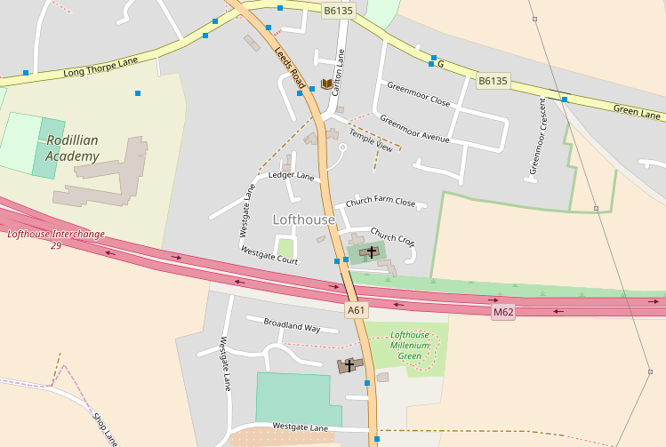

**The Manse Surgery**

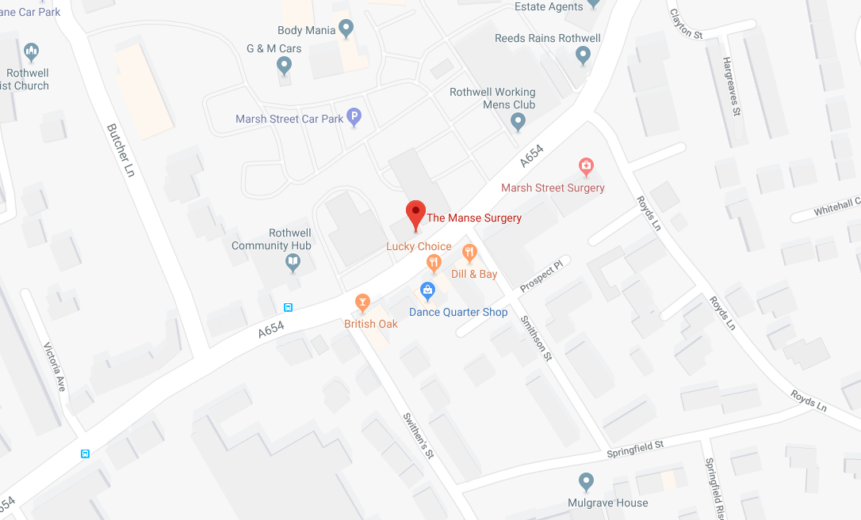

**Friends and Family Survey**

If you would like to complete one of our ‘Friends and Family’ questionnaires with regards to your experiences within the practice and if you would recommend our services to another, please fill out a form which are available in both reception areas or on the practice website.

**Freedom of Information – Publication Scheme**

The freedom of Information Act 2000 obliges the practice to produce a Publication Scheme. A publication Scheme is a guide to the ‘classes’ of information the practice intends to routinely make available.

**Health Records**

As part of the NHS, Church Farm Close Medical Practice collects information from health and care organisations that are providing your care. Under Article 15 of the General Data Protection Regulation, you have a right to access personal information that we hold about you. For more information please see the practice website or contact your surgery.

**Zero Tolerance**

We strongly support the NHS policy on zero tolerance. Anyone attending the surgery that abuses the GPs, staff or other patients be it verbally, physically or in any threatening manner whatsoever, will risk removal from the practice list.

In extreme cases we may summon the police to remove offenders from the practice premises.

**Confidentiality Statement**

We hold your patient records in the strictest confidence, regardless of whether they are electronic or on paper. We take all reasonable precautions to prevent unauthorised access to your records, however they are stored. Any information that may identify you is only shared with the practice team, or, if you are referred to hospital, to the clinician who will be treating you. We will only share information about you with anyone else if you give your permission in writing.

**Useful Telephone Numbers**

|  |  |
| --- | --- |
| **Chemists** | |
| Carlton Lane Pharmacy, Lofthouse | 01924 823137 |
| Day Lewis, Rothwell | 0113 282 3189 |
| Boots, Rothwell Health Centre Pharmacy | 0113 282 1155 |
| Naseems, Rothwell | 0113 282 2686 |
| Boots, Commercial Street, Rothwell | 0113 282 2269 |
| **Hospitals** | |
| Pinderfields General Hospital | 01924 541000 |
| St James' University Hospital | 0113 243 3144 |
| Seacroft Hospital | 0113 264 8164 |
| Leeds General Infirmary | 0113 243 2799 |
| **Other** | |
| NHS 111 Service | 111 |
| Citizen Advice Bureau Leeds | 0113 245 7676 |
| RELATE (Marriage Guidance) | 0113 245 2595 |
| Child Line | 0113 0800 1111 |
| Samaritans | 0113 245 6789 |