Information for People on SGLT-2 inhibitors

What are SGLT-2 inhibitors?
Sodium glucose co-transporter inhibitors (SGLT-2 inhibitors) are sometimes known as ‘gliflozins’ e.g. canagliflozin (Invokana®), dapagliflozin (Forxiga®), empagliflozin (Jardiance®), ertugliflozin (Steglatro®).
They are prescribed for type 2 diabetes, heart failure (weak pump function of the heart) or kidney disease. They can also be prescribed if you have one or more of these conditions.
What are the benefits?

These medicines were first developed to treat people with type 2 diabetes. They lower blood glucose (sugar) by increasing the amount of glucose in the urine. They have added benefits too. They can protect the kidneys and heart. They can slow the decline of kidney disease. They can reduce the risk of heart failure and heart attacks. These benefits apply to all people, not just those with type 2 diabetes. Sometimes they can also reduce blood pressure and weight. This is an additional advantage. For most people, the benefits outweigh the possible side effects.
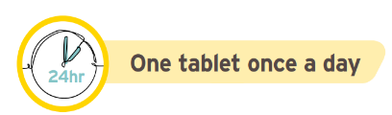
How do I take them?
Tablets should be swallowed whole with a glass of water ONCE daily, with or without food, at any time of day.
When should I stop my medication if I become unwell?
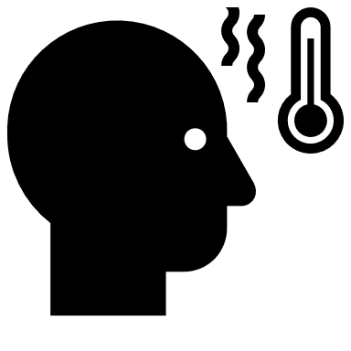
It is important that you follow ‘sick day rules’ with SGLT-2 inhibitors and some other medication if you are unwell, or if you are fasting e.g. before an operation.
Sick Day Rules
If you are unwell (vomiting, diarrhoea, fever (high temperature), sweats and shaking), you should temporarily stop taking the medicines listed below.
- Diabetes tablets – metformin and SGLT2-inhibitors/’gliflozin’ (e.g. empagliflozin, dapagliflozin, canagliflozin) - see important information overleaf relating to SGLT2-inhibitors and DKA - seek urgent medical attention if concerned you have DKA symptoms. Do not stop taking your insulin
- Blood pressure tablets ending in ‘pril’ or ‘sartan’ (e.g. ramipril, lisinopril, losartan, candesartan, valsartan)
- Diuretics (water tablets) – furosemide, bumetanide, metolazone, spironolactone, eplerenone, indapamide, bendroflumethiazide.
- Anti-inflammatory tablets such as ibuprofen, naproxen, diclofenac, meloxicam
If you are taking any of these medicines for heart failure, you should speak to your heart failure specialist team, GP practice, Pharmacist or NHS 111 for advice about whether to stop these medications if you are unwell. If you are taking sacubitril/valsartan (Entresto®), please contact your heart failure specialist team before stopping. Restart your medicines as soon as you are well, this is usually after 24 to 48 hours of eating and drinking normally. Please seek medical advice from your GP, Pharmacist or NHS 111, if you continue to feel unwell for longer than 48 hours.

What are the common side effects?
- Hypoglycaemia (low blood sugar) in people with diabetes: This usually only occurs when SGLT-2 inhibitors are used in combination with insulin or sulfonylurea diabetes drugs (e.g., gliclazide, glimepiride, repaglinide). The dose of these diabetes medicines may need to be adjusted when the SGLT-2 inhibitor is added. Never stop insulin altogether when starting an SGLT2- inhibitor. Hypoglycaemia is uncommon in people without diabetes.

- Dehydration: These medicines increase the amount of urine you make and may cause dehydration. You may need to increase the amount of fluid you drink; your doctor will advise you about this.

- Fungal Genital Infections: Your chances of infection can increase e.g., thrush, around the vagina and penis. This is easily treated, discuss with your community pharmacist or your GP if irritation or itching occurs in these areas. Washing your genital area with warm water, using non perfumed soap. Avoid wearing tight underwear, this will reduce the risk of infection.

- Foot Care in people with Diabetes: Having type 2 diabetes increases your risk of infection and sores on your feet. Whilst taking an SGLT-2 inhibitor, it is particularly important to check your feet regularly and follow your diabetes professionals’ advice on foot care and fluid intake. Tell your healthcare professional if you have any wounds, discoloration, ulcers, problems with circulation, tenderness or pain affecting your feet.

What about uncommon and rare side effects?
Diabetic ketoacidosis (DKA) – SGLT-2 inhibitors may cause acids (ketones) to build up in the blood, this is called diabetic ketoacidosis (DKA). It is a rare event in people who have diabetes and is extremely rare in people without diabetes. DKA can happen when your blood glucose is normal. Symptoms include stomach pain, feeling sick and vomiting, rapid breathing, and dehydration. If dehydrated you may feel dizzy and be very thirsty. The breath can smell like pear-drops or nail varnish remover. The risk of DKA is increased if you do not eat for long periods, become dehydrated, drink excessive alcohol, or become very unwell. For people with diabetes, it can be caused by reducing your insulin dose too quickly. Seek medical advice before starting any new diet particularly very low carbohydrate diets (ketogenic diets) as these can increase the ketones in the blood. Seek urgent medical attention if you think you are developing symptoms of ketoacidosis as this can make you seriously unwell.
Fournier’s Gangrene: This is an extremely rare infection of the genitalia or area between the genitals and anus. Please seek urgent medical attention and tell the doctor about the medication you are taking if you experience any severe pain, tenderness, redness or swelling in this area and you feel unwell or have a fever.

Pregnancy and Breastfeeding: Do not take SGLT2 inhibitors when pregnant or breastfeeding. You should not take these medicines if you might become pregnant, therefore you need to speak to your doctor if you are planning to get pregnant.

