We may be able to book you an appointment in our extended access clinics, which may be at The Centre Surgery in Hinckley.

See the images below to help you locate this surgery:

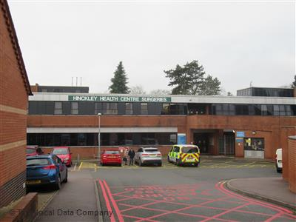 **Centre Surgery: Hill Street, Hinckley LE10 1DS**

**See below further information for how to get to centre surgery:**

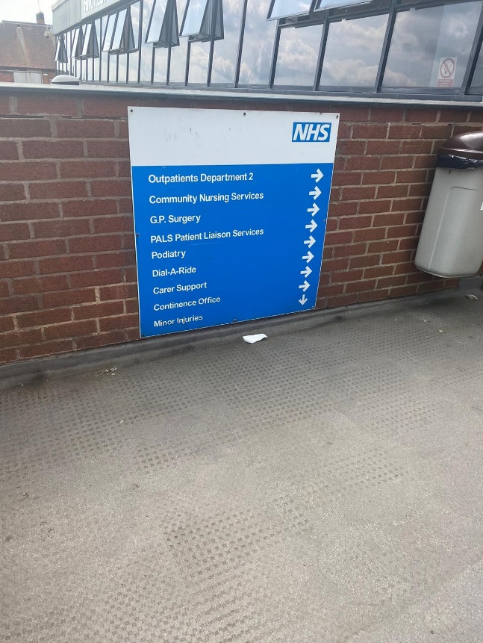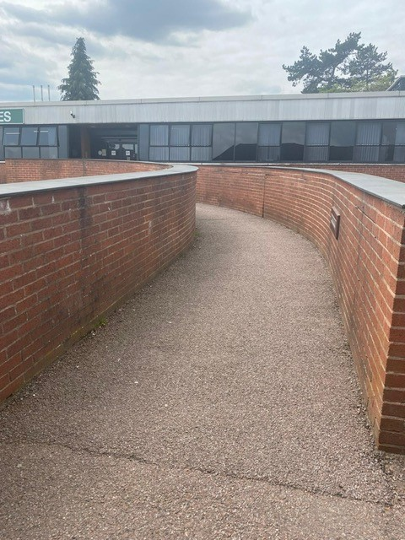**1. From the car park, head up the ramp**

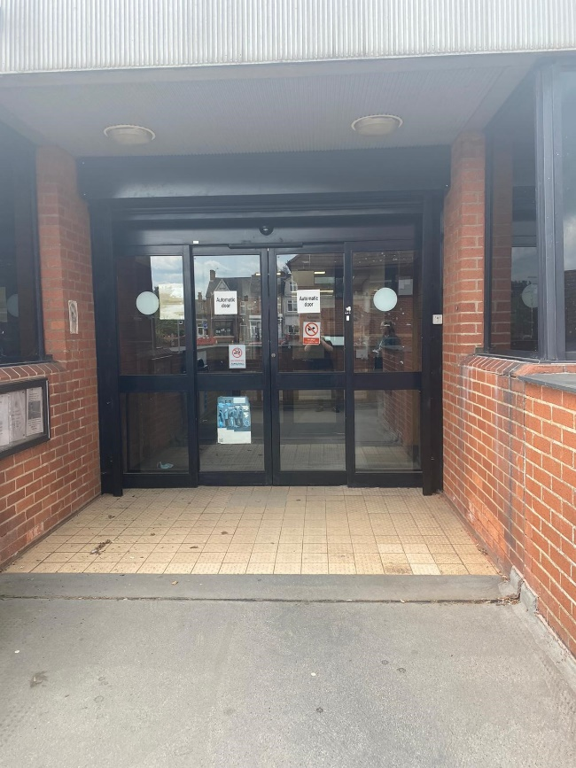2**. Enter the double doors**

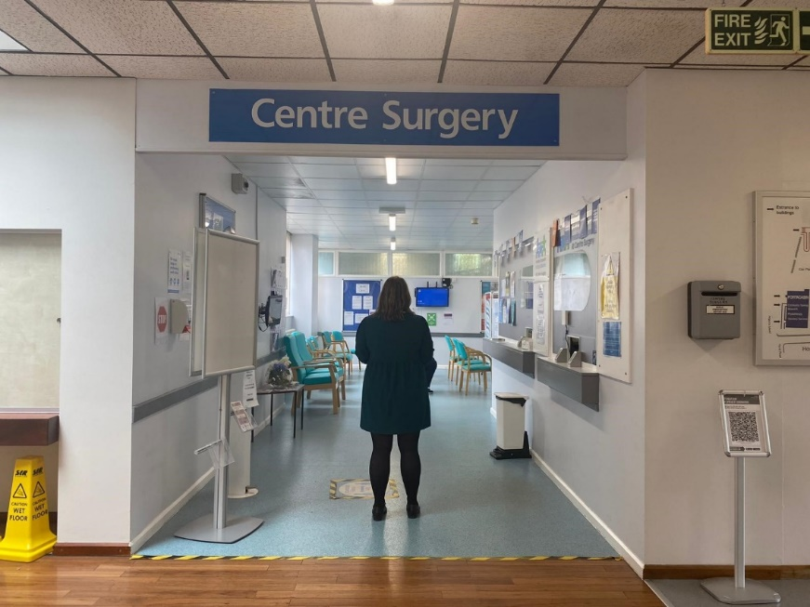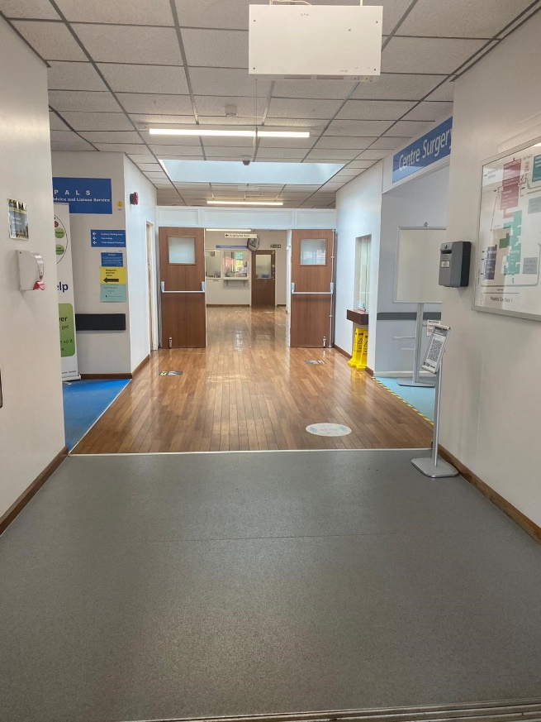3. **As you enter the corridor you will see The Centre Surgery on the right.**