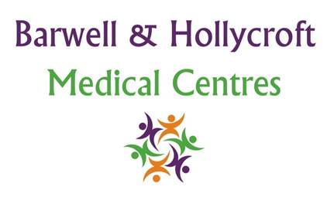

**Barwell & Hollycroft Medical Centre – Infection Control Annual Statement**

Annual Infection Control Statement 2022-2023

Barwell and Hollycroft Medical Practice aims to keep the surgery clean and tidy in order to offer a safe environment for all staff, patients and visitors to the practice.

***If you have any concerns about cleanliness or infection control, please report these to our reception team.***

Our GP’s and Nursing team follow procedures to ensure that treatment of our patients and clinical equipment used meet infection control guidance.

**Purpose of this statement**

This statement will summarise;

* Any infection transmission incidents and any action taken
* Details of any infection control audits undertaken and action taken
* Details of any staff training
* Reviews and updates of policies, procedures and guidelines

**Background**

Our infection control lead is Rachel Drury, who works closely with Gemma Moore Infection Control link nurse, the practice is overseen by Sarah Gibson Practice Manager.

**Significant Events**

In the past year there has been one significant event regarding infection control where a clinician obtained a sharps injury at a COVID vaccination clinic. Severity – Moderate.

Needlestick policy adhered to, bloods taken swiftly at A&E and booster hepatitis vaccine administered.

Key learning points: To use large sharps bins and not to overfill.

**Staff Training**

Rachel Drury attends regular meetings at the GP Infection, Prevention and Control Link Worker Forum and both Gemma and Rachel attend annual updates regarding infection control and disseminate information to all staff accordingly. Regular audits for hand washing, and antibiotic use are carried out too, ensuring high standards are met.

All staff must complete an infection control and hand hygiene module as part of their annual general training, and have undertaken a hand wash training session.

**Audits**

Audits that have taken place in the last 12 months include:

* Infection Prevention Control Audit
* Donning/Doffing PPE
* Hand washing audit
* Cold chain audit

**Policies and Procedures**

The Infection Control policy is constantly being updated in light of COVID-19, all staff can access this via GP Team Net and all changes are cascaded to the staff where appropriate.

Regular public health updates are disseminated to all staff and protocols created with immediate effect if sudden outbreak of illness occurs, eg; Coronavirus

Changes are being made rapidly in line with government guidance, and the practice adapts swiftly with implementing changes. Telephone triage remains in place, some additional clinician face to face appointments created. Policies remain to be updated, such as our contraception policy allowing patients to complete a questionnaire prior to receiving their prescriptions reducing patient numbers attending both practices. A new wound photography protocol has been implemented allowing a more effective means to review wounds in practice ensuring continuity and the best patient care is received. Barwell & Hollycroft care home protocol also has been updated, ensuring staff and patients safety is maintained at all times in light of the COVID-19 pandemic adhering to strict PPE measures.

**CQC Report May 2018**

Barwell and Hollycroft received a good report following inspection by the Care Quality Commission, it was noted that there are good measures in place to manage risk so that safety incidents were unlikely to happen within the practice.

Written by Rachel Drury 17.01.2022

Review by Rachel Drury 01.01.2023