How is the test performed?

The appointment will last for 30 to 40 minutes.

Your height and weight will be checked.

You will be asked to blow through a tube which monitors how much air is breathed out. This may be repeated several times.

You will then be asked to inhale the Salbutamol inhaler that your Dr has prescribed for you. The nurse will assist with this.

The medication takes 20 miuntes to work. After this time, the test is repeated.

The results will be discussed with you by either the nurse or a GP appointment may be required. This will be arranged after the tests.

Barwell and Hollycroft Medical Centre.
Barwell 01455 849149
Hollycroft 01455 234414

If you require any further information please contact the Surgery.

Telephone:
Hollycroft 01455 234414
Barwell 01455 849149

Ask to speak to:
Sister Cara Findlay at Hollycroft
Or
Sister Lucy Berry at Barwell

Spirometry - Reversibilty
Patient Information Leaflet

It has been recommended that you attend the Surgery to have a spirometry test. This leaflet provides some information about the procedure.

What is spirometry?

Spirometry is the gold standard for diagnosis, assessment and monitoring of COPD and can assist in the diagnosis of Asthma.

IF YOU HAVE BEEN TREATED FOR A CHEST INFECTION IN THE LAST 6 WEEKS, THE TEST CANNOT BE PERFORMED. PLEASE CONTACT THE SURGERY TO POSTPONE APPOINTMENT.

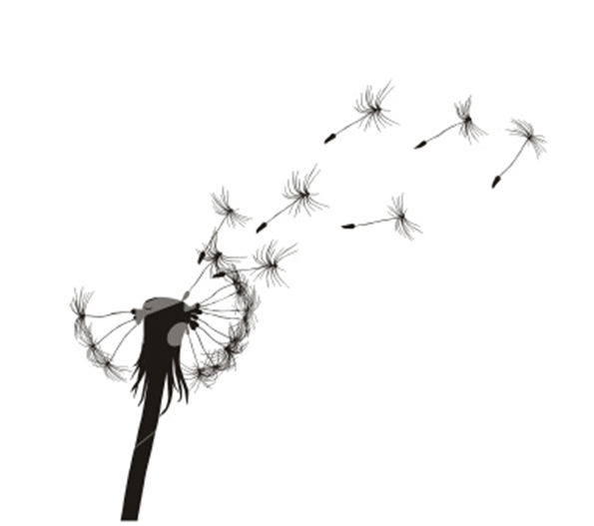

COPD management in Leicestershire & Rutland
COPD management in Leicestershire & Rutland

Inhaler advice.

Please bring your inhalers and spacer device with you to this appointment.

To ensure the test is accurate please note the following advice:

- Try to refrain from smoking for 24 hours before the test.
- Wear loose and comfortable clothing that will not restrict your breathing.
- Do not eat a heavy meal for 2 hours before the test.
- Do not drink any alcohol for 4 hours before the test.
- Do not do any vigorous exercise for 30 minutes before the test.
- Ensure that your bladder is empty.
- Remove any loose fitting dentures.
- Let the nurse know if you are feeling unwell today.

Safety advice

Spirometry is a very low risk procedure. To ensure it is safe to perform these tests please inform the nurse if you have had:
- A recent chest infection
- A collapsed lung
- Been coughing up blood
- A heart attack or stroke
- Unstable angina
- Any chest, abdominal or eye surgery
- High blood pressure
- An aneurysm
- A perforated ear drum

Spirometry is not painful but may cause a light headed feeling for a few moments.

