## Patient’s Rights and Responsibilities

You can expect the NHS to respect your privacy, dignity and any religious or cultural

beliefs at all times and in all places. Staff within the Practice would also expect patients to respect and treat them with the same courtesy. We are a zero tolerance practice and therefore would ask patients to refrain from using any unsuitable behaviour, which may result in the patient and family members being removed from the Practice.

Patients are asked to cancel any appointments they are unable to attend so that the appointment can be offered to another patient out of courtesy.

**Practice Leaflet**

## Confidentiality

Any information that we hold on any patient is treated with confidentiality. Infor- mation will not normally be disclosed to other members of the family/friends/carers without your explicit consent. We may need to share your personal information with

other NHS organisations where it would be appropriate for providing you with on-going healthcare.

In some circumstances there are statutory obligations to disclose information to others (such as public health issues, safeguarding concerns) which may not require your

consent. However you will be consulted about these in advance unless there is an over-riding public interest in not doing so.

Please contact the Practice Business Manager for more information or if you have any questions about this.

## Access to Medical Records

All patients registered with us have a right to have access to their medical records. You can contact our Reception Team and complete a form available which will be reviewed by the Practice prior to any discloser. Alternatively look on our website for all information and privacy notices

## Suggestions/Complaints

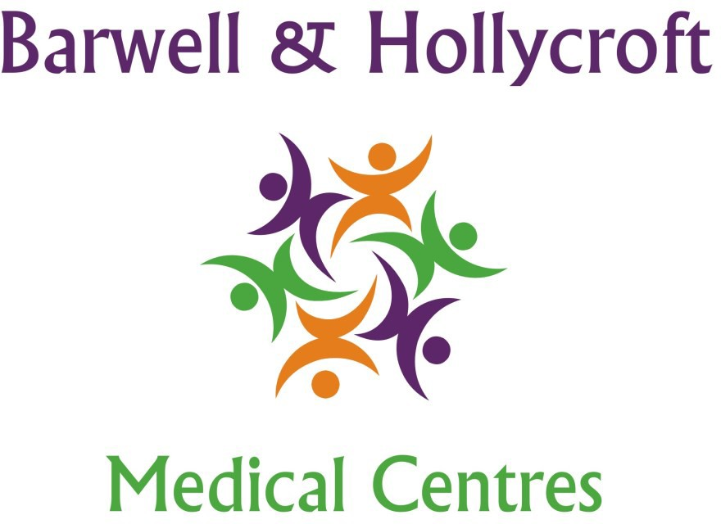**Barwell Medical Centre**

Jersey Way Barwell Leicestershire LE9 8HR

Tel: 01455 849149

**Hollycroft Medical Centre**

Clifton Way Hinckley Leicestershire LE9 8HR

Tel: 01455 234414

We try to do our best for all our patients at the Practice but sometimes things do go wrong for whatever reason. If you feel like you need to make a suggestion/complaint, then please contact our Reception via telephone in the first

# [www.barwellmedicalcentre.co.uk](http://www.barwellmedicalcentre.co.uk/)

## Practice Catchment Area

instance.

## The Care Quality Commission

The Care Quality Commission make sure hospitals, care homes, dental and GP surgeries in England provide people with safe, effective, compassionate and high-quality care, and encourage them to make improvements. Further information is available from their website <http://www.cqc.org.uk/>.

## Opening Hours

Mon: 08:00 - 18:30

Tue: 08:00 - 18:30

Wed: 08:00 - 18:30

Thu: 08:00 - 18:30

Fri: 08:00 - 18:30

Sat & Sun: Closed

* Barwell
* Burbage Earl Shilton
* Hinckley (certain areas only)
* Kirkby Mallory
* Stapleton Stoke Golding
* Stoney Stanton

## Who are the Doctors?

We have 4 Partners and 6 Salaried General Practitioners who work across both our sites:

Partners Salaried General Practitioners

Dr. Darren Jackson. *Dip IBLM/BSLM* Dr. Jacinta Jackson

*MBChB (hons) DRCOG DFFP FRCGP MBChB MRCGP DFFP DRCOG DCH*

Dr. Mark Findlay Dr. Shane Mistry

*MBChB DRCOG MB ChB, MRCGP*

Dr. Michelle Findlay Dr. Faiqa Faraz

*MBChB (Hons) BSc (Hons) MBBS MRCGP*

Dr. Rohitkumar Rajyaguru Dr. Sun Joo Park

*MBBS BSc (Hons) MRCGP MBBS MRCGP*

Dr Sharon McGreal

MBcHB MRCGP

Dr Rashi Malhotra

*MBcHB, PGcert, MEDFD, MRCGD*

We are also a teaching and training Practice and regularly have fully qualified doctors who are

training to become a General Practitioner. They are always supervised by a Partner or Salaried GP so if they are unable to help you, they will be able to ask.

## Who are the other members of the healthcare team?

We have a Lead Nurse, Practice Nurses, Advanced Nurse Practitioner, paramedics, Nurse Associates and Healthcare Assistants (HCA).

At the surgery, we are able to provide a wide range of services including blood tests, INR checks, wound care/suture removals, immunisations (childhood as well as flu,

pneumococcal and shingles), travel vaccinations, contraception and smears; as well as annual health checks for patients with specific medical conditions.

In addition, we also have a Pharmacist, Mental Health Facilitator, specialist Respiratory and Diabetes Nurses who come to the surgery and run monthly clinics. They provide excellent care for patients with complex medical conditions.

Attached to the surgery, we have Health Visitors, community Phlebotomists and District Nurses.

## How do I register at the Practice?

In order to register at the Practice, please come and see any member of our Reception Team who will give you a registration pack to fill in and return or go online and download a form from our website.

The pack contains questions about you and your previous GP so that we can register you safely. If you have any questions, our Reception Team will be more than happy to answer them. Keep in mind that if the form is not completed in its entirety the form will be rejected and you will not be registered. Speak to one of the team if you need assistance.

## Where can I get more information about the Practice?

Please speak to our Reception Team who will be more than happy to answer any questions you may have. Alternatively, please visit our website.

## How can I book an appointment?

To book an appointment with a doctor, please contact us at our surgeries from 08:00 in the morning. Our Reception team will ask you if you want an appointment for the same day or if you want to book an appointment in advance.

I have a physical/mental disability so am I able to be seen?

There is no reason why you cannot be seen by us at the surgery. We have disabled parking available outside the surgery, a bell situated at wheelchair height on the front door and a hearing aid loop system installed in Reception. We have a disabled toilet. If you require any assistance of have any questions, please speak to our Reception Team.

## Do you do home visits?

Our doctors and other members of the healthcare team can do visits to your home if you are truly housebound. We also offer annual checks at home for patients who are housebound as well as vaccinations like flu etc. when they are needed.

In order to have a home visit for a new problem, please contact our Reception Team before 11:30. You may get a phone call back from the Doctor requesting more information and it may be more appropriate/suitable to send another member of the healthcare team.

## What do I do in an emergency or if the Practice is not open?

If you feel the condition you have is life-threatening, then you should call 999 or go to the nearest Emergency Department. If however you feel it can wait until when we are next open, please do so as it is usually better to see your own GP. If you feel it cannot wait, then please contact 111.