
PATIENT PARTICIPATION GROUP
Minutes of Meeting Held at the Surgery
16 January 2024 at 1730
Present: John Leslie (JL) Chair
Phil Marston (PM) Secretary
Victoria Ferguson (VF)
Daniel Medhurst (DM)
Dr Dan Pickering (DP)
Sue Pickwoad (SP)
John Twidell (JT)
Pat Triffitt (PT)
Lara Upton (LU)

ITEM AND DECISION | ACTION
CHAIRMAN’S WELCOME.
The Chair (JL) welcomed all adding that Richard Ongley had tendered his resignation which had been reluctantly accepted.
APOLOGIES.
Apologies were received Vicki Abbott, Amanda Shaw and Christine Stanesby
MINUTES OF PREVIOUS MEETING.
The minutes of the meeting held on 7 Nov 2023 were approved.
MATTERS ARISING.
There were no matters arising that were not on the agenda for discussion.
PRACTICE UPDATE.
The Practice report is attached to these minutes together with the key components that the practice have which is referred to in the update document.
SP when appointments would be available on-line. DP stated that there were no immediate plans for this as it results in a waste of time and is much easier coped with via the website. SP stated that she had difficulty in getting at the correct website and DM stated that this could be due to the use of different web browsers. Chrome and https://www.uppinghamsurgery.co.uk/ works correctly.
SP stated that there seemed to have been a problem with annual reviews and DP replied that all patients were told via text when/how to commence the annual review. PT asked if the program was running to time and DP replied in the affirmative. Where possible, the practice were trying to pass the information out in advance.
CHAIRMAN’S UPDATE.
JL had submitted his report in advance and is attached to these minutes. There were no additional questions.
DEMENTIA MEETING  JL had attended a meeting covering Dementia Awareness by the organisations shown in this flyer.  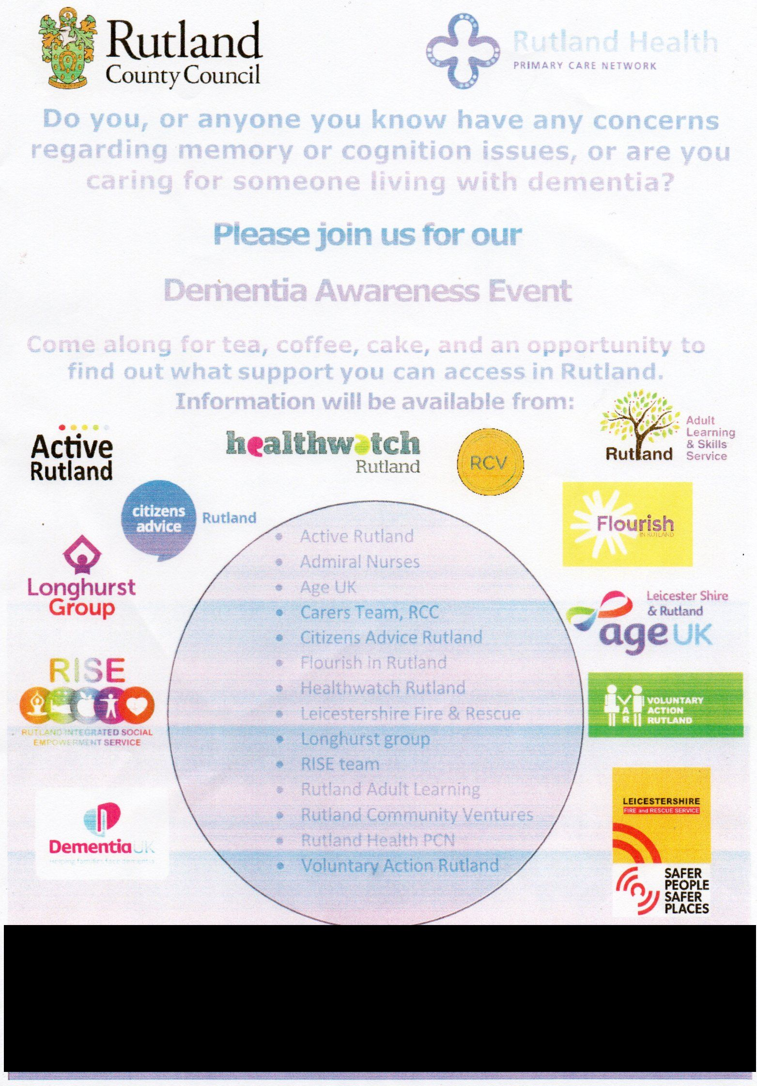  Following a long discussion it was decide that JL would approach the organisers with a view to holding an event in Uppingham (Falcon Hotel) with support from the Surgery and the PPG as appropriate. Previous events had not been well attended due to poor publicity and JL stated that the Surgery Newsletter and the Uppingham Neighbourhood Forum (UNF) Newletter, which was delivered to every house in Uppingham, could be used to maximise publication. The Surgery Newsletter would also cover outlying villages. | JL
NEWSLETTER UPDATE.  The Dec 2023 edition of the Newsletter hard copies had to be returned to the printers due to last minute noted errors. It was made known that the 2nd print of 250 had been picked up by an Uppingham person for distribution leaving none available for the external population. This error should be avoided in future additions.  LU said that the operation of the pharmacy might be useful to cover  PM – Give a run-down of the referral System (See Incident Reports)  Other suggestions can also be made by email | DM  All
INCIDENT FORMS & REFERRAL PROCEDURES.
One form had been submitted by PM regarding updating the information passed to patients when a referral had been made. DP replied that once a referral has been sent by the practice for a patient there are many ways this is processed depending on the type or referral and where it is sent. The practice does not receive information about the progress of referrals and have no easy way of checking the progress other than the same process available to patients. If the referral can be made by the e-referral system information then the practice sends information how to book, but it is the patients responsibility to contact the booking service.
LU tabled a further form which DM agreed to look into further
SP had encountered problems with annual review initialisation procedures from the clinical pharmacist. Is was believed that this had been improved recently so that the person would introduce himself correctly and explain the reason for the call.
VF stated that she had recently received three compliments to be passed to the Surgery.
DEBRIEF ON PPG NETWORK GP SURVEY 2024
JL and PM attended a Zoom meeting on 15 Jan 2024. JL has obtained a copy of the slides which were tabled at the meeting and also shown attached to these minutes following the Chairman’s Update. It was decided that this should be primarily PCN/Practice led with PPG participation if required..
PCN UPDATE.
There was nothing to report at this stage and the next PCN meeting is being held on Thursday 18 Jan 2024. Anything significant will be reported under separate cover.
DATE OF NEXT MEETING. The next meeting has been set for Tuesday 12 Mar 2023 at 1730 in the Surgery.

Patient Participation Group Update January 2024

Staffing
We have a new practice nurse, Anna Newbon starting at the practice at the end of January.

Operations
We were informed at the beginning of January that Aberdeen House residential home was closing, all affected patients have been transferred to an alternative residence.

Clinical governance
The practice has received 5 complaints:
- Content of secondary care appointment letter
- Travel vaccination appointment wait time
- HRT prescribing
- Mental health review appointment offer
- Cholesterol management

CQC
As with a new year, there is always a focus to review and improve our processes, with the release of the new CQC, Single Assessment Framework this will be a main focus for the year ahead. More information can be found here and I have attached a document which details all the key components we have to demonstrate achievement in. This is not only about having a policy in place but gathering feedback from patients, stakeholders, and staff.

ARI (Acute Respiratory Infection) Clinics
We are hosting this service on behalf of the PCN whereby patients with respiratory illnesses are seen in a dedicated clinics every afternoon, so far, we have seen over 150 patients since 4 December 2023.

Patient feedback
The practice has received 1 compliment since our last meeting and approximately 50 Christmas cards attached to boxes of sweet offerings!
I look forward to seeing you all on Tuesday 16 January at 5:30pm.
With thanks, Vicki

CQC Quality Statements
SAFE | 1 | Learning culture
 |  | We have a proactive and positive culture of safety based on openness and honesty, in which concerns about safety are listened to, safety events are investigated and reported thoroughly, and lessons are learned to continually identify and embed good practices.
 | 2 | Safe systems, pathways and transitions
 |  | We work with people and our partners to establish and maintain safe systems of care, in which safety is managed, monitored and assured. We ensure continuity of care, including when people move between different services
 | 3 | Safeguarding
 |  | We work with people to understand what being safe means to them as well as with our partners on the best way to achieve this. We concentrate on improving people’s lives while protecting their right to live in safety, free from bullying, harassment, abuse, discrimination, avoidable harm and neglect. We make sure we share concerns quickly and appropriately.
 | 4 | Involving people to manage risks
 |  | We work with people to understand and manage risks by thinking holistically so that care meets their needs in a way that is safe and supportive and enables them to do the things that matter to them
 | 5 | Safe environments
 |  | We detect and control potential risks in the care environment. We make sure that the equipment, facilities and technology support the delivery of safe care.
 | 6 | Safe and effective staffing
 |  | We make sure there are enough qualified, skilled and experienced people, who receive effective support, supervision and development. They work together effectively to provide safe care that meets people’s individual needs.
 | 7 | Infection prevention and control
 |  | We assess and manage the risk of infection. We detect and control the risk of it spreading and share any concerns with appropriate agencies promptly.
 | 8 | Medicines optimisation
 |  | We make sure that medicines and treatments are safe and meet people’s needs, capacities and preferences by enabling them to be involved in planning, including when changes happen.
EFFECTIVE | 9 | Assessing Need
 |  | We maximise the effectiveness of people’s care and treatment by assessing and reviewing their health, care, wellbeing and communication needs with them.
 | 10 | Delivering Evidence Based care and Treatment
 |  | We plan and deliver people’s care and treatment with them, including what is important and matters to them. We do this in line with legislation and current evidence-based good practice and standards.
 | 11 | How staff, teams and services work together
 |  | We work effectively across teams and services to support people. We make sure they only need to tell their story once by sharing their assessment of needs when they move between different services.
 | 12 | Supporting People to live healthier lives
 |  | We support people to manage their health and wellbeing so they can maximise their independence, choice and control. We support them to live healthier lives and where possible, reduce their future needs for care and support.
 | 13 | Monitoring and Improving Outcomes
 |  | We routinely monitor people’s care and treatment to continuously improve it. We ensure that outcomes are positive and consistent, and that they meet both clinical expectations and the expectations of people themselves.
 | 14 | Consent to Care and Treatment
 |  | We tell people about their rights around consent and respect these when we deliver person-centred care and treatment
CARING | 15 | Kindness, Compassion and Dignity
 |  | We always treat people with kindness, empathy and compassion and we respect their privacy and dignity. We treat colleagues from other organisations with kindness and respect
 | 16 | Treating People as Individuals
 |  | We treat people as individuals and make sure their care, support and treatment meets their needs and preferences. We take account of their strengths, abilities, aspirations, culture and unique backgrounds and protected characteristics.
 | 17 | Independence, Choice and Control
 |  | We promote people’s independence, so they know their rights and have choice and control over their own care, treatment and wellbeing
 | 18 | Responding to People's Immediate Needs
 |  | We listen to and understand people’s needs, views and wishes. We respond to these in that moment and will act to minimise any discomfort, concern or distress
 | 19 | Workplace Wellbeing and enablement
 |  | We care about and promote the wellbeing of our staff, and we support and enable them to always deliver person centred care.
RESPONSIVE | 20 | Person Centred care
 |  | We make sure people are at the centre of their care and treatment choices and we decide, in partnership with them, how to respond to any relevant changes in their needs
 | 21 | Care provision, Integration and Continuity
 |  | We understand the diverse health and care needs of people and our local communities, so care is joined-up, flexible and supports choice and continuity
 | 22 | Providing Information
 |  | We provide appropriate, accurate and up-to-date information in formats that we tailor to individual needs
 | 23 | Listening to and involvement People
 |  | We make it easy for people to share feedback and ideas or raise complaints about their care, treatment and support. We involve them in decisions about their care and tell them what’s changed as a result
 | 24 | Equity in Access
 |  | We make sure that everyone can access the care, support and treatment they need when they need it
 | 25 | Equity in Experience and Outcomes
 |  | We actively seek out and listen to information about people who are most likely to experience inequality in experience or outcomes. We tailor the care, support and treatment in response to this
 | 26 | Planning for the Future
 |  | We support people to plan for important life changes, so they can have enough time to make informed decisions about their future, including at the end of their life.
WELL LED | 27 | Shared Direction and Culture
 |  | We have a shared vision, strategy and culture. This is based on transparency, equity, equality and human rights, diversity and inclusion, engagement, and understanding challenges and the needs of people and our communities in order to meet these
 | 28 | Capable, Compassionate and Inclusive Leaders
 |  | We have inclusive leaders at all levels who understand the context in which we deliver care, treatment and support and embody the culture and values of their workforce and organisation. They have the skills, knowledge, experience and credibility to lead effectively. They do so with integrity, openness and honesty.
 | 29 | Freedom to Speak Up
 |  | We foster a positive culture where people feel that they can speak up and that their voice will be heard.
 | 30 | Workforce Equality, Diversity and Inclusion
 |  | We value diversity in our workforce. We work towards an inclusive and fair culture by improving equality and equity for people who work for us
 | 31 | Governance, Management and sustainability
 |  | We have clear responsibilities, roles, systems of accountability and good governance. We use these to manage and deliver good quality, sustainable care, treatment and support. We act on the best information about risk, performance and outcomes, and we share this securely with others when appropriate
 | 32 | Partnership and Communities
 |  | We understand our duty to collaborate and work in partnership, so our services work seamlessly for people. We share information and learning with partners and collaborate for improvement.
 | 33 | Learning, Improvement and Innovation
 |  | We focus on continuous learning, innovation and improvement across our organisation and the local system. We encourage creative ways of delivering equality of experience, outcome and quality of life for people. We actively contribute to safe, effective practice and research.
 | 34 | Environmental Sustainability
 |  | We understand any negative impact of our activities on the environment and we strive to make a positive contribution in reducing it and support people to do the same.

UPPINGHAM SURGERY
PATIENT PARTICIPATION GROUP

CHAIRMAN’S UPDATE
JANUARY 2024

I would like to wish you all a Happy New Year for 2024.

Since our last meeting back in November, I have not attended any external meetings, due to an extended foreign holiday. Nonetheless, there are a number of points to report to the PPG.

1. I was asked to produce a presentation and Surgery Update for the Uppingham First Board meeting and the Uppingham Neighbourhood Forum meetings early in December. Due to my holiday, other members of these groups delivered the content, which I enclose for your information. Thanks to Janet Thompson and Ron Simpson for their assistance.

2. On 24 November, I attended a meeting organised by our local MP, Alicia Kearns, on the subject of Dementia. Attended by over 20 local health and welfare representatives, including Dr. Burden from the Surgery, the idea is to initiate a training programme for local retailers and others who come into contact with the public, and to provide them with suitable training to enable them to better understand those with this condition.
Whilst no formal notes were issued, the MP has promised to develop a plan of action based on the discussions, with a view to organising a follow-up meeting in January.

3. Feedback regarding the latest edition of the Surgery Newsletter has been very positive.

4. Following a recent discussion, I have been informed that the Defib machine has now been re-installed in the Market Place, and is now operational.

5. Richard Ongley has written to me, offering his resignation from the PPG, due to personal reasons. I would like to thank Richard for his contribution to the group in recent times, and to wish him well for the future.

6. Healthwatch Rutland are offering to provide a Dementia Awareness Day at the Uppingham Surgery within the next few of months, similar to the one undertaken in Barrowden some time ago.
I have a meeting to discuss this proposal on Monday 15 January, and will report back to the group on Tuesday evening.

7. There is an emergency meeting of the LLR PPG on Monday 15 January, to discuss the forthcoming local GP Patient Survey.
Feedback will be provided at our meeting on Tuesday evening.

8. The re-arranged PCN PPG meeting will now take place on 17 January, and it is anticipated that notes will be included with the Minutes of our PPG meeting.

9. The next meeting of the Uppingham Vanguard Board will take place during March. The purpose of this group is to create a positive discussion forum for local land owners, property developers and other affected groups of residents.
The focus of this meeting will be Health and Education, and to discuss the impact of any increase in the number of houses built in and around the Uppingham area.
I look forward to seeing you at 17.30 on Tuesday 16 January at the Uppingham Surgery.
John Leslie
Chairman
Uppingham Surgery PPG

