TRAVEL HEALTH
ADVICE

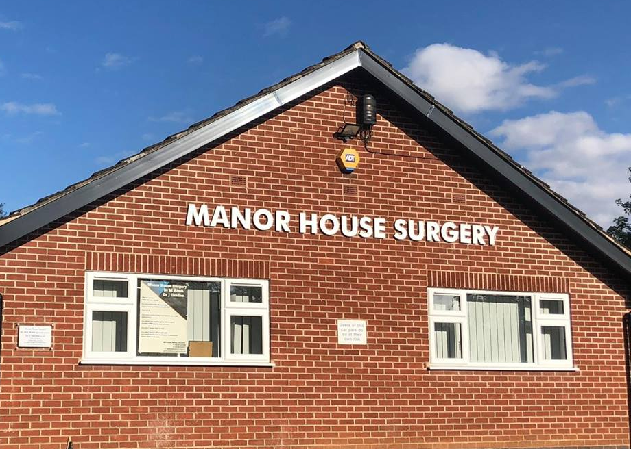

BELTON SURGERY

Travelling abroad, whether on business or for pleasure should be well planned to avoid potential health risks for you and your family.
BEFORE YOU GO
Visit the websites below to research your travel vaccination requirements and then contact the surgery to make a 20 minute appointment with our Practice Nurse, the same 20 minute appointment can be used for 2 adults travelling together or, if you are travelling with children you can make a 20 minute appointment for one adult and two children. At the appointment the nurse will confirm your requirements, give you any required vaccinations that are available through the NHS and provide further information as appropriate. Please note that appointments should be booked at least 8 weeks prior to travel.
- www.masta.org
- www.mallariahotspots.co.uk
- www.traveldoctor.co.uk
- www.nathnac.org
- www.fitfortravel.nhs.uk
Sort out a first aid kit and any medication you may need including enough prescription medication for the trip, please note that you are only allowed a maximum of 3 months of prescribed medications at a time.
Check your passport is valid and does not expire before you return. (Most countries require at least 3 months left on your passport)
Check on visa requirements for your destination.
MEDICATION AND FIRST AID
Medication
- If you take regular prescribed medication including contraceptive pills, please ensure prior to travel that you will be taking enough to cover your time away.
- In this current climate of extra security / precautions your particular airline may require documented evidence that the medication you carry is yours. The right hand side (the white piece) of your latest / current prescription should suffice, but it may well be worth checking with your tour operator / airline if other written confirmation is needed. If a GPs letter is required there will be a charge for this.
First Aid Kit For Travel
It is always a good idea to go prepared. Here is a basic list of items you may think about taking on your travels.
- Painkillers e.g. paracetamol and / or ibuprofen
- Anti-diarrhoea i.e. loperamide
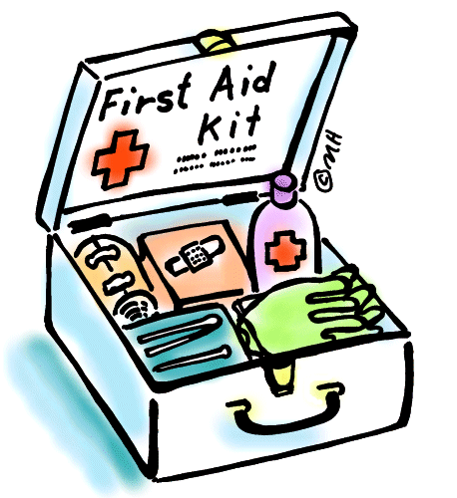
- Anti-sickness tablets
- Anti-histamine e.g. piriton, cetirizine (will also help with prickly heat)
- Rehydration e.g. dioralyte
- Water purification tablets if appropriate
- Anti-antacids e.g. rennies
- Plasters
- Antiseptic cream
- Scissors (not in hand luggage)
FLYING AND DEEP VEIN THROMBOSIS (DVT)
(Economy class syndrome)
- Drink plenty of water as this can help minimise dehydration during your flight.
- Try and avoid alcohol.
- Most airlines now provide information about prevention of a DVT; this includes stretching, leg exercises and ensuring adequate walking during your flight.
- Walking around the cabin area during a flight is now acceptable and it minimises the risk of DVT’s occurring.
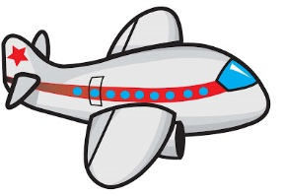
- Flight socks can be purchased, however, ensure that a measurement of your calf is taken prior to purchase. This is required along with your shoe size for a correct fit.
- Flight socks need to be put on before your flight and not removed until you’ve landed at your final destination. They can be hand washed and reused for future travel.
PROTECTION AGAINST SUN

Most people instantly feel more cheerful when the sun shines. However it’s advisable to avoid too much exposure, particularly between 11.00am and 3.00pm when the sun is at its strongest. Use an appropriate strength sun block (at least SPF 15) and remember to re-apply it every two hours. Wearing a hat and sunglasses will help protect you in bright sunlight. If you have fair skin and / or red hair or know that you are susceptible to sunstroke or sunburn you should take extra care.
FOOD AND DRINK
To avoid the risk of diarrhoea, vomiting or diseases such as typhoid and hepatitis A, adhering to the following will help minimise the risks
- Drink bottled water whenever possible.
- In restaurants, ensure bottle is opened in front of you.
- Boil any drinking water you are unsure about wherever possible
- Brush teeth using bottled water where possible or if unsure.
- Avoid ice in your drinks.
- Avoid shellfish, salads and fruits that you haven’t prepared yourself.
- Be cautious of ice-creams / lollies / soft cheeses.
- Ensure hot / cooked food is piping hot, if not then avoid.
- Avoid roadside vendors.
- Ensure hand hygiene is maintained, never use communal towels in toilets etc.

INSURANCE
It is advisable to take out adequate medical insurance before departing. You may want to check that the insurance covers the cost of being flown home in an air ambulance. Take copies of all insurance documents and emergency telephone numbers when you travel.
When you buy your insurance, make sure it will cover the possessions you are taking with you. If you are carrying a laptop, mobile phone or camera think through the cost of replacement and consider paying for a top-up on the insurance if a basic policy will not cover it. Most policies have a single item limit and that might not cover your most expensive items.

ANIMALS
Local animals can carry rabies so try to avoid close contact with them. If you are bitten, wash the wound and seek medical advice urgently, even if you have been previously vaccinated against rabies.
SAFE SEX
Hepatitis B, HIV and other infections are risks in all parts of the world in varying degrees and can be transmitted sexually. Therefore, casual sex is risky. Using condoms will provide good, but not 100% protection
MALARIA
Malaria is widespread in many countries and is a serious and sometimes fatal disease. You cannot vaccinate for this disease but you can protect yourself.
You will be advised on any anti-malarial medication suitable for your destination during your travel consultation. All anti-malarials need to be commenced prior to travel.
Precautions-
- Avoid mosquito bites, especially after dusk. Wear long shorts or trousers.
- Use a good insect repellent that is 50% deet during the key times.
- Before retiring to bed spray bedclothes with insect repellent.
- A plug in mosquito repellent should be used.
- Do not leave the windows open.
- Mosquito nets should be used if appropriate.
- Ensure you take an adequate supply of anti-histamine.
ON RETURN
If you feel ill on your return, remember to tell your doctor you have been abroad, as early symptoms of some tropical diseases can mimic common UK illnesses. You may need to continue taking anti-malarial drugs for a period after you get home. Check the duration of your prescription with the practice nurse.
GAP YEAR / BACK PACKERS
These travellers will need more extensive information / vaccinations so are advised to seek travel advice with an itinerary several months before the planned travel date.

