**V:\Secretaries\Mary\Letter Heading\MUNRO MEDICAL CENTRE.tif**

**MUNRO MEDICAL CENTRE NEWSLETTER**

**SUMMER 2024**

Welcome to the Practice Newsletter. In it you will find some useful information, especially if you are not able to use a computer. However, there are references to important websites and it might be useful if you have a friend or relative who could gain access to the relevant information for you.

**New Phone System**

The new phone system is now in full operation, we will be sending out some questionnaires to randomly selected patients to ask how you are finding the new system in order for us to try and improve the service. Should you receive one of these questionnaires we would appreciate your time in completing and returning them to the practice.

**Clinicians**

Congratulations to Dr Marcus who has completed his GP training, and will be staying with us as a full time Associate GP.

Dr Makolo, who you may remember was at the practice a couple of years ago, is coming back to Munro to complete his final year of GP training.

I am sure you will give them both a very warm welcome to the practice team.

Sadly, Dr Oluwatosin will be leaving the practice in August as her and her family are relocating overseas. Dr Adeola has completed her rotation with the practice and will be moving on in August. We wish her well for the next stage of her GP her training.

Our Practice Nurse Gail has recently retired and we would like to wish her well and enjoy her well-earned rest spending time with her family. Sara, our Triage Nurse has also moved on to pursue her advanced clinical practice qualifications within the prison service. We are currently recruiting into our nursing team, so there will be some new faces when you attend the practice.

We also welcome our two Physician Associates, Habeeb and Lucy. These are trained clinicians to treat minor illness in patients between the ages of 5 and 60 years.

Physician Associates provide first point of contact care for patients presented with undifferentiated, undiagnosed programs by utilising history taking, physical examinations and clinical decision making skills to establish a working diagnosis and management plan in partnership with the patient (an their carers where applicable)

**Reception**

We have welcomed four new members of staff to our Care Navigator Team, they are all undertaking their training and we would appreciate your patience and understanding while they are trying to learn the ropes.

**Secretaries**

Please be aware that the practice secretaries (option 4) are only able to answer queries relating to referrals, they are experiencing a number of calls into their department which they are unable to help with and unfortunately are having to redirect patients to the most appropriate department. If you are contacting the secretaries regarding an appointment for the Community Surgical Scheme, please select option 5.

**NHS App**

During your next visit to the GP surgery, speak to reception about accessing new entries to your GP health record on the NHS App.

View consultation notes, letters, and test results at the touch of a button, and also order your repeat prescriptions

<https://nhs.uk/helpmeapp>

**The National GP Survey**

The national patient survey results have been reviewed and we are really pleased with the results. We have discussed and assessed the areas of satisfaction and feedback. 77% of patients felt overall their experience of this practice was good, this was a 2% increase from last year and with the Lincolnshire average being 73%, we were happy that progress was being made.

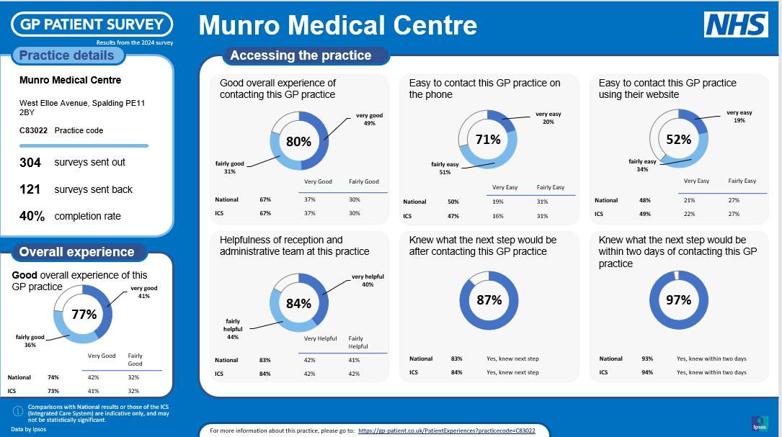

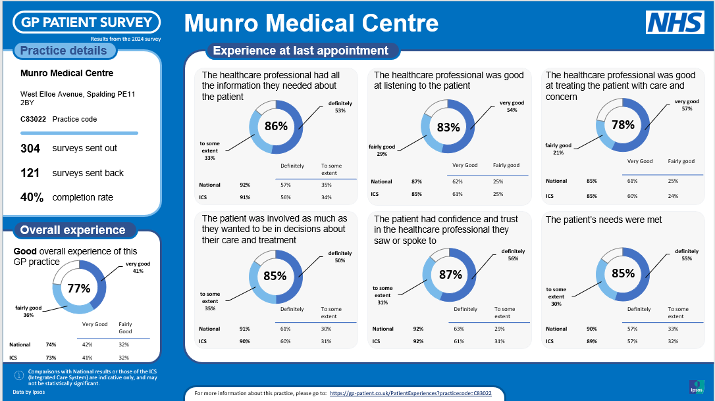

**Travel Vaccinations**

If you require vaccinations for travel, please contact the practice to complete the necessary documents at least six weeks before you travel, this ensures that sufficient time is allowed to check which appropriate vaccinations are required for your destination and subsequent appointments can be arranged .

**Patient Participation Group (PPG)**

You may be aware of our “friends of the surgery” group. (PPG). We are currently trying to re-establish this after the covid pandemic. The group is currently “virtual” receiving a copy of the quarterly practice newsletter and advised of any upcoming changes to the services offered and their feedback is welcomed. If you think you might be interested in getting involved in the group, please email [licb.ppg.mmc@nhs.net](mailto:licb.ppg.mmc@nhs.net)

The next edition of the Practice Newsletter will be available in Autumn 2024.