**Friends and Family Test**

The friends and family test (FFT) is an important feedback tool It’s a quick and easy way to share your views after receiving NHS care or treatment.

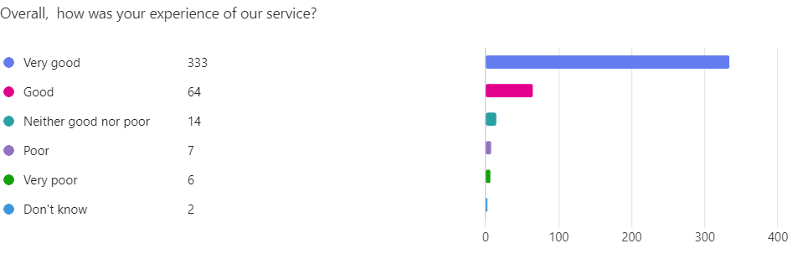

Here’s what you said about us in October 2024:

397 out of 426 patients stated their experiences were either ‘Very Good’ or ‘Good’.