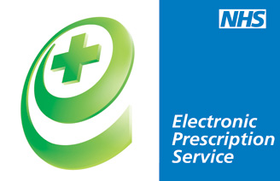

**Electronic Prescription Services (EPS)**

**IMPORTANT FACTS:**

**EPS have been available since 2005.** This is a free service and is just another way of prescriptions being sent to pharmacy.

**What is Electronic Prescription service?** If you have regular prescriptions the Electronic Prescription Service (EPS) may be able to save you time by avoiding unnecessary trips to your GP.

The Electronic Prescription Service (EPS) allows your prescription to be sent electronically from your GP surgery to a nominated pharmacy of your choice.

**How to sign up?** Your local community pharmacist will ask you to complete a form naming them as the nominated pharmacy.

Choosing a pharmacy contractor to process your EPS prescription is called a nomination.

This means you’ll no longer have to collect a paper repeat prescription from your GP practice – instead you can go straight to the nominated pharmacy to pick up your medicines. When using EPS your pharmacist may have already received your electronic prescription and prepared your items in advance possibly reducing your waiting time.

**What are the benefits?** You can choose the most convenient pharmacy for you, **such as near your home, where you shop or where you work.** This is flexible and can be changed at any time – just let your GP surgery or community pharmacy know.

**Who can see my prescription?** EPS is reliable, secure and confidential. Your prescription will be seen by the same people who sees your prescription now GP practices, pharmacies and the NHS prescription payment and fraud agencies.

**Check if your medicines are suitable for Electronic Prescription Service as not all medicines can be sent using this scheme**. Your GP surgery and or community pharmacy staff will be able to advise you.

<https://digital.nhs.uk/services/electronic-prescription-service#section-summary>