Advocacy support  - POhWER support centre can be contacted  via 0300 456 2370  - Advocacy People gives advocacy support on 0330 440 9000  - Age UK on 0800 055 6112  - Local Council can give advice on local advocacy services  - Other advocates and links can be found on this PHSO webpage  Further action  If you are dissatisfied with the outcome of your complaint from either the Nottingham and Nottinghamshire Integrated Care Board or this organisation, then you can escalate your complaint to Parliamentary Health Service Ombudsman (PHSO) at either:  Milbank Tower, Milbank  LONDON  SW1P 4QP  Citygate, Mosley Street  MANCHESTER  M2 3HQ  Tel: 0345 015 4033  www.ombudsman.org.uk | The Abbey Medical Group  59 Mansfield Road  Blidworth, Nottinghamshire, NG21 0RB  01623 700805  nnccg.c84037@nhs.net |  |  | The Complaints Process  - The Abbey Medical Group  
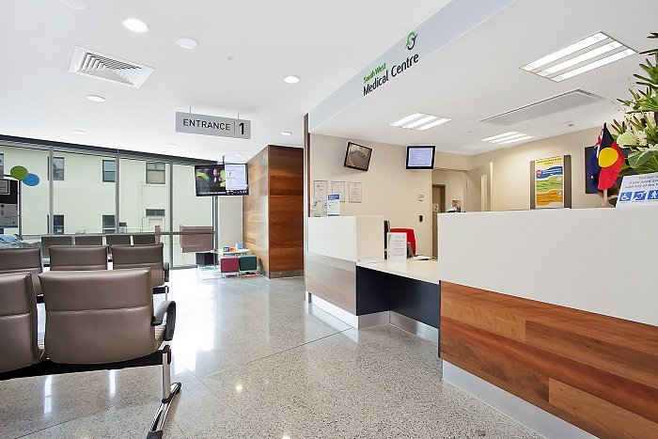  Practice Complaints Procedure  Patient feedback is important to us as it helps us to improve the service we provide to patients. We take patient complaints seriously and will attempt to address your concerns to your satisfaction.  How do I make a complaint?  Most complaints can be resolved at a local level. Please speak to a member of staff if you have a complaint; our staff are trained to handle complaints. Alternatively, ask to speak to the complaint’s manager, Frances Chater, Practice Manager.  What Happens Next?  The complaint will be acknowledged within 3 working days. The practice will respond, after an investigation, within the timeframe specified to you at the acknowledgement stage of the process. Some complaints may take longer to address but you will be informed of an approximate response time. | Please be assured making a complaint will not adversely affect your ongoing healthcare at the practice. We will deal with you fairly, compassionately and will endeavour to resolve the situation to a satisfactory conclusion.  Wherever possible, we aim to learn from complaints and take action to avoid similar occurrences.  How do I complain to someone Independent?  GP Practices would prefer to have the opportunity to answer complaints ourselves in the first instance. However, you may pass your complaint directly to:  Patient Experience Team  Nottingham and Nottinghamshire Integrated Care Board  Sir John Robinson House  Sir John Robinson Way  Arnold  Nottingham  NG5 6DA  Tel: 0115 8839570  Email: nnicb-nn.patientexperience@nhs.net  However, please note, patients cannot raise the same complaint with the practice and the ICB. |  | Is there a time limit?  A complaint must be made within 12 months of the date of the incident that caused the problem or the date of discovering the problem.  Please remember, the quicker you complain, the easier it will be to investigate the facts.  Investigating complaints  The Abbey Medical Group will investigate all complaints effectively and in conjunction with extant legislation and guidance.  Confidentiality  The Abbey Medical Group will ensure that all complaints are investigated with the utmost confidentiality and that any documents are held separately from the patient’s healthcare record.  Third party complaints  The Abbey Medical Group allows a third party to make a complaint on behalf of a patient. The patient must provide consent for them to do so. A third-party patient complaint form is available from reception.  Final response  The Abbey Medical Group will issue a final formal response to all complainants which will provide full details and the outcome of the complaint.

