**Home Blood Pressure Record Sheet**

**Name:**

**Date of Birth:**

|  |  |  |  |  |  |  |  |
| --- | --- | --- | --- | --- | --- | --- | --- |
| **Date** | **Time (am)** | **Systolic (upper value)** | **Diastolic (lower value)** | **Time (pm)** | **Systolic (upper value)** | **Diastolic (lower value)** | **Pulse** |
|  | **:** |  |  | **:** |  |  |  |
|  | **:** |  |  | **:** |  |  |  |
|  | **:** |  |  | **:** |  |  |  |
|  | **:** |  |  | **:** |  |  |  |
|  | **:** |  |  | **:** |  |  |  |
|  | **:** |  |  | **:** |  |  |  |
|  | **:** |  |  | **:** |  |  |  |
|  | **:** |  |  | **:** |  |  |  |
|  | **:** |  |  | **:** |  |  |  |
|  | **:** |  |  | **:** |  |  |  |
|  | **:** |  |  | **:** |  |  |  |
|  | **:** |  |  | **:** |  |  |  |
|  | **:** |  |  | **:** |  |  |  |

**Please return your readings on this sheet to the reception desk along with your borrowed machine**

**Alternatively, if you have your own machine at home, you can email your readings in this document to**[**nnccg.manorsurgeryreceptionist@nhs.net**](mailto:nnccg.manorsurgeryreceptionist@nhs.net)

**How To Use Your OMRON Blood Pressure (BP) Monitor**

Please note this is the property of The Manor Surgery.

Please return the monitor promptly on the date advised so that it can be cleaned and loaned to another patient.

**Instructions:**

Please check your BP every morning and evening for 4-7 days and make a note of the readings on the chart supplied on the reverse.

Please sit and relax for 15 minutes before taking your BP.

Rest your arm on a table/arm of chair according to the diagram below

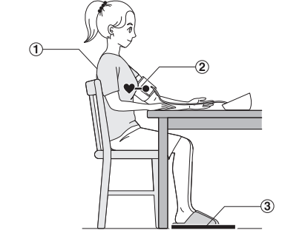

Apply the cuff to your bare upper arm according to the diagram below

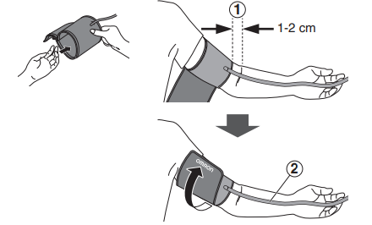

Press the start button and the monitor will measure your BP automatically

Do not talk, move, eat or drink whilst the reading is being taken.