Do you look after someone with dementia?
Specialist information is now available for
YOU
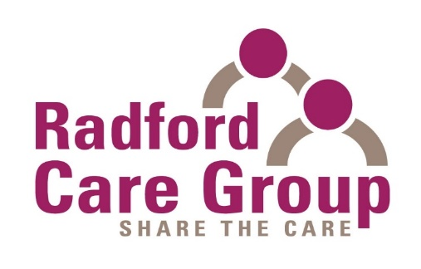
are pleased to announce their next FREE Programme
for carers of those with dementia at:
Middle Street Resource Centre
74 Middle St, Beeston, Nottingham
NG9 2AR

13th January 2025 to 24th February 2025
Every Monday 10.30 am – 12.30 pm

Making Sense of Dementia

What carers need to know

This programme of special support sessions for carers of people with dementia will give an improved understanding of all aspects of dementia.

The free seven-week programme has experts guiding the group and also offers mutual support from other carers, refreshments and a chance to get your questions answered in a relaxed and informal setting. Help with respite care may be available (subject to suitability).

Booking is required

For more information or to reserve a place please contact us on 0115 9786133 or 07513 856647 or email sue.cain@radfordcaregroup.org.uk

