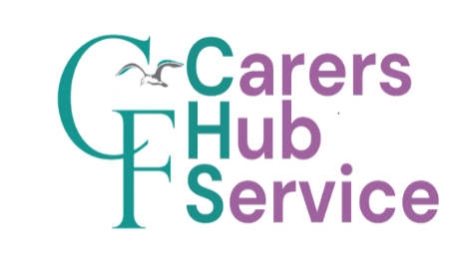

Are you a Carer?
A Carer is anyone who cares, unpaid, for a friend or family member who due to illness, disability, a mental health problem or addiction cannot cope without their support.
You are a Young Carer if you do this role and are under 18 years of age.

If you are looking after someone, we would like you to let us know so we can provide the support and information you might need.
You can be added to our Practice Carers Register and we can then give you further information and support.

A Carers Champion is a Staff member at the Practice who supports Carers.
The Carers Champion at the Practice is:
Mirabelle

Carers can get information, advice and support by contacting the Carers Hub on 0808 802 1777, lines are open Monday to Friday 9am until 5pm or message via Text or WhatsApp on 07814678460.
You can also make contact using the following methods:
Website: https://carershub.carersfederation.co.uk/
Email: carershubinfo@carersfederation.co.uk

Information and support for Carers provided by Nottingham City Council can be found at:
https://www.nottinghamcity.gov.uk/information-for-residents/health-and-social-care/adult-social-care/support-if-you-care-or-look-after-someone/ or by contacting the Customer Service Centre on 0300 131 0300

