Guide to Using SystmOnline – Viewing your Detailed Coded Record and Test Results

Access the website at www.sgmp.nhs.uk

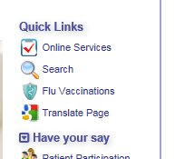
To Request Access to view Online Record

- From the home page click on the ‘Online Services’ link at the top of the right-hand menu. Then select ‘Login to Online Services’

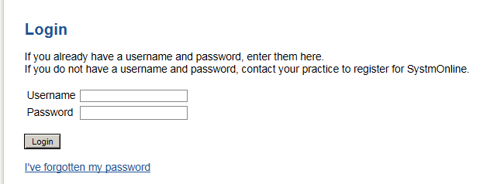
- Enter your login details and click login. This will bring you to the home page.

- To obtain access to your detailed coded record, you will first need to request the service. From the menu click on the ‘Manage Online Services’ link

- From this page click the ‘add’ button on the detailed coded record section.

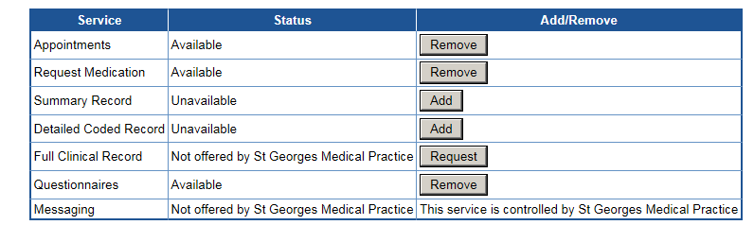

- When you click ‘add’, a notification will be sent to the Practice requesting access, which will usually be actioned within 10 working days from receipt. Log out.

6. The practice will then send out to you a consent form which you will need to sign and
return to us before access to your detailed coded record can be granted.
Once the signed consent form is received your records will be checked and access
granted.

To View Online Record once Access Granted

1. Login in following steps 1 and 2 above.

2. From the menu select ‘Patient Record’ and then ‘Patient Record’ again. Type in the dates you wish to view in the ‘show events between’ boxes and click go. All coded entries between those dates will be shown below.
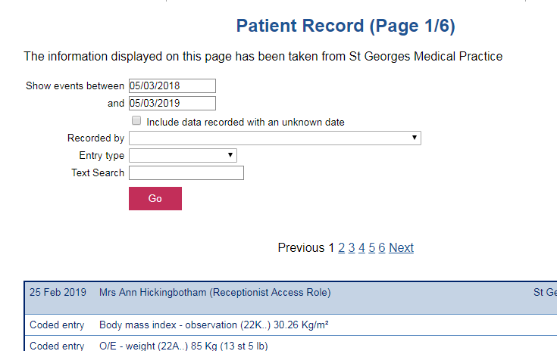

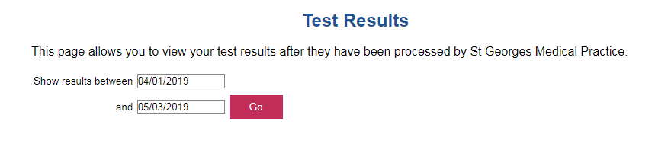
3. If you just wish to view test results. From the main menu select ‘Patient Record’ and then ‘View Test Results’

Type in the relevant dates and click go

Please Note: If there are any problems with your test results someone from the surgery will call you, however if you are concerned at all please call reception, ideally between 2.00 – 4.00pm.

4. When finished, either click on the ‘Home’ button from the top menu if you wish to use another service or click the ‘Logout’ button.

