Guide to Using SystmOnline – Ordering Repeat Prescriptions

Access the website at www.sgmp.nhs.uk

- From the home page click on the ‘Online Services’ link at the top of the right-hand menu. Then select ‘Login to Online Services’

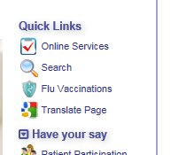
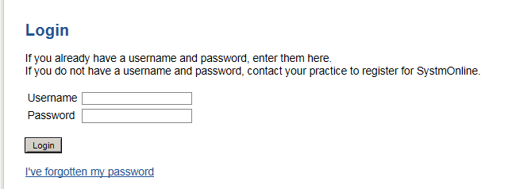

- Enter your login details and click login. This will bring you to the home page.

- To order a repeat, click on ‘medication’. On the next page click on ‘medication’ again. This will bring up a list of all the medication you currently have on a repeat prescription.
.
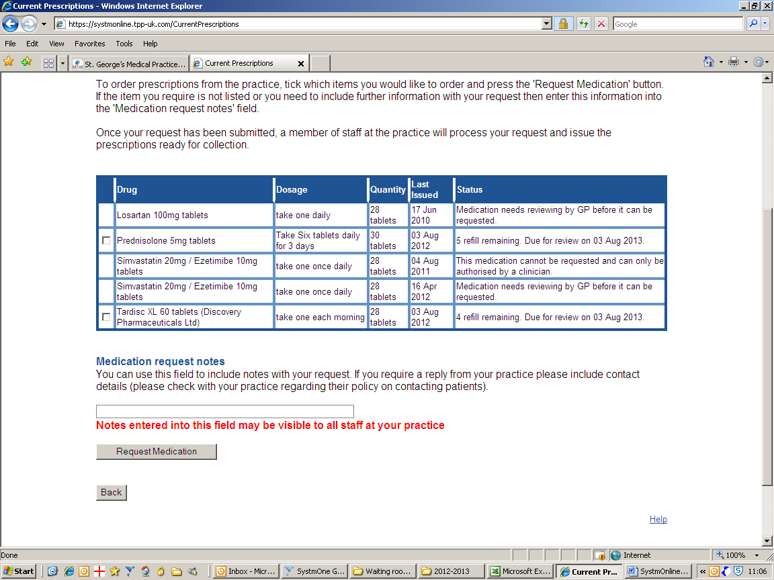
Click in the tick box on the left-hand-side of the item(s) you require. NB: If a tick box is not available then this is likely to be either because the medication is due for a review, or it is too soon after your last request. Click on ‘request medication’
This will bring up a summary of your request.

- In the ‘medication request notes’ box near the bottom of the page you can indicate if you would like the prescription to be sent to a particular chemist. You can also enter here any items that you wish to order that weren’t available from your repeat list.

- Click on ‘request medication’
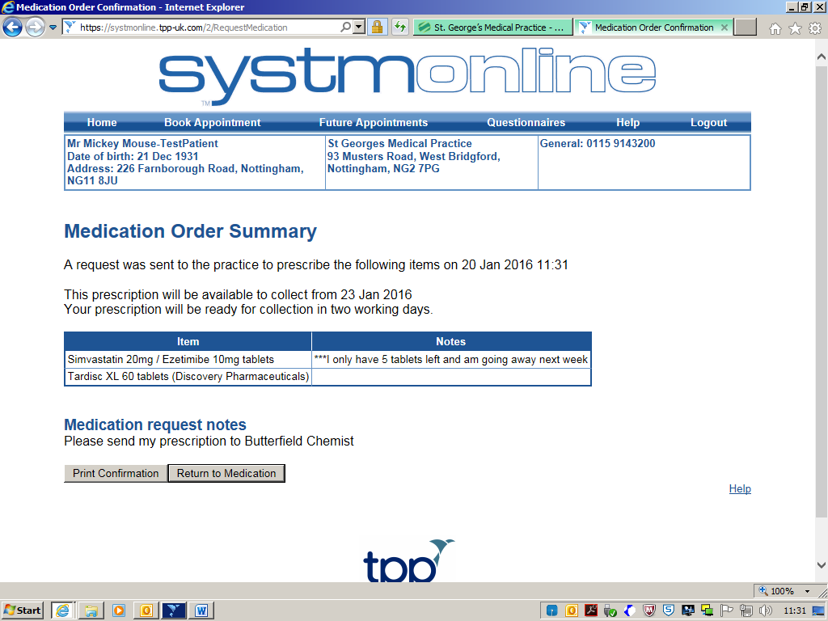

- A confirmation of your request will be displayed. You can now log out.

Guide to Using SystmOnline – Booking a GP Appointment

Access the website at www.sgmp.nhs.uk

- From the home page click on the ‘Online Services’ link at the top of the right-hand menu. Then select ‘Login to Online Services’

2. Enter your login details and click login. This will bring you to the home
page.

3. Click on ‘book appointment’

4. This will bring up a list of available GP appointments for the next 2 weeks. If you wish to look for an appointment at a later date you can alter the time period box for the following two weeks.

5. Select the date and GP that you want to see from those available and click ‘view’

6. Select the appointment time you want and click ‘book’

7. It will display details of the appointment. Check the details and if correct click ‘book
appointment’. If they are not correct click ‘cancel’ and reselect.

Please Note: This is for booking routine GP appointments only. You cannot book
nurse, HCA or blood test appointment online.

