**St Georges Medical Practice**

**A Guide to SystmOnline for patients using browsers on computers, tablets or smartphones**

This guide has been written by members of the PPG (Patient Participation Group) to help new users of the SystmOnline. We hope that it is neither too simple nor too complicated. Please feel free to pass on suggestions for improvement to us.

**Using SystmOnline on a mobile device (smartphone / tablet)**



If you prefer to use an “App” on your device, you will need to download the free SystmOnline App from the relevant store onto your device just as you would for any other App.

The App works differently to the browser version and is not as comprehensive.

**Receiving your login details**

Before you use the software, you will need to ask at the practice reception in order to be assigned a username and a password. Please bring photo ID with you – such as a passport or driving licence. You should find the username easy to remember, but the password is more complicated. Do not worry – when you use the system for the first time, you can change the password to something easer to remember!

**Accessing the services**

Open up your browser (Chrome, Firefox, Safari, Edge etc.)

1. On your device, go to the website [www.sgmp.nhs.uk](http://www.sgmp.nhs.uk) – this website works on all browsers.
2. Click on “Online Services” from the list at the right side of the webpage or “Prescriptions” or “Appointments” in the toolbar near the top of the page (Circled below)

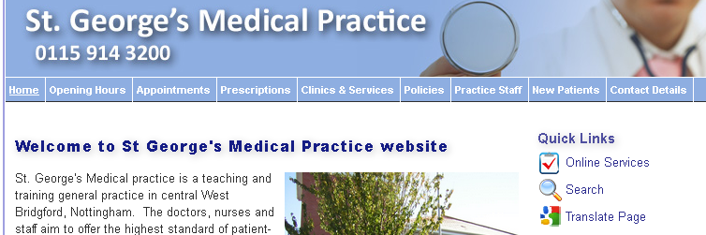

1. After clicking on the link to access any of these options, you will be asked to log in using your username and password as supplied by the practice. Please note that to ensure personal security, name and password must be typed exactly as supplied – including any capital letters.

**Changing your password**

If you are logging in for the first time, we suggest you change your password to something easier to remember. You can do this in the section “Your Account.” Please note that your password must fulfil certain requirements to ensure your security. These requirements will be displayed on your screen. Your password should be easy to remember, but not too easy for others to guess using information they know about you. Consider something like your mother’s maiden name, where you were born or married - in combination with some other unrelated information. A mixture of upper-case, lower-case and non-alphanumeric characters (such as * or #) can be addition safety factors.

**Naming/Changing your pharmacist**

In the “Your Account” section you can also name or change the pharmacist who will handle your prescription. The prescription will usually be sent to them electronically.

**REPEAT PRESCRIPTIONS**

**Requesting medication**

1. Under the heading “Your Medication”, click on “request medications”.
   1. All your regular repeat medications will be listed.
   2. Click on the box to the left for each of the medications you wish to order
   3. If this is all you need, click on ‘continue’ at the bottom of the page.
2. If you need to send any special notes about your request such as requesting an extra supply because of holidays, you can do it on this screen by clicking on “make a custom request”

This can also be used to request medications which are not on your repeat list but which the GP prescribes from time to time to treat previously diagnosed “occasional” problems such as Hay Fever etc. Please note that such requests are processed manually and may take longer to process.

1. If your list of medications is correct and the pharmacist who handles your prescription is named, click on “Request medication”.
2. Your prescription will be processed and sent to your pharmacist electronically -much more quickly than via the manual method.
3. When finished, click at the top of the screen “Logout”.

**APPOINTMENTS**

**Booking appointments**

1. Under the heading “Your appointments”, select “Book Appointments”.
2. The webpage will show you some of the appointments available for approximately the next three to four weeks.
3. If you see an appointment that fits your needs, click on “View” and, on the next screen, book it. There is the opportunity to advise the GP of the reason for your visit.
4. Use “Back” at the bottom of the screen to go back to a previous page.
5. Please be aware that some appointments are kept back for urgent cases or follow ups and are managed by Reception.
6. If there is no suitable appointment slot offered, you will need to contact reception as usual to ask whether any of the reserved slots is available. Failing that, there is always the “Extended Hours” service; this is described on the home page under “Opening Hours” then “Opening times”.

**EXTRA FACILITIES**

Once you have mastered the basic functions, you may wish to explore slightly more complex items such as “Summary Patient Record”, “Patient Record”, or “View Test Results”.

**Summary patient record** is fairly straightforward and shows current medications and any sensitivities / allergies.

**“Patient Record”** and **“View test results”** are not available initially. If you wish to access them, you will need to go to the “Your account” section and then select “Manage Online services”. Here you will see the services which are available / unavailable. If there is one you wish to become available, click on “Add”. This will send a prompt to the practice who will send you a form to fill in. More information on this is contained in the “Help” section which you can access by clicking on this tab at the top right of the screen.

Remember to always use the “back” button at the bottom of each page to return to a previous page and “logout” at the top right when you have finished with the program.

Congratulations. You have now completed your first visit to SystmOnline at St George’s Medical Practice.