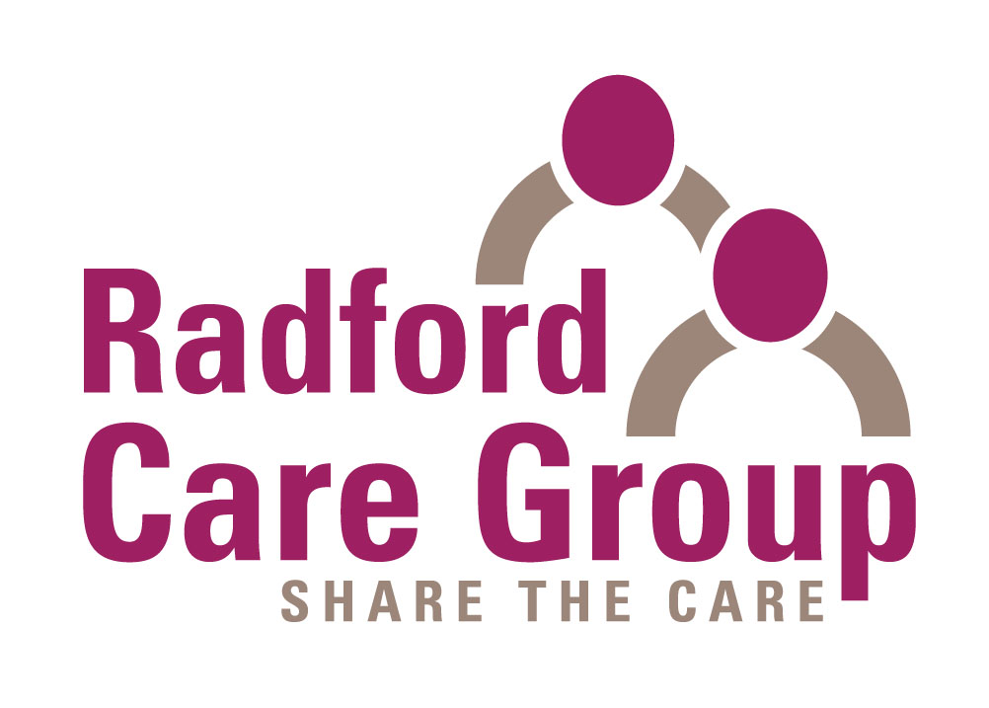
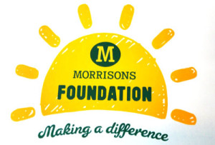

RADFORD CARE GROUP ARE PLEASED TO ANNOUNCE DATES
FOR THE 2019 / 2020
INFORMATION PROGRAMMES FOR CARERS OF PEOPLE WITH DEMENTIA

Details are as follows:-

Saturday 19th January 2019 – Saturday 2nd March 2019
10.30am – 12.30pm

Thursday 2nd May 2019 – Thursday 13th June 2019 *
2.00 pm to 4.00 pm

Tuesday 9th July 2018 – Tuesday 20th August 2019
6.30 pm to 8.30 pm

Wednesday 16th October 2019 – Wednesday 27th November 2019 *
2.00 pm to 4.00 pm

Thursday 17th October 2019 – Thursday 28th November 2019
10.30 am – 12.30 pm

Saturday 25th January 2020 – Saturday 7th March 2020
10.30am – 12.30pm
These free programmes consist of seven, two hour weekly sessions, covering a different aspect of dementia at each session and are held in City & County* locations – Please contact Radford Care Group for more information.
The groups are facilitated by specialists in dementia group work and will consist of about 12 carers. Help with respite services and transport may be available. The carers are asked to contribute £2.50 per session towards refreshments. - We are happy to take referrals from both Nottingham City and County.

The Information Programme has been very successful and proved to be of considerable value to carers who are often coping alone and in difficult circumstances.

“I found the information evenings I attended with my mum a very very helpful source of information for us to learn about my dad’s dementia. Without the info provided I would not be able to cope with some of the experiences we are going through right now, as I would not understand what is going on in my dad’s head and I wouldn’t be able to help him. These courses are very important for helping people cope with experiences like this in life”.

“Within the first hour of the first session I felt like someone had wrapped me in a warm blanket – I no longer felt alone”

To book a place, refer a carer or for further information about the Information Programme, please call
Radford Care Group on 0115 9786133. Or visit www.radfordcaregroup.org.uk

