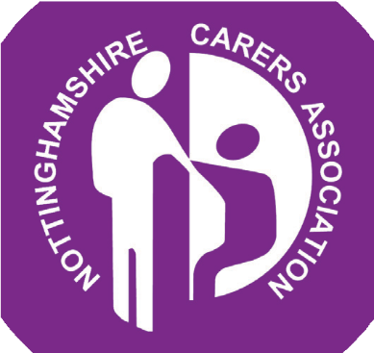

**Practice**

**CERTIFICATE**

Castle Healthcare

has completed Nottinghamshire Carers Associations’

Carers Awareness Training

PRESENTED BY: Smita Sandu

ON THIS DAY: 03/11/20