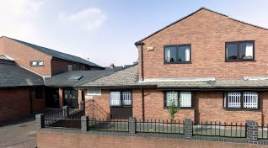
gj
SURGERY OPENING HOURS:
Monday: 7:00am- 6:30pm
Tuesday- Friday: 8:00am- 6:30pm
SURGERY WEBSITE: http://www.sherwoodrisemedicalcentre.co.uk SURGERY EMAIL ADDRESS: nnccg.sherwoodrise@nhs.net
SURGERY ADDRESS:
31 Nottingham Road, Nottingham, NG7 7AD.
EID UL FITR & EID UL ADHA CELEBRATIONS
May this beautiful occasion of Eid give you all the reasons to make this life more beautiful.
May Allah accept your good deeds, forgive your transgressions & ease the suffering of many.

PRESCRIPTIONS
- Please be aware we no longer take prescription requests over the phone.
- URGENT prescriptions are inhalers, diabetic & psychotic/depression medication.
- Prescriptions take 48hrs please call the pharmacy to ensure its there & ready to collect.
HELPFULL NUMBERS
Stop smoking: Stub It: 01158240583
Physiotherapy: 01158838320
Mental health: insight: 03005555582
Nottingham Carers hub: 01158248824

NEW STAFF MEMBERS
- Agnieszka our HCA has left us after 10years.
- Shona & Zoe are our new HCAs.
- Catherine Patel is our new clinic pharmacist & will be doing medication reviews
- Claire Toal is our new social prescriber & will help you in areas such as finances/dept, benefits, housing, social care, family support etc. If you feel you need any help in these areas please inform reception & we will book you an appointment.

- …………. Is our new physian associate & he …………

Welcome to the latest issue of Sherwood Rise Medical Centre newsletter. We produce an issue on a regular basis to keep you up to date on the latest news from the surgery.

SHERWOOD RISE MEDICAL CENTRE NEWSLETTER SPRING 2023

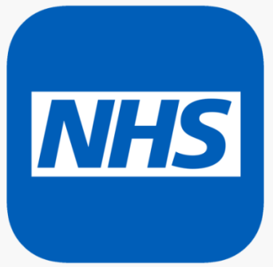
Pharmacy First
Doctors are in such high demand at the moment! Please go to the pharmacy first for:
cold/flu, itchy/dry eyes, constipation/diarrhoea, warts/verruca’s, indigestion/heartburn, thrush/BV, fungal nail infections, athletes’ foot, chicken pox, hay fever & headlice.

COVID SUMMER BOOSTERS
Please call 111 to book an appointment at the Haydn Road site.
Housebound patients will receive a letter from the Roven Team to arrange home visits
Missed Appointments This Month
100
If you are unable to make your appointment, PLEASE call us to rebook so another person in need can see the doctor instead.

SIGN UP WITH THE NHS APP!
The NHS App is available to all patients! With the NHS App you are able to:
- Order your regular repeat medication.
- View your medical records (may take up to a few weeks)
- View your COVID-19 vaccination record.
- Search, book or cancel appointments at the Surgery.
- Get health, and coronavirus advice
To sign up with the NHS App, you have to download it on the App Store on your mobile phone, and follow all the steps to register.
If you are struggling to register, you can always contact a dedicated support line which offers free help on 01158838873.
Have you changed your address or any other details recently?
If you have recently changed your address, or telephone number please inform the Surgery so we can update your medical records. To change your address and telephone number, please attend the Surgery and fill out a slip at reception.

