
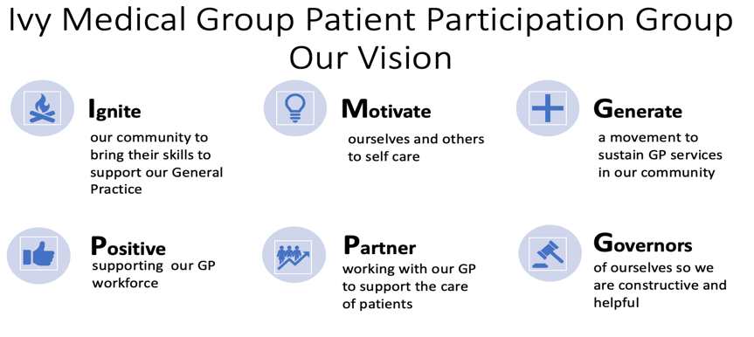

Ivy Medical Group (IMG) Patient Participation Group (PPG)
DRAFT Meeting Minutes (to be approved at the next meeting)
29 June 2023
Agenda item (see agenda 02-03-2023) | Notes | ACTION/OWNER/DATE
- Attendees | Tracy Madge (TM), Bob Barrett (BB), Liz Breeze (LB), Ingrid Glover (IG), Steve Scott (SS), Lindsay Hall (LH), Christina Juliff (CJ) and Mel Maddock (MM) Dan Howarth (DH) and Dr P. Panesar (PP)  Patients in attendance:  Georgina Hadjigeorgiou, Marion Welton, Jeanette Johnson, Jane Barber and Chris Helmore  IMG staff in attendance  Ros Ward | Action: to note
- Welcome and apologies | Apologies David Morley and Brandon Lee. CJ sent late apologies and arrived at 18:15. | Action: to note
- Conflicts | No new conflicts declared | Action: to note
- Action notes from the last meeting | Agreed as an accurate record and actions completed/progressed | Completed
- End of Life (EOL) update | LH and Notts Hospice reviewed the surveys about experience of EOL in hospital. There is currently no primary care equivalent. LH and the hospice have adapted the hospital survey and produced one specifically for General Practice and home EOL.  LH has placed EOL booklets and posters in the church hall. Dr P thanked LH for all her work on this how helpful it will be on improving services.  The PPG members gave positive feedback. | Actions:  - MM to ensure survey has been issued by MJOG by 3 July 2023  - TM to send paper version to IMG for printing and place on receptions by 10 July 2023
- Under 18 | Progress slower due to governance process in schools. Survey designed by sixth formers to be issued about GP experiences across sixth forms and what they would like to have available for example preparing for university and/or working life.  Over the summer the survey will be refined and may also include other age groups and schools.  Once completed PP will issue a letter thanking students for the input. | Actions:  - SS to work with BL to progress the survey by Oct. 2023  - PP to issue letter once survey completed date TBC
- Health promotion | BB presented an update from the work completed on health awareness and the NHS App.  PPG members thanked BB for the excellent work undertaken.  PPG members thanked CJ for an excellent article on mental health.  Next campaign is diabetes, PP stressed that we need to work on lifestyle improvements as some of the impact is due to the pandemic changed habits and behaviours. Notts does have some high complications for diabetes so a focus on this is important. | Actions:  - TM to upload the presentation on IMG website and social media by 10 July 2023  - IMG to discuss with system one to address updating the pharmacy list by Sept 2023  - BB to arrange James Hastings support to patients in receptions by 10 July 2023  - Next campaign diabetes. BB to send out by end of July 2023  - LB to ensure spread of the information across all areas by Sept 2023  - LH to send TM details of Lambley magazine by end of July 2023
- Strategy | TM updated members on the actions from the public listening exercise and the progress made on most of the key findings including electronic prescriptions, access through patient triage and communication. | Action:  - To note
- Practice Update | You said: improve access.  We did:  Launched the patient triage and shared the progress on IMG website this week. More to do to refine the system but generally very well received. Considerable impact on waiting times with face to face appointments available in days.  Staff feedback also positive.  For those who are not sure about the technology BB, LB and TM will be leading two workshops to help patients set the system up.  You said: What are you doing for Lowdham.  We did: IMG have completed a survey and are analysing the results. IMG have a dedicated meeting to feedback to Lowdham patients on 12 July. Patient Triage has addressed a key concern about access with and plans for Lowdham will be shared at the meeting.  You said: Communicate with us better.  We did: Patient triage does allow for better communication so this will keep improving the patient experience.  In addition IMG have launched a new website. There is more to do but the site will improve. Staff are currently being trained on the new website. SS and TM will have access to enable them to update the PPG area of the website.  PPG members have been running NHS app workshops with more planned. IMG will keep collating patient views through these and other routes. | Actions:  - PP and MM to keep PPG updated on the Patient Triage service. Case Study update at November AGM.  - BB, TM and LH to facilitate two workshops to support use of Patient Triage. TM to advertise by 3 July 2023
- Premises | TM presented the IMG journey on trying to secure new premises for the patient population. | Actions:  - TM to publish slides on social media by 30 June 2023  - TM to arranged drop in sessions for patients and the public to present the slides
- Group Q&A – core/non-core members | Question: Jeanette Johnson - Patient triage and non-technical patients.  Does IMG know how many patients do not have a mobile phone. Answer: MM confirmed the data on patients without mobile phones was available but was a small number of patients.  Question: Georgina Hadjigeorgiou raised the letter to IMG patients about new premises as upsetting for nursery staff.  Answer: PPG confirmed that there is never an intention to cause distress to any party. PP highlighted that communication both ways could be improved.  Question: Jane Barber on Lowdham developments  Answer: MM/TM and BB holding an update for all Lowdham patients on 12 July 2023. Lowdham Village Hall | Actions:  - Jeanette Johnson to feedback on using telephone access only at November AGM 2023  - Post meeting action: PPG to reinforce that the meeting is non-political at future meetings and restate the terms of reference and code of conduct.  - PPG to note: Meeting with IMG PPG Chair and Secretary to take place with Parish Council and Assura on 12 July 2023  - PPG to note Parish Council meeting with IMG on 18-07-23 TM/SS with PP.  - PPG to note Lowdham update on 12-07-23
- Communication | Key health messages via village communication routes and social media across all geographies  IMG website to be updated. | Actions:  - LB to work with DH to make sure information is spread across the villages by end of July 2023  - MM to ensure PPG access to IMG website by end of July 2023  - TM to remove Q&A from agenda and replace with questions from non-core members at the start of the meeting with responses against the relevant agenda items by 08-11-23
- Next meeting | Formal PPG  AGM Wednesday 8 November 2023  Post meeting note: Jane Barber requested to become a core PPG member. To be agreed at AGM.  Social meeting dates:  Thursday 20 July. Ship Inn, Lowdham, 18:00 - 19:30  Thursday 7th September, Woodlark, Lambley, 18:15 - 19:30  Thursday 26th October, Wheatsheaf, Burton Joyce 18:15 - 20:00 | Actions:  - PPG agreed to change start of meeting to 18:15 – 19:45 TM to action  - Next PPG socials to be arranged by end of July 2023 by TM  - PPG to approve Jane Barber membership 08-11-23

