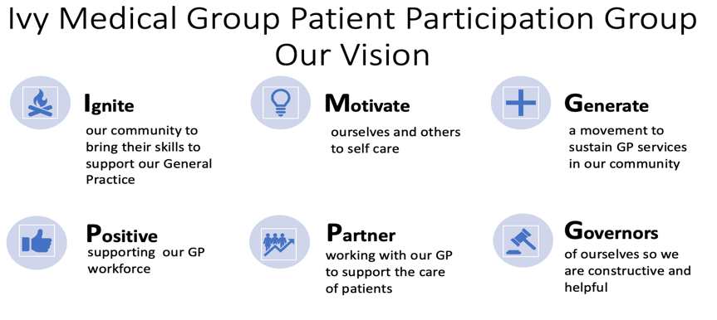


Ivy Medical Group (IMG) Patient Participation Group (PPG)

DRAFT AGM Minutes (to be approved at the next meeting)
11 December 2023
Agenda item (see agenda 11-12-2023) | Notes | ACTION/OWNER/DATE
- Attendees | Tracy Madge (TM), Martin Maynes, (MMa),Bob Barrett (BB), Liz Breeze (LB), Ingrid Glover (IG), Steve Scott (SS), Lindsay Hall (LH), Christina Juliff (CJ), Melanie Maddock (MM),Brandon Lee (BL),David Morley (DM) and Dr P. Panesar (PP) | Action: to note
- Welcome and apologies | Chair welcomed all, and put on record her appreciation for the work done by the PPG over the past year, particularly Tracy Madge’s contribution.  Apologies Sharon Hill, Claire Leggett and Dan Howarth. | Action: to note
- Conflicts | No new conflicts declared | Action: to note
- Action notes from the last meeting | Agreed as an accurate record and actions completed/progressed | Completed
- Action log | Action Log Reviewed and updated | Action. Circulate updated Action log post meeting
- Election of Committee Members | Martin Maynes was elected as Co Secretary and was expected to take the lead for the PPG in relation to premises.  Clare Leggett elected as PPG member and was expected to take the lead in Under 18s  Sharon Hill also elected. | Action: to note
- 2023 Annual Report | Introduction  TM presented the Annual Report, the following was duly noted  Availability of Annual Report  PPG members have personal copy  Additional reference copy available in BJ Library until February  Available on website | Action: to note
2023 Annual Report | Chair’s Report  - Thanks to previous Chair Steve Scott.  - Noted with sadness that previous long standing Chair Janet Kenwood had recently passed away. Condolences to husband Gerald.  Main themes PPG covered in 2023 were:  - Access  - Best Practice  - Improved Communication  - Valuing Workforce & Volunteers  - Premises  Secretary Report - Tracy Madge  - Shared an anonymised quality report showing Ivy on all green for the ICB quality markers, an external assessment. This looks at surgery system data to give a rating against clinical outcomes, patient experience, safety and overall. The only practice in Arrow PCN to have achieved green across the board.  GP Principal report - Dr Panesar  - Dr Panesar expressed gratitude for the invaluable support provided by the PPG.  - Noted that PPG and Ivy Staff have worked effectively as a team  - PPG has particularly supported in providing health insights and journey to new premises  - PPG’s support of patient triage had attracted external attention to what was being done in our practice  - Supported PPG role going forward  - Dr Panesar echoed recognition of the work done by previous Chair Janet Kenwood  Patient Triage - Dr Panesar  - Noted this had been a fundamental change for the practice, requiring a huge amount of work by staff  - Had been hugely successful in improving services provided  - Better clinical oversight straight away from experienced clinicians enabled potentially serious illness cases to be prioritised, vastly reducing waiting times for this category of patients.  - Improved system for managing long term conditions  - Implementation was hard, took 8-9 months to fully embed  - Staff input was impressive  - Currently triaging aprox 80 - 130 patients each day  - Currently Max 48 hour turnaround for triaged cases, although most responded to far quicker than this.  - Support from PPG in improving patient awareness of the benefits of triage system would be welcome  Patient Triage - Bob Barrett  - BB highlighted the data showing much improved uptake of patient triage  - Noted that 40% of users were over 60  - Generally people find it easy to use  - Noted that new version of NHS App was due to be released shortly  Other points made by PPG members  - Maybe trial audiovisual in practice to promote triage  - Use of strapline “save time book online”  - Noted that triage did not remove other methods of accessing care  Health Awareness - Bob Barrett  - Article on health awareness had been published every two months in magazine. Need to consider themes for 2024.  - NHS App/Triage workshops had been well attended  - There was useful data from App survey as discussed  - Noted that 67% were registered for App against target of 60%, so Ivy ahead of most practices  - Logins had increased by 64%  End of Life Care - Lindsay Hall  - Survey carried out in association with Notts Hospice consisting of 26 questions  - 55 responses received, more than expected  - 4 x 2 hour workshops held in each locality  - Lots of learning re methodology for the future  - Highlighted the need to support those left behind following bereavement  - On a positive note 78% of relatives felt that loved one had died in the right place for them  - Thanks to relatives and patients for participating  - Dr Panesar endorsed the work and thanked Lindsay  Under 18s - Brandon Lee  - BL worked with a number of students to produce a survey of the views of U18s with regards to accessing healthcare  - BL subsequently analysed and shared the results in the form of a report to the PPG  The main recommendations were;  - Comms toolkit on how to access services for young people  - Standardised policy for phone access for students requiring access to healthcare during school/college hours  - generic health hub pilot to provide one stop access to healthcare for U18s  - Encourage U18s to use triage system to access healthcare  The Chair thanked Brandon for an excellent piece of work for an under represented patient group  Premises - Tracy Madge  - Premises review had been introduced at public meeting in July  - 80 attendees and a variety of views obtained  - Assura are still looking at potential sites in and around the area  - No new communication from Assura since last meeting, but expecting an update in the New Year  - Premises will be a key theme in 2024  Communication - Liz Breeze  - Very active year in communications  - Patient notice boards had been well received  - Visibility of PPG had greatly increased  - Multiple workshops with patients have been held  - Dan’s role in delivering communications to patients who do not use technology, as well as his time spent putting up posters in BJ and Lowdham. This has been a direct result from the support that we have received from Louise and her team of carers at Bridle Lodge.  Areas for improvement  - Triage process still very much in progress, some found it complex  - Should start to see the full impact in practice data over the next six months  - Social media had been used a number of times to criticise the practice which was undermining for staff and other patients.  Questions from members of the public  - Enquiry whether triage could be extended to out of hours.  - Dr Panesar responded that this was not possible as there was a possibility that serious health conditions could be missed if a clinician was not able to triage immediately. Only admin requests were available out of hours.  Chair thanked patients who had attended AGM. | Actions:  To Note  To Note  Action; PPG to add Patient Triage to 2024 Work Programme  Add health awareness themes to action plan for 2024. Suggestions were:  - Work with Under 18s  - Kidney Awareness  - Prostate awareness  - Diabetes/Blood Pressure  - Healthy Eating  To Note  BMA advice to refrain from making negative comments about NHS on social media to be publicised, and highlight how patients can make formal complaints should they wish to do so.
- 2024 Plan | 2024 Action Plan Reviewed and Updated | Updated Action Plan to be circulated post meeting
- Meeting Close | Meeting Close - 7:15PM
- Next meetings | Formal Meetings 2024  6:15 PM - Thursday 4th April, Lowdham  6:15PM - Wednesday 17th July, Burton Joyce  6:15PM - Wednesday 11th December, Lowdham  Social Meetings 2024  6:15PM - Wednesday 7th February, The Ship, Lowdham  6:15PM - Thursday 6th June, Wheatsheaf, Burton Joyce  6:15PM - Wednesday 18th September, The Ship, Lowdham | To Note

