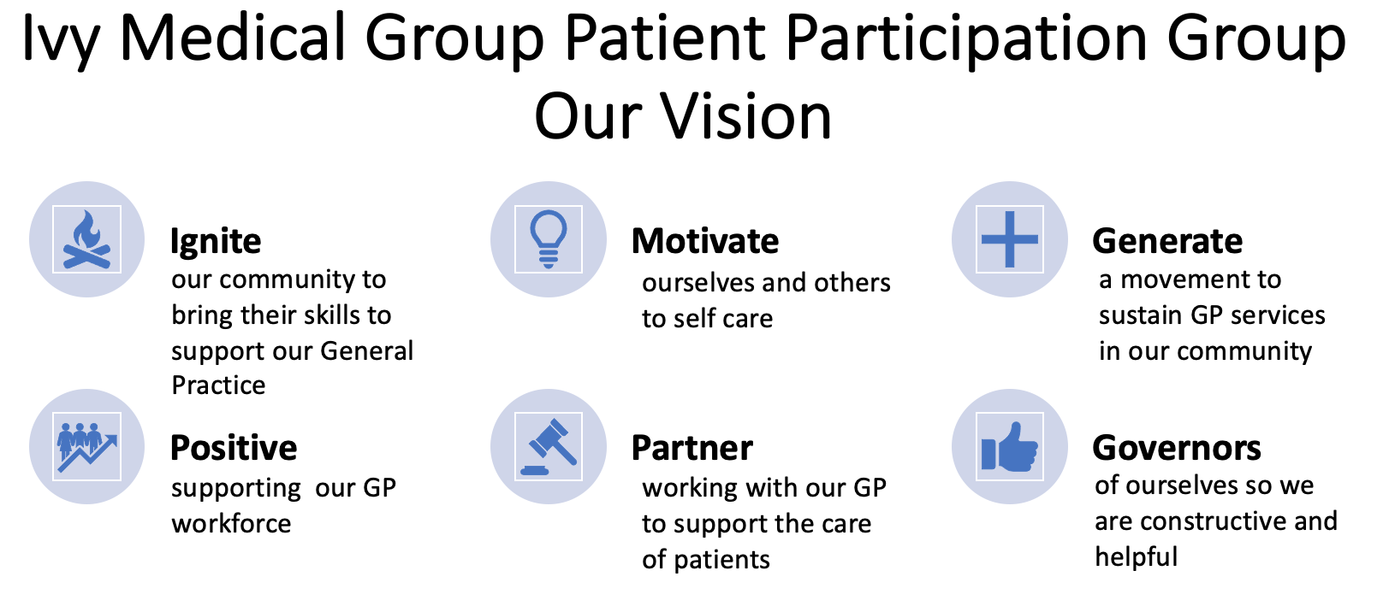
Ivy Medical Group Surgery
Patient Participation Group
Terms of Reference
Approved 09 December 2023

The Group shall be called the Ivy Medical Group (IMG) Patient Participation Group.
1. Aims of the Ivy Medical Group (IMG) Patient Participation Group (PPG)
- To facilitate good relations between the GP practice (referred to as the 'practice' throughout this document) and patients by communicating patient experience, interests and concerns and providing feedback to the practice on current procedures and proposed new developments.
- To work collaboratively and positively with the practice to improve services and facilities for patients and to act as a sounding board for practice staff on issues affecting patients.
- To build two-way communication and co-operation between the practice and patients, other individuals and organisations in healthcare, and the wider community to the mutual benefit of all.
- To act as a representative group to support the practice and influence local provision of health and social care.
- To lead an area of work as a ‘Patient Partner’ to support delivery of the strategy.
- To deliver an annual programme of work agreed with the lead GP.
2. PPG Structure and Membership
- Membership of the PPG shall be open to all registered patients. The role is unpaid and voluntary.
- Membership will endeavour to reflect the patient profile and be widely representative and inclusive of different genders, ethnicities, ages and abilities as required in the GP contract, and will be approximately 12 people.
- All registered patients of the practice are invited to apply for membership of the IMG PPG. If a patient moves to another practice that will mean that he/she will cease to be a member of the PPG.
- The PPG will be non-political and non-sectarian and will at all times respect diversity and exemplify its commitment to the principles contained within the Equality Act.
- A representative of a patient registered with the practice can be an associate member of the PPG even if the representative is not a patient at the practice.
- A Patient Partner is a member of the PPG taking a lead role in a topic area of their choice.
2.1 PPG and PPG Committee
- The IMG PPG may elect officers from among the members of the PPG and they will be known as the committee. These will include Chair, Vice Chair and Secretary. Other posts may be created by the Annual General Meeting on a proposal from the PPG.
- The PPG and the PPG committee shall both hold regular meetings, held a minimum of 3 times a year, giving 4 weeks’ notice of meeting dates.
- To maintain an active PPG, any PPG committee member who fails to attend three consecutive PPG committee meetings without any contact with the group may be deemed to have resigned. The PPG will extend an open invitation to practice staff to attend its meetings as agreed with the practice manager.
- The PPG committee shall normally be a minimum of 12 members representing the diversity of the practice population. Between the Annual General Meetings, the PPG may co-opt members if needed to ensure that the PPG is fully representative of the patient community.
- Members who do not attend 2 out of 3 meetings per year will be deemed to have resigned.
2.2 Virtual and extraordinary PPG meetings
- To support the PPG and extend its reach, the PPG may establish an online group to be called the Virtual Patient Participation Group (VPPG). Any patient may volunteer to join the VPPG. The PPG will regularly contact the VPPG in order to obtain their views on specific matters or to discuss a matter of urgency.
- A member of the PPG will be made responsible for liaising with the VPPG and ensure that no one is excluded. There will be a standing item on the PPG agenda reporting any key themes, issues or suggestions that have been identified by any member of the VPPG to help ensure its members are engaged. Notwithstanding the above, any patient may send views and suggestions directly to the PPG.
- Members of the VPPG will follow the same Code of Conduct as those in the PPG that meets face-to- face.
- All business and meetings of the PPG committee, the Main group and any future Virtual group, shall be run in accordance with Appendix 1.
2.3 Notes of the meeting
The action notes of the meeting will be shared with members and on the practice communication platforms withing 5 working days of the meeting.
3. Review date
- These terms of reference will be reviewed annually in each year.
- If necessary, the chair can request a review date before the review date.
4. Signed agreement
NB: To ensure a jointly agreed approach by the practice and PPG members, this section should be signed by both parties.

These Terms of Reference were adopted by IMG PPG as follows:
Venue: Burton Joyce Library
Date: 09/12/23
Signed by:
PPG Chair: Ingrid Glover (virtual)
General Practice representative: Dr Panesar (virtual)

Appendix 1
IMG PPG Code of Conduct
The PPG Membership is not based on opinions or characteristics of individuals and shall be non-political and non-sectarian, at all times respecting diversity and exemplifying its commitment to the principles contained within the Equality Act.
All Members of the PPG (including the Virtual PPG) make this commitment to:
- Support the PPG vision (below) by being positive and actively supporting the IMG to deliver high quality services.
- Attend and actively contribute to the agenda.
- Not use the PPG as a forum for personal or political agendas or complaints. These should be taken forward through other appropriate channels.
- Respect practice and patient confidentiality at all times.
- Declare conflicts of interest.
- To treat each other with mutual respect and act and contribute in a manner that is in the best interests of all patients.
- To be open and flexible and to listen and support each other.
- To abide by the seven Nolan Principles of Public Life: Selflessness, Integrity, Objectivity, Accountability, Openness, Honesty and Leadership.
- Accept that the ruling of the Chair or other presiding officer is final on matters relating to orderly conduct.
- Sign up to the code of conduct at the start of every meeting.
- Work in accordance with this code of conduct in all work associated with the PPG.
- Otherwise, to abide by principles of good meeting practice, for example:
  - Reading papers in advance
  - Arriving on time
  - Switching mobile phones to silent
  - Allowing others to speak and be heard/respected.
PPG Vision

