PPG Meeting: 25 April 2024

Practice Performance Quarter 1: January 2024 – March 2024
Complaints, compliments and public feedback

Introduction
Firstly, THANK YOU, to all the patients/carers who wrote to or contacted the practice or Patient Participation Group (PPG) with compliments, complaints or concerns, we welcome all.

This report will detail the numbers and themes from these sources and we will publish a ‘you said: we did’ after each quarterly report

Purpose
The purpose of gathering complaints and compliments:
- Identifies areas of good practice
- Identifies areas for improvement, lessons learned and changes that need to be made
- Demonstrates we value patients and others’ concerns and comments about our service by making the changes we can based on your feedback

The PPG receive a quarterly and an annual report on all the feedback from a range of sources. This is shared at a public PPG meeting and the outputs published on our website, notice boards and on all available media forums.

Summary of feedback in quarter 1
We have approximately 6,800 patients registered with the practice.
In the first quarter of 2024 the practice have undertaken an average of 750 patient contacts a week or around 9,000 from January to March 2024. These were either face to face and/or telephone appointments.

From these 9,000 contacts this report provides details from the following sources of feedback:
- 12 written/emailed formal (table 1 below)
- 8 written/emailed informal complaints (table 2 below)
- 12 Compliments (table 3 below)
- One PPG public meeting with patients (table 5 below)
- Social media comments (table 6 below)

Another key source of information is the GP Survey (Appendix 1). The 2023 will be our baseline, as it was completed before the major service change of patient triage. We will assess 2024, results when they are published, against this baseline and agree any actions required.

Themes from the feedback
The themes and numbers of compliments and formal complaints from quarter 1 were the same:
- Clinical services
- Reception services
- Triage
- Appointments
- Prescriptions

Table 1: Quarter 1 Jan – Mar 2024 Formal Complaints
Patients/carers who formally wrote in or emailed the practice.
Formal complaints ‘You said’ Q1 2024 | No | We did/are doing
Clinical care  - Care received by clinician  - Care received by surgery  - Duty of care  - Referral waiting times | 4 | Reviewing the policy and procedure and informing the team at protected learning sessions  IMG by June 2024
Triage  - Online requests logged but no response (days later, sometimes longer) | 2 | Reviewing the system to ensure this is prevented  One patient had to be issued with a zero tolerance letter  IMG by May 2024
Service  - Online requests not answered  - Booking of correct tests/booked for wrong test  - Reception behaviour  - Private work waiting times | 3 | All complaints about reception staff are taken through the Human Resources procedure. All calls are recorded. If a member of staff is found to have behaved incorrectly disciplinary procedures are commenced; e.g. more training or, in the worst case, dismissal.  IMG by May 2024  The GP is contracted to provide NHS work and therefore non-NHS work needs to be undertaken outside this this contract time.  GP roles are not 9-5 and the work behind the scenes is often done outside surgery hours. For example prescribing, medication reviews, reviewing blood tests, referrals to hospital, reading discharge letters, external clinical meetings and staff management  The General Medical Council state the GP must not sign anything unless they are sure it is true, they cannot simply sign a letter without a full review of the patients record.  The wait for this work is anything from 2 – 12 weeks across the country.  Communicate via ‘you said we did’ and at all public meetings  IMG and PPG by July 2024
Prescriptions  - Repeat prescription: process, errors logged but no action to date.  - days on average | 2 | Reviewing the system to ensure this is prevented  One patient had to be issued with a zero tolerance letter  Pharmacists offered training on patient triage to enable them to send in queries  Message about prescriptions to be amended as not all are ready immediately  IMG and PPG by May 2024
Total formal complaints = 11

Practice Performance Q1 2024
Table 2: Quarter 1 Jan – Mar 2024 Informal Complaints
Patients do not write in, talk to the staff or do not want to make a formal complaint
Informal complaints ‘You said’ Q1 2024 | No | We did/are doing
Clinical care – results | 1 | Reviewing the system to ensure this is prevented  IMG by May 2024
Consultation  - quality of care; did not feel listened to  - Conduct | 2 | One to one with clinician undertaken
Triage  - access to appointments  - NHS App | 3 | Reviewing the system to ensure this is clearer  IMG by May 2024
Service –  - not aware of the staff, name or role  - More chairs needed at Lambley Lane | 1 | PPG meeting with all staff to produce a who’s who  IMG by July 2024
NHS App information regarding appts | 1 | Explanation of NHS App features undertaken  IMG by May 2024
Total INFORMAL complaints = 8

Table 3: Quarter 1 Jan – Mar 2024 Compliments

Compliments ‘You said’ Q1 2024  patients who send cards/emails or letters | Number | We did/are doing
Clinical care received - GP | 2 | Sharing this feedback across multiple communication platforms  IMG by May 2024
Clinical care received Nurse | 2
Triage | 1
Service – reception | 2
Service – the whole team | 3
Flowers with a thank you | 4
Total compliments 12

PPG feedback
Your PPG has volunteer patients who hold at least 4 open meetings per year to gather views of registered patients and to provide information and updates. These meetings are advertised widely, and a text message is issued to all patients who have a mobile phone registered with the practice.

The PPG are independent of the practice, and they feedback and represent your views, good and not so good! They also feedback from issues raised on social media.

The PPG hold at least 4 public meetings a year for registered patients. Patients can drop-in and the meeting includes a Q&A and information sharing. Table 4, below is the summary from the 4 April 2024 meeting: Number of attendees: 50 Average age: 70

Table 4: Quarter 1 - Jan – Mar 2024 PPG feedback

Theme/Area | Compliments  Examples | Concerns  Examples | We did/are doing
Medication reviews | Excellent |  | Feeding back to the team
Who are the team | Times have changed and we can’t always see the same person | Continuity of care  Want to see the same Dr/Nurse | PPG are meeting with all staff to produce a who’s who  PPG by July 2024
Who are the team | Times have changed and we can’t always see the same person | Who are the team? Who knows me? What is a clinician?
GP qualifications and GP trainees |  | Other practices show what specialist training or specialism the GPs have.  Do trainees have enough knowledge and skills to handle complex needs?  Do they understand the practice systems e.g. referrals | - PPG are meeting with all staff to produce a who’s who which will collate the specialisms of the team  PPG by July 2024  - GP specialist trainees  These staff are defined as qualified medical practitioners (doctors) who are undertaking training to be a GP.  They have a medical degree undertaken over 4-6 years. In addition they have 2 years foundation training so they are qualified doctors  All GP trainees have a full induction to the systems and processes in the practice  All GP trainees have supervision from Dr Panesar weekly and daily access to discuss patient cases.  Please note training practices such as Ivy are seen to be at the cutting edge of primary care as they are a critical pipeline for GPs of the future.  Dr Panesar and the surgery have undertaken and passed extensive assessments by the University of Nottingham to become a GP training practice.  Communicate widely via ‘you said we did’  IMG and PPG by May 2024
Prescriptions | Repeat prescriptions are simple | Repeat prescriptions not on time | The pharmacists at Lowdham and Burton Joyce can use Patient Triage to query all prescriptions, they need the patients permission. IMG will respond within 48 hours (Mon-Fri only)  PPG to provide PT updates by July 2024  Complaints help the surgery investigate specific issues.  Advise patients to write to the surgery and communicate via ‘you said we did’ and at all public meetings  IMG and PPG by May 2024
Prescriptions | Repeat prescriptions are simple | Items missing or incorrect
Prescriptions | Repeat prescriptions are simple | Text from Dr says prescription is ready but is not available when trying to collect
Prescriptions | Repeat prescriptions are simple | Confusion over prescriptions  Dr blames pharmacy; pharmacy blame Dr
Prescriptions | Repeat prescriptions are simple | Inability for pharmacy to contact surgery to query prescription
Prescriptions | Repeat prescriptions are simple | Changes in medication made by hospital not actioned by Dr
Prescriptions | Repeat prescriptions are simple | Mistakes being made on prescriptions and no response from surgery
Phlebotomy |  | Why do some people get bloods at Ivy and others have to go to park house | The only bloods taken at IMG are for those patients who  - Cannot get to park house due to frailty  - Have an urgent health issue that needs blood tests quickly  Communicate via ‘you said we did’ and at all public meetings  IMG and PPG by May 2024
Appointments | Like the text message reminders | Mix up over appointments issued | Reviewing the system to ensure this is prevented  IMG by May 2024
Appointments | Like the text message reminders | Given a 5 hour window for the practice to provide a telephone conversation | The demand for urgent care can mean that a precise time is unable to be accommodated.  Communicate via ‘you said we did’ and at all public meetings  IMG and PPG by July 2024
111 |  | Being told by 111 we can have an appointment but when we ring the surgery they say we have to go through triage | IMG to discuss with 111 as they do not have access to see appointments  IMG by May 2024
Triage | Very enthusiastic | Don’t trust the triage service as believe the receptionist is making the decision so only want to talk to and/or see the Dr | Improve communication and education about the service, through drop in meetings and visiting local groups  PPG by May 2024
Triage | Love the triage, went online, sent appt link next day. Seen and referred to specialist services within 2 weeks | Lack of understanding that even if classed as ‘urgent’ there are no appts and they are sent elsewhere
Triage |  | Don’t understand the triage process – what is a clinician
Service |  | Loop induction not working | Ivy will request urgent works  IMG by May 2024
Service |  | Message on phone too long and boring | The message will be reviewed and changed but will need to comply with NHS policy  IMG by May 2024
Communication |  | Use parish magazine more | The PPG already publish articles in the magazine. A chairs’ update will now be produced.  PPG by June 2024
Communication |  | Worry that they will never be able to use technology and therefore have equality of access  Not able to use Connect Health so discharged without being seen | Improve communication and education about the service, through drop in meetings and visiting local groups  Contact all patients on paper prescriptions and who have not declared they use a mobile phone. Offer bespoke education to this cohort  PPG to action by May 2024
Discharge |  | Letters and tests done in hospital not communicated e.g. when follow up required | CQC check this by directly accessing the GP records. They monitor that letters are acted upon within a set timeframe and they regularly check the waits. IMG are within the agreed timeframe for all letters  IMG to communicate by May 2024

Social Media comments
These are people/patients who chose to raise issues on social media via the village Facebook pages instead of through the practice processes. The PPG issue a standard statement to all complaints made on Facebook please see the PPG Engagement Plan.

Posts are seen by PPG members in the Lowdham, Lambley, Stoke Bardolph and Burton Joyce village Facebook pages.

In Q1 (Jan – Mar 2024) there were 4 Facebook posts on Burton Joyce (BJ) Village page and 1 on Lowdham
5 people commented positively on the BJ posts. 2 people commented positively on the Lowdham page.
10 people commented with concerns on the BJ post. Of the four BJ posts two were from the same person.
Table 5 provides extracts from the posts.

Table 5: Social Media - Quarter 1 Jan – Mar 2024
Area/Theme | Compliments  Example comments  ‘you said’ | Concerns  Example comments  ‘you said’ | We did/are doing
Change or registering with the practice | Responses when asked to recommend a practice…  I have no issues with Ivy, filled my online form in today…got assessed and had antibiotics by 1.30, been with them many years | I am so done with Ivy…can anyone recommend anywhere else | Patients can register with a practice that covers the geographical area they live in. Patients can find out where by searching online at https://www.nhs.uk/nhs-services/gps/how-to-register-with-a-gp-surgery/  IMG to include on website by May 2024
Change or registering with the practice | Ivy is really good and their online service is excellent | I am so done with Ivy…can anyone recommend anywhere else
Appointments  Face to face and telephone | The world of primary care has changed and we need to adapt to the changes  It’s not fair that the community makes judgements about Ivy on the basis of an incomplete picture and is exactly why complaints are best done through the official route | Not able to get an urgent appointment and directed to urgent care centre with elderly patient with 5 hour wait. When a Dr is in the surgery on a Friday night and be told its 48 hour triage.  Once upon a time the elderly of the village got priority | The impact of people living longer means they have more complex conditions. GPs no longer have enough time in the day to see everyone that asks for an urgent appointment. The NHS has urgent care services to ensure that anyone who has an urgent need can be directed to them by GPs when they have no capacity.  Communication required to ensure the community understand the pressures on the service  Communicate via ‘you said we did’ and at all public meetings  IMG and PPG by July 2024
Appointments  Face to face and telephone |  | Sent to urgent care with whooping cough  Not prioritising more vulnerable patients, makes you not feel safe
Appointments  Face to face and telephone |  |  | Review the 48 hour message to ensure patients understand the system and opening times  Communicate via ‘you said we did’ and at all public meetings  IMG and PPG by May 2024
Appointments  Face to face and telephone |  | I am a retired registered nurse and have seen so many changes. I am a daughter (mum 93), wife. Mum/step mum, granny…I have been shackled to the phone all day and afraid to leave the house for a phone call appointment for my um (who is deaf and has no internet). …the system is broken and I’m fed up with propping it up – my health is my priority and it is not good at the moment. Don’t know how long I can do this | The demand for urgent care can mean that a precise time is unable to be accommodated.  Social prescribers are assigned to the practice and can support patients/carers to ensure they have the information and support they need  Communicate via ‘you said we did’ and at all public meetings  IMG and PPG by July 2024
Triage 48 response | Urgent cases seen much sooner; it’s a much better system | Not contacted within 48 hours and having to default to urgent care centre | As above
Triage 48 response | Everyone get access to support on the basis of clinical priority and not on who can sit on the telephone the longest at 8am | Urgent cases need seeing much sooner than in 48 hours, what about Friday? | As above
Reception | Really lovely caring staff, sometimes under great pressure us trying their best to help | The attitude of some of the receptionists is disgusting. We have to be courteous but it’s fine for them to be rude | All telephone calls are recorded. Patients should use the complaints process so the time and date of the issue can be investigated. If any staff are found to have not behaved in accordance with the policy then disciplinary action will be taken.  Communicate via ‘you said we did’ and at all public meetings  IMG and PPG by July 2024
Reception | I’ve always been very happy with Ivy
Reception | Well done Ivy you’ve always supported my family
Private letters/non-NHS work  e.g. insurance |  | Had to laugh speaking to a guy …had to wait 10 days for the Dr to sign a letter (West Bridgford) said my Dr had mine for 6 weeks and it would probably be another 9 weeks  Ivy Medical strikes again… | See Table 1
Service |  | Processes and systems need to be improved. | Complaints are a way of ensuring the practice review its systems and processes on a regular basis.  CQC assess the system both remotely and through inspection visits.  Communicate via ‘you said we did’ and at all public meetings  IMG and PPG by July 2024

Appendix 1
The NHS National GP patient survey

This is an external survey undertaken by Ipsos on behalf of the NHS. This is Europe’s largest patient experience survey and has been running for 18 years. Each year around 2.5 million people, aged 16 and over and registered with a GP practice in England, are invited to take part confidentially.

Please note the 2023 survey was undertaken before the launch of Patient Triage.

Examples from the patient survey:
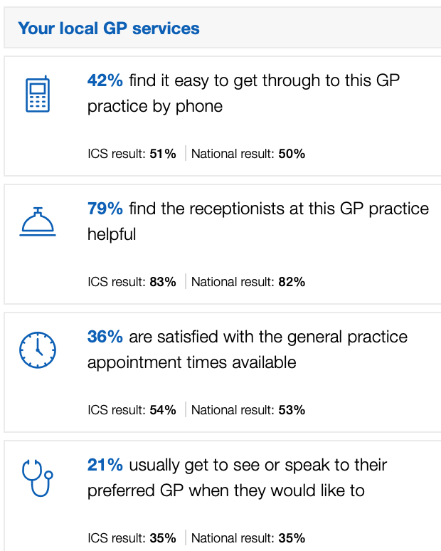 | 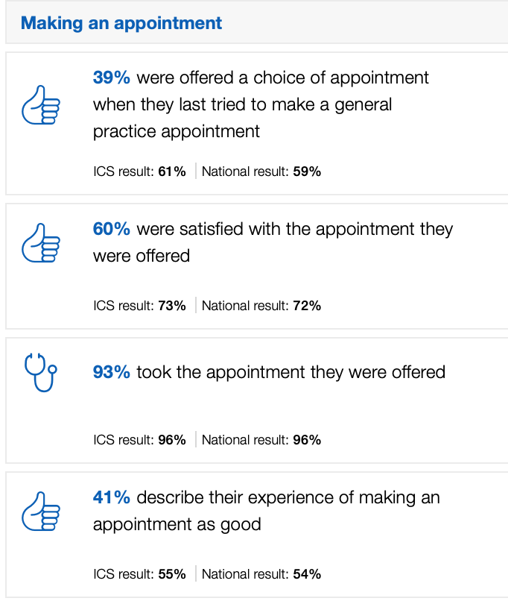
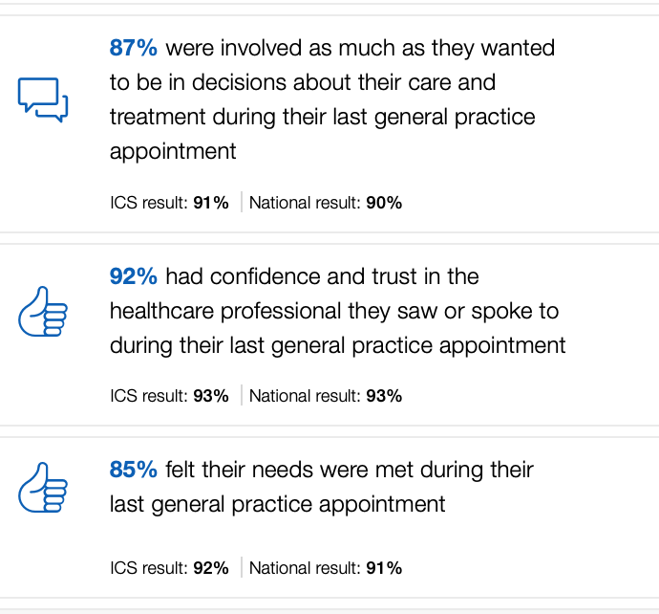 | 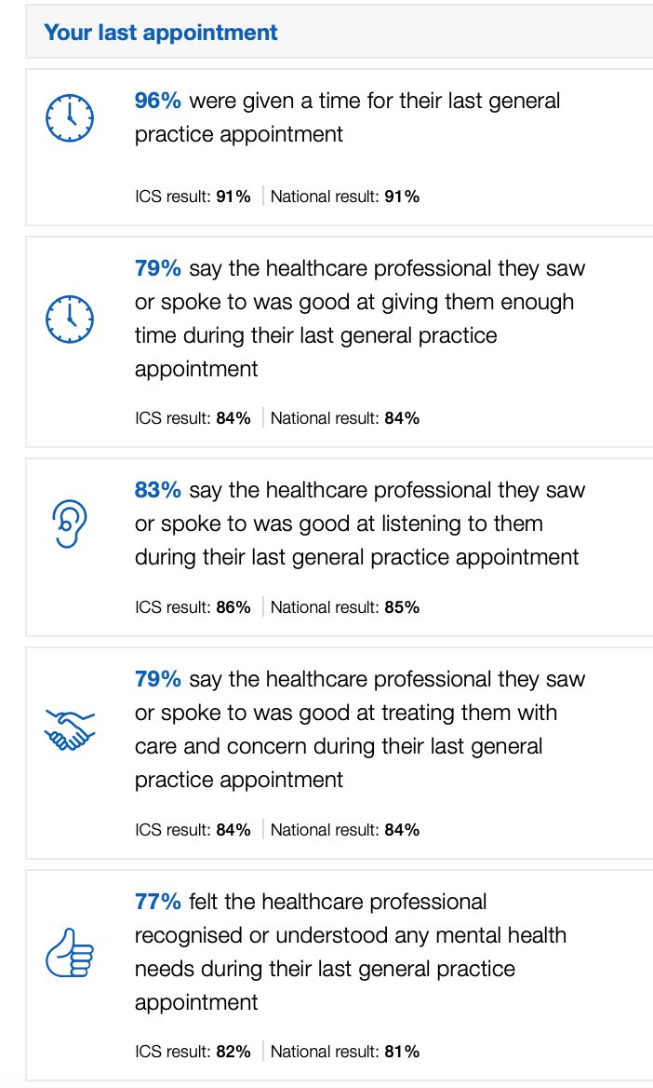
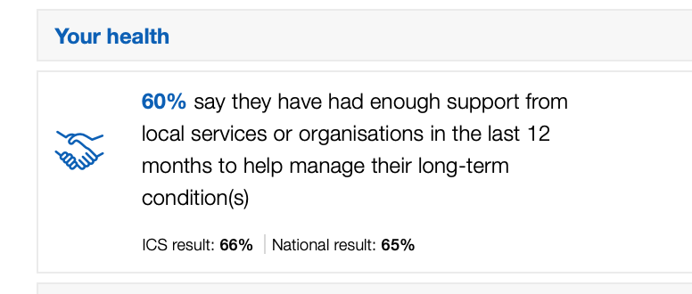 | 