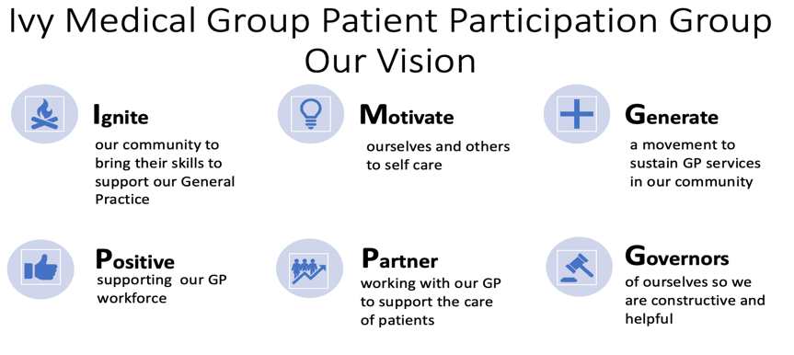


Ivy Medical Group (IMG) Patient Participation Group (PPG)

DRAFT AGM Minutes (to be approved at the next meeting)
25 April 2024
Agenda item (see agenda 25-04-2024) | Notes | ACTION/OWNER/DATE
Attendees | Tracy Madge (TM), Martin Maynes (M Ma), Bob Barrett (BB), Liz Breeze (LB),Clare Leggett (CL), Anne Butler (AB), David Morley DM), Lindsay Hall (LH), Christina Juliff (CJ) and Mel Maddock (MM) and Dr P. Panesar (PP)  Patients in attendance: David Sheath | Action: to note
Welcome and apologies | Apologies Dan Howarth and Brandon Lee. | Action: T M to enquire whether Dan needs further assistance to attend PPG meetings by end of May 2024
Conflicts | No new conflicts declared | Action: to note
Action notes from the last meeting | Agreed as an accurate record and actions completed/progressed | Completed
Appointment of Chair | Bob Barrett was duly elected to the recently vacated position of PPG Chair. BB made the following points in his opening remarks;  Thanks to previous chairs Ingrid and Scott.  Also, thanks to Tracy and Martin for support as Co Secretaries  Highlighted a very successful PPG meeting in Lowdham which has produced a lot of valuable feedback for Ivy. This has now been incorporated into our Action Plan.  Highlighted need for PPG to encourage people to make any complaints to the practice rather than on social media.  Mentioned recent unannounced CQC visit to Ivy. Report not yet received and expressed disappointment that PPG was not consulted during the visit.  Noted huge disruption to patients as a result of CQC inspection  Dr P supported these comments. Although valuing the work and role of CQC there had been a significant impact on the practice. Dr P was informed of the visit with less than 24 hours notice. The inspection had lasted a week and had a large impact on staff and quality of care to patients. Over 100 documents had also been requested.The visit may have been based on 5 individual complaints/feedback, all of which turned out to be minor in nature or not supported by facts. May query process/proportionality of visit with CQC following the issue of final report.  Anne Butler was welcomed as a new member of the PPG, supported by both Chair and Co Secretary. | PPG to support Ivy in implementing CQC recommendations when outcome published  Dr P to consider following up with CQC following issue of final report when published
Terms of Reference | Terms of reference were reviewed. It was agreed that new members would be appointed by the Chair and Secretary. | M Maynes to amend Terms of Reference accordingly by end of May 2024
Question & Answer Session for Patients | Noted only one patient present at the meeting.  Question 1 asked about the number of doctors available at Ivy as there was a perception the practice was shorthanded. Dr P responded that as well as himself there was Dr Roland and Dr Kennedy, plus a locum, Advanced Care Practitioner (ACP), 2 x practice nurses and a healthcare assistant. In addition there was a wider team of primary care staff, pharmacy, physiotherapy and mental health professionals. Overall staffing was in line with the expectation for the list size of the practice. Agreed to publish monthly capacity data.  Question 2 asked how blood test results could be obtained. Dr P responded that clinician will always view results and arrange to discuss with a patient if required. It was noted that there was usually no follow up if test results were normal. It was also highlighted that test results could also be obtained via NHS App although Dr P cautioned that this was often not accompanied by a clinician’s interpretation of the results. | MM to develop high level quarterly performance report next due July 2024  BB to develop blood test flow chart
Engagement Plan | Tracy informed that this plan had been developed in response to some very negative comments on social media regarding Ivy. The plan was to enable the practice to be a respected member of the community and highlighted the role of the PPG to provide independent support to patients who were unhappy with the service provided. | See detailed action plan in report
Premises | MMa reported that he had contacted the ICB and Assura for an update on practice premises. It was reported that a suitable and affordable site was still in the process of being identified. | M Ma to monitor situation
Communication | LB reported that key health messages continued to be made via all village communication routes and social media across all geographies | See detailed action plan in report
End of Life (EOL) update | LH reported that survey results have been received and the current plan is to run 3-4 sessions per annum to address actions required. Support would be required from the Hospice and local vicar. Agreed to continue the annual survey but focus more on bereaved families. | See detailed action plan in report
Under 18 | CL reported that Grace had volunteered to replace Brandon as U18 representative on the group. Work is still ongoing to implement the action plan. | See detailed action plan in report
Health promotion | BB presented an update from the work completed on health awareness and the NHS App. | See detailed action plan in report
Practice Update | MM presented the latest Practice report which covered complaints, compliments and patient feedback received between January and March 2024. MM thanked all patients who had been in touch as feedback is invaluable to the practice. It was noted that there are around 750 patient contacts per week as either face to face or phone consultations. There had been 12 formal complaints, 8 informal complaints, 12 compliments, one PPG meeting with patients, and some social media comments. It was agreed that the total number of complaints was very low compared to the number of patient contacts. | See detailed action plan in report  T M to produce performance infographic by end of May 2024
Next meeting | Formal PPG Wednesday 17 July 2024, Carnarvon Room, BJ | To Note
Post Meeting Notes | PPG Who’s who will be updated  Ingrid Glover requested to rejoin PPG. Supported by Chair and Co Secretary | T M to update PPG Who’s Who  To note

