|  |
| --- |
| North Leverton Surgery Newsletter |

|  |
| --- |
| SPRING 2022 |

**Welcome to our Spring Newsletter.**

Throughout the Pandemic our Practice Doors have remained open and most services went ahead, with the exception of Spirometry which was not deemed safe. Our on-site Dispensary remained open and although patients were and are continuing to be triaged by telephone first, in order to protect the vulnerable, we have continued to provide face to face appointments when necessary. The data below shows the number of appointments provided as monitored by NHS England from 01.02.21 to 30.01.22.

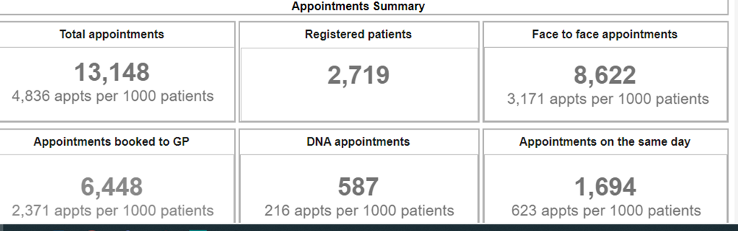

Despite the challenges of the covid pandemic, and the challenges we have faced with staff illness and staff isolation, we have managed to provide a full service with staff working many hours overtime and weekends both at the surgery and at the Covid Vaccination Centre in Retford and we are proud to have been able to be part of the vaccine roll out programme as well as maintaining our usual high level of flu vaccine provision. The data above however has shown an increase in non-attendance for appointments, and we would like to stress that if you cannot attend your appointment, please cancel in order that the appointment can be reused and waiting times for appointments do not creep up because of this.

**COVID Vaccination Update**

A further booster will be given to all patients aged over 75 or classed as vulnerable. Please wait to be invited and this cannot be done until 6 clear months from your last booster. This service will continue to run at the Outpatients Department at Retford hospital provided by Retford and Villages Primary Care Network of which we are a member Practice.

**Flu Information**

Although the flu vaccination was extended to all patients aged 50-64 yrs last year this will return to only vulnerable patients with underlying health conditions in this age group this year. If you are eligible, we will contact you when the time comes.

**Parking**

As some of you may know the Practice has been working with Parish and District Councillors and the school and church to try and create more parking (or off-site parking for staff) to help alleviate the problem of insufficient parking for the surgery. This work was ongoing before the Pandemic, and we had meetings with Highways regarding the school access near to the Practice entrance and options. We put in a bid for funding and had offers for donations but unfortunately some of these (including the bid) were denied and the project is currently on hold.

**Staff**

The Practice has been delighted to welcome new staff members in nursing, dispensing and reception during the pandemic and we now employ over 20 staff. We will be welcoming locum doctors in the summer whilst Dr Drughe takes maternity leave. Please be assured that the staff are doing their absolute best to provide the best service we can for the communities we serve.

For those of you who are unaware our service covers the following areas: -

Bole,Bottom Woodbeck,Church Laneham,Cottam,Dunham,Fenton,

Habblesthorpe,Laneham,Littleborough,Little Gringley,North Leveton,North Wheatley,Rampton,Saundby,South Leverton,South Wheatley,Stokeham

Sturton-Le-Steeple,Treswell,West Burton,Woodbeck.

For your information the team consists of the following Roles: -

|  |  |
| --- | --- |
| GP Partners | Dr James Reader, Dr Emilia Drughe |
| Salaried GP | Dr Gemma Brownson |
| Practice Manager | Jacqueline Dickenson |
| Practice Nurses | Linsey (Lead Nurse), Kerry |
| Health Care Assistant | Deborah |
| Phlebotomist | Lisa |
| Administrator | Lyndis |
| Secretaries | Maria, Helen, Louise |
| Reception Manager | Maria N |
| Receptionists | Louise, Liz, Tracey, Lisa |
| Dispensary Manager | Julie |
| Lead Dispenser | Alison |
| Dispensers | Natalie, Claire, Philippa |
| Delivery Driver/Administrator | Charlii |

**Facebook**

Visit our Facebook page for current information

<https://www.facebook.com/northlevertonsurgery/>

**Easter Opening Times**

|  |  |
| --- | --- |
| Thursday 14th April | 7.45am - 6.30pm Normal Hours |
| Friday 15th April | Closed |
| Saturday 16th April | Closed |
| Sunday 17th April | Closed |
| Monday 18th April | Closed |
| Tuesday 19th April | 7.45am - 6.30pm Normal Hours |

**HAPPY EASTER EVERYONE!**

