Armley Medical Practice
Newsletter

Spring 2020 Edition Issue 24

PRACTICE OPENING TIMES  Monday 08:00 - 18:00  Tuesday 08:00 - 18:00  Wednesday 08:00 - 18:00  Thursday 08:00 - 18:00  Friday 08:00 - 18:00  Saturday 08:00 - 12.00  HUB OPENING TIMES AT PRIORY VIEW  7am-8am Monday - Friday  8am-2pm Saturday & Sunday  Compulsory Training  The Practice will be closed on the following Thursday afternoons for compulsory staff training:-  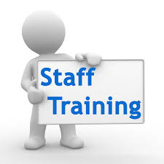  TRAINING DATES  2017/2018  27th February 19th March  30th April | ORGAN DONOR REGISTER - What is changing?  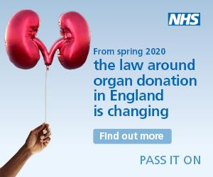  From spring 2020, organ donation in England will move to an 'opt out' system. You may also hear it referred to as 'Max and Keira's Law'.  This means that all adults in England will be considered to have agreed to be an organ donor when they die unless they have recorded a decision not to donate or are in one of the excluded groups.  You still have a choice if you want to be an organ donor or not when you die. Get the facts about organ donation to help you decide.  Why is the law changing?  The law is being changed to help save and improve more lives. Every day across the UK, someone dies waiting for a transplant  What do I have to do?  We are asking everyone to:  - Record your organ donation decision on the NHS Organ Donor Register  - Tell your family and friends what you have decided  CANCER WISE LEEDS  The national cancer screening programmes save the lives of thousands of people each year. But there are still a significant number of people in Leeds who don’t or can’t access this lifesaving service – we want to help to change this.  A Cancer Screening and Awareness Co-ordinator has started working with our Primary Care Network (PCN) to help us improve screening uptake for Bowel, Breast and Cervical Cancers as well as promoting awareness and understanding of the risk factors and signs and symptoms of cancer in our local population.  This exciting and innovative post has been created as part of the ‘Cancer Wise Leeds’ project, a three year project funded by Yorkshire Cancer Research. This project recognises and celebrates the fact that Leeds is an incredibly diverse city. We understand that people will have different needs and different barriers to accessing screening and the coordinator for our PCN will focus specifically on the needs in Armley.  The project will also provide opportunities for us to develop and test approaches to increasing screening uptake and awareness raising activities with other partners so if you know of any group in our PCN area that would like to know more about cancer screening and how we can work with them then please get in touch and we can arrange for someone to come out and talk to them.
Page 1

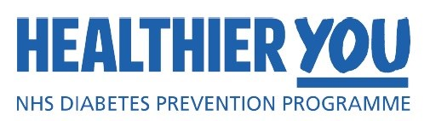  People finishing the world leading NHS Diabetes Prevention Programme have lost the equivalent weight of 43 ambulances.  Around four million people in the UK live with type two diabetes. Diabetes and its complications are costing the NHS more than £10 billion to treat every year.  89,604 people have now finished the programme, losing a combined weight of 185,051kg.  The world first service is the first of its kind to have achieved a full national roll-out.  With expert advice on dieting, exercise and healthy lifestyle, the programme will double in size to treat around 200,000 people every year as part of the NHS Long Term Plan.  Complications from the disease can include blindness and foot amputations.  Around nine out of 10 people with diabetes have type 2 and there were over a million obesity diagnoses in hospital patients last year.  Projections show that the growing number of people with diabetes could result in nearly 39,000 people living with diabetes suffering a heart attack in 2035 and over 50,000 people suffering a stroke and one in six hospital beds are occupied with someone with diabetes.  A lack of exercise, poor diet and being overweight are all risk factors for developing the disease.  Many people are unaware that Type 2 diabetes is a reversible condition. It is caused almost entirely by the foods that we eat and our lifestyles. We know that with the right changes, people with diabetes can reverse their condition, come off medication and lose weight.  If you are an existing type 2 diabetic or pre-diabetic and you are interested in attending one of our in house sessions with either Jo Kendall or Dr Kumar, our Diabetic Management Specialist. Please contact the surgery to make an appointment in one of our bi-monthly sessions. You are welcome to bring one other person with you – especially if they do the cooking.  We are so proud to be the first surgery in Leeds to receive the Gold Award accredited Practice, as part of the government equalities  Pride in Practice pilot.  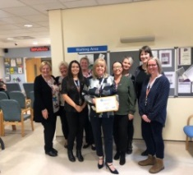  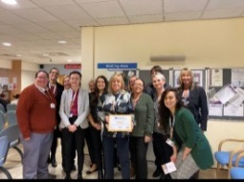 | Cash for Kids responds to the needs of  children in our community, especially at Christmastime. They support children aged  0-18 who are disadvantaged, disabled or  suffering from abuse/neglect. Last year  staff at Armley Moor donated lots of  Christmas presents for the children. We  were very proud of all the gifts collected.  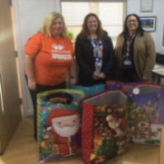  FESTIVE FOOD HAMPERS  Also for the past few Christmas’ we have  also asked staff to donate something for our Festive Food Hamper so that we can donate this to one of our patients in the community who are a little bit more vulnerable at this  time of year. There was so much donated,  we had enough to send to Armley Helping Hands to support their food bank.  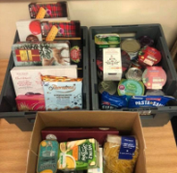  HGV/TAXI MEDICALS  Should you require a HGV or TAXI medical  please contact the surgery so that you can be added to the waiting list.  These medicals are NOT done in surgery appointment times, therefore please give the practice plenty of notice for this.  THE WAITING LIST FOR THESE MEDICALS  CAN BE ANYTHING FROM  1-6 WEEKS.  1367  What does this number mean?  Over the last 3 months the appointments not attended at our surgery were 1367. This equates to over 227 hours of wasted appointment time. If you have an appointment you can’t attend, be it here or elsewhere, please call and cancel/reschedule it. This means the appointment can be given to someone else and isn’t wasted.  PLEASE TEXT 07494835218 to cancel your appointment.
Armley Medical Practice, Armley Moor Health Centre, 95 Town Street, Leeds, LS12 3HD
Tel: 0113 4677499 Fax: 0113 2631915 www.armleymedicalpractice.co.uk
Page 2

