Leigh View Medical Practice
Tel: 0113 253 7628/9
Fax: 0113 238 1286

Bradford Road
Tingley
Wakefield
WF3 1RQ
www.leighviewmedical.co.uk

Dental 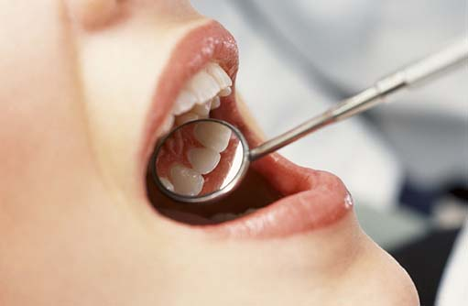

Emergency Dentists and out-of-hours dental care
GPs and Minor Injuries units are NOT appropriate for emergency dental care.
If you require urgent dental treatment, please contact your usual dental practice as they may be able to see you or direct you to an urgent care dental service.

If you do not have a regular dentist, contact NHS 111 for advice on where you can get urgent care.
Telephone:111
Emergency dental treatment will deal with the problem at hand and the fee for the treatment is currently £19.70. You may be advised to make another appointment for a separate course of non-urgent treatment. In this case, you will have to pay a second charge in the relevant treatment band.

