

**What happens**

**with your**

**information?**

**This is a short easy read leaflet to explain what Abbey Grange Medical Practice does with your information.**

This leaflet is called a privacy notice.

It tells you about the information we have about you.

It also tells you what we do with it and who we share it with.

If you want to see the full privacy notice please click here https://www.abbeygrangemedicalpractice.co.uk/about/patient-data/your-medical-record/

**Who and what Abbey Grange Medical Practice are**

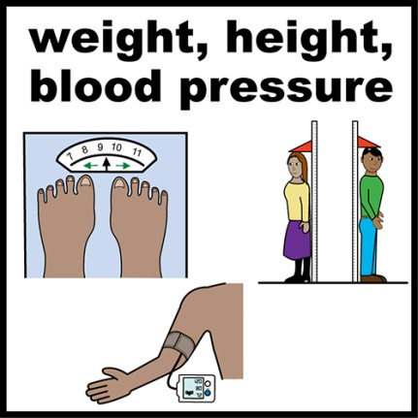We are part of the National Health Service (NHS) in England.

We provide you with medical care when you are ill

**Why do we need information about you?**

We need this information to make sure we give you the right treatment when you are ill

**What information do we have about you?**

The information we may hold includes:

* Name and address
* Telephone number.
* Date of birth.
* Records of the times you have visited the doctor, and what happened
* Details of your family and support network.

We may have to share this information with others for your health and care services.

We will only do this if the law says we can.

**Do we have any other information about you?**

We may also need special types of information about you including:

Any health and safety concerns

Race.

Are **there** any laws to protect your information?

* Yes, there’s the General Data Protection Regulation, or GDPR for short.
* And there’s the Data Protection Act 2018.
* There are other laws too. Please see the full privacy notice for these.

We follow these laws to make sure your information is protected.

**What do these** laws **say?**

The law says that we must:

* Not keep information about you for longer than needed.
* Destroy your information securely when we have finished using your information.

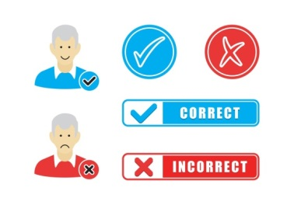

* Make sure the information is correct.
* Let you know what information we hold, and why we need it.

**How do we look after your information?**

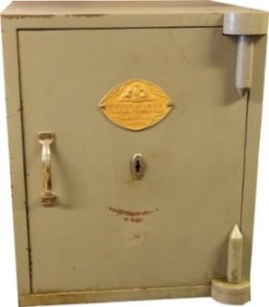

* We make a computer record about you and your health.
* We use appropriate safety measures to help stop your information from being lost or used in the wrong way.

**Who can see your information?**

We take protecting your privacy very seriously.

* 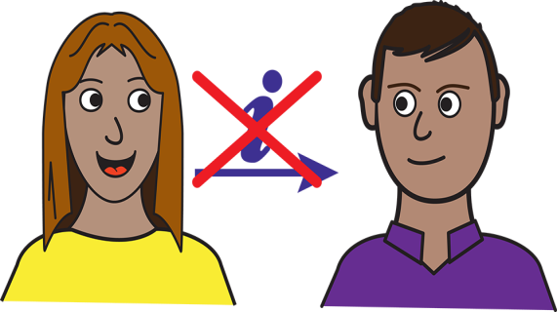Only our staff who need to see your information are able to do so- these are people who need to access your information to help you.
* They use your information in strict confidence and it is not shared with anyone who doesn’t need to know.

**What are your rights?**

* You have the right to ask for a copy of the information we hold about you.
* You have the right to let us know if we have made a mistake and ask us to correct it.
* You also have the right to complain to the Information Commissioner.

You have some other rights as well.

Please [click here](https://ico.org.uk/your-data-matters/) if you want to find out about your other rights.

**Who can you ask for help, or complain to?**

**Please contact us if you:**

**Are not happy with the way your information has been used**

**If you wish to use one of your rights**



Please write to this address:

**Abbey Grange Medical Practice**

**Norman Street**

**Leeds LS5 3JN**



You can also telephone us on 0113 2951844

And you can email us at this email address:

abbeygrange.medicalpractice@nhs.net

**Who else can you complain to?**

If you are still unhappy after contacting us, you can complain to the Information Commissioner.



This is the person in the UK who makes sure we look after your information.

Please write to this address:

**The Information Commissioner,**

**Wycliffe House, Water Lane,**

**Wilmslow, Cheshire SK9 5AF.**

You can telephone the Commissioner on:

**0303 123 1113 (local rate) or 01625 545 745**



Or send an email to this address:

[**casework@ico.org.uk**](mailto:casework@ico.org.uk)

The Information Commissioner’s website is: [**http://www.ico.org.uk**](http://www.ico.org.uk)