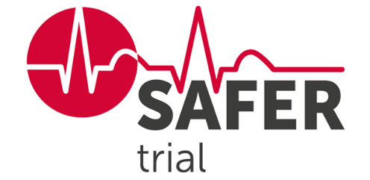The SAFER Trial –   
Screening for Atrial Fibrillation with ECG to Reduce stroke

Alconbury & Brampton Surgeries took part in the SAFER Trial, a research trial about screening for **atrial fibrillation** (irregular heartbeat) to reduce the risk of stroke.

Researchers at the University of Cambridge want to find out if a national screening programme for atrial fibrillation:

* is possible
* will prevent strokes
* is good value for money

Eligible patients aged 70 years and over received an invitation letter from us in the post. A total of 363 patients from the surgery consented to take part in the trial.

Participants were randomly allocated into one of two groups: control or screening. Those in the screening group were invited to screen for atrial fibrillation at home using a hand-held ECG monitor, 4 times a day over 3 weeks (see ECG device below).

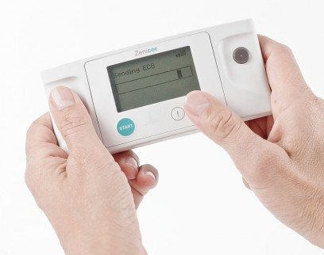

The trial has now completed recruitment and is in the long-term follow-up phase, collecting outcome data via relevant electronic health records until 2028.

A word from the SAFER research team:

*“Thank you to everyone who consented to join the SAFER trial – we are very grateful for your valuable contribution in helping us to answer our research question.*

*Final trial results will be available in late 2028. In the meantime, updates on the SAFER trial will be posted to our website* [*www.safer.phpc.cam.ac.uk*](https://www.safer.phpc.cam.ac.uk/)*.”*