**Self Vaginal Swab Instruction**

1. Wash your hands and unpack the kit on a clean surface, ideally near a toilet.
2. Remove the swab from its tube. **Avoid lying it down or touching its tip.**
3. Carefully insert the swab **half a finger length** into your vagina.

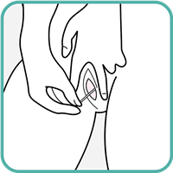

1. Now **rotate the swab** around the inside of your vagina 5-10 times.

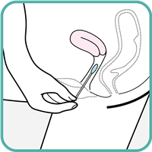

1. Return the swab to the tube and close tightly.