
Welcome to Vida Healthcare
Please complete all sides of the registration form
In order to make our medical care more efficient we would be grateful if you could complete this form and hand into reception.

NHS Number (if known): …..………………………………..
Please contact previous GP if not known.

Title: □ Mr □ Mrs □ Miss □ Ms □ Dr
Other …………………………………………………….

Gender: □ Male □ Female

First Name: ………………………………………………………………………….
Date of Birth: ………………………………..
Surname: …………………………………………………………………………….

Address: …………………………………………………………………………………………………………………………………………………
……………………………………………………………………………………………………………………………………………………………….

Post Code: …………………………………….

Place of Birth: ………………………………………………………………….
Tel (Home): …………………………………… (Work): …………………………………… (Mobile): ………………………………………

Email: ……………………………………………………………………………………………..
Preferred method of contact: □ Telephone □ SMS □ Email □ Letter
Other ………………………………………………………………….
Consent to send contact by □ SMS □ Email

Main Language Spoken: ……………………………………………………………………………….
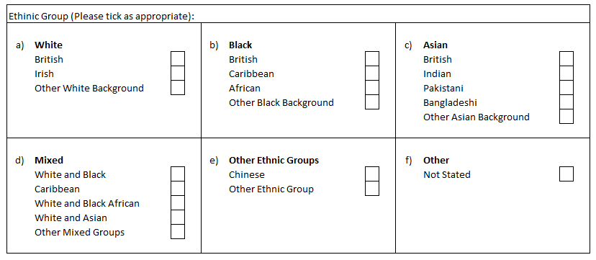
Are you a registered carer? YES/NO
If so who for: Name: ……………………………………………… Tel: ………………………………………………...
Do you have a registered carer? YES/NO
If so please give their details: Name: ……………………………............ Tel: …………………………………………
Relationship: ……………………………….

Alcohol Consumption
(1 Unit is approximately equal to ½ pint of beer, a small glass of wine or a single spirit)

Daily intake of alcohol: OR units per week

(PLEASE CIRCLE AS APPROPRIATE BELOW)
• How often do you have an alcoholic beverage? | Never | Monthly or less | 2-4 times per month | 2-3 times per week | 4+ times per week
• On average, how many units do you consume a day? | 1-2 | 3-4 | 5-6 | 7-9 | 10+
• In the last 6 months, how often have you had  more than 6 units on any one occasion if female, or more than 8 units if male? | Never | Less than monthly | Monthly | Weekly | Daily or almost daily
Would you like further information on how to reduce alcohol intake or receive further advice? YES / NO
Height: …………………………………………………………… Weight: ………………………………………………………

Smoking Status:
I am a smoker If YES, how many cigarettes do you smoke? /day
I am an ex-smoker
I use an electronic cigarette
I have never smoked

Would you like support in giving up smoking? YES / NO

Information on support can be found: https://www.smokefreenorfolk.nhs.uk/

Other:
If you have any regular medications please provide the practice with a copy of your repeat medication slip

Do you suffer from any allergies, drug/non drug? (Please state)

Do you have any medical history of (please circle): Asthma / COPD / Hypertension / Cancer / Epilepsy / Diabetes / Heart disease

Do you have any family history of (please circle): Asthma / COPD / Hypertension / Cancer / Epilepsy / Diabetes / Heart disease
Are you currently or have you ever served in the armed forces?

Do you have any family members in the armed forces?

Accessibility - Communication Needs
If you have a communication need that you would like to advise us of, please complete the section below;
I require large print  I require information verbally | I require written information  I require Easyread
Other (Please explain)

I don’t have a communication need.

Health Check Invitation
Now that you are registering with the Practice you are entitled to see one of the nursing team to have a basic health check performed, this is available to you regardless of your age. We would suggest that anyone with a known medical condition books to see one of the relevant chronic disease nurses.

However, if you're aged 40 to 74, and not already on a disease register, you will be entitled to an NHS Health Check. If you're in this age group, you can expect to receive a letter inviting you for a check. Don't worry if you haven't got your invitation yet, you will be invited for one over the next few years. If you've already had an NHS Health Check, you can expect to have another one in five years' time.

If you wish to be contacted to book your Health Check, please tick

Online Services & Online Consultations, NHS App
Several tools are available including the NHS App if you have this downloaded, which allows medication ordering and access to some clinical information.
SystmOne Online services allow the requesting of repeat medication and viewing some clinical information.
Patchs is an online consultation system that enables you to contact a GP or other health professional over the internet. It saves you waiting for an appointment or going to the GP surgery. You are able to create a Patchs account through the links on our website.

https://www.vidahealthcare.nhs.uk/online-services/

Dispensing - For King’s Lynn & Carole Brown Health Centre patients
Vida Healthcare has a dispensary at our Carole Brown Health Centre branch and is able to offer a full dispensary service for patients living in many villages.

Repeat medication is ordered via the dispensary and dispensed to you, either by collection at the chosen surgery or home delivery. The dispensary also offers a managed repeat service, where medication is automatically ordered each month and is available via delivery or collection. If you wish to find out more about the dispensary’s services please call them on 01485 545365

