Blood pressure readings sheet

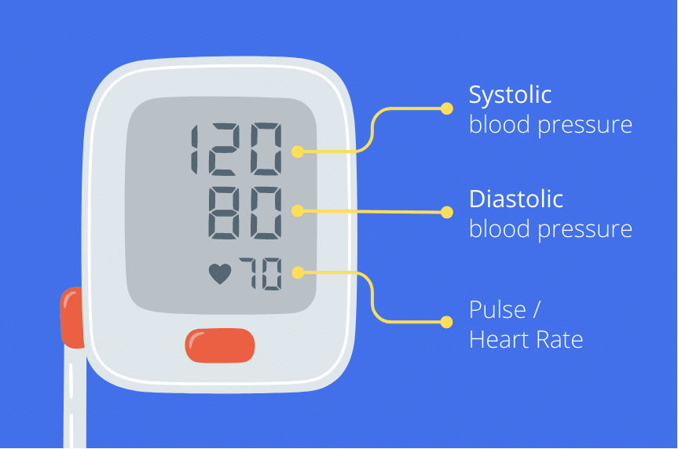
Your full name: ………………………………………………………………….

Your date of birth: ……………………………………………………………….

Date of your first reading: ………………………………………………………

Instructions:
- Take two readings in the morning and two in the evening
- Each reading should be at least a minute apart
- Perform recordings for 7 days
- We do not need to know your pulse/heart rate
- Add total of each column in the bottom row

IMPORTANT: Seek urgent medical help if your reading is above 180/120
If your systolic blood pressure is over 180 OR your diastolic blood pressure is over 120

Day |  | Reading1  Systolic / Diastolic  (first number) / (second number) |  | Reading 2  Systolic / Diastolic (first number) / (second number)
 |  | 120 / 80 |  | 122 / 78
1 | Morning ☀ | / |  | /
1 | Evening ☾ | / |  | /
2 | Morning ☀ | / |  | /
2 | Evening ☾ | / |  | /
3 | Morning ☀ | / |  | /
3 | Evening ☾ | / |  | /
4 | Morning ☀ | / |  | /
4 | Evening ☾ | / |  | /
5 | Morning ☀ | / |  | /
5 | Evening ☾ | / |  | /
6 | Morning ☀ | / |  | /
6 | Evening ☾ | / |  | /
7 | Morning ☀ | / |  | /
7 | Evening ☾ | / |  | /
 |  | Total Systolic 1 | Total Diastolic 1 | Total Systolic 2 | Total Diastolic 2
example

Office Use Only | Systolic1 + Systolic 2 | Diastolic1 + Diastolic 2 | Total Average
 | + = ÷ 28 = | + = ÷ 28 = | /

Taking Your Blood Pressure At Home

There are several simple steps you should take to make sure that your home blood pressure readings are as accurate as possible.

Before you take your reading:

- There are many factors that can make your blood pressure rise for a short period of time. You should not smoke, have a drink containing caffeine (such as coffee) or exercise for 30 minutes before you take your blood pressure reading. You should also avoid measuring your blood pressure when you need to use the toilet.

- It is important that you always measure your blood pressure in the same arm. You should use the arm which your doctor or nurse uses when they take your blood pressure, or whichever arm they ask you to use.

- Do not wear any tight or restrictive clothing around the arm you are measuring your blood pressure in. For example, you should avoid rolling up tight shirt sleeves.

- You should rest for at least five minutes before measuring your blood pressure. During this time, you should sit down in a quiet place, try to relax and avoid speaking to anyone.

Taking your reading:

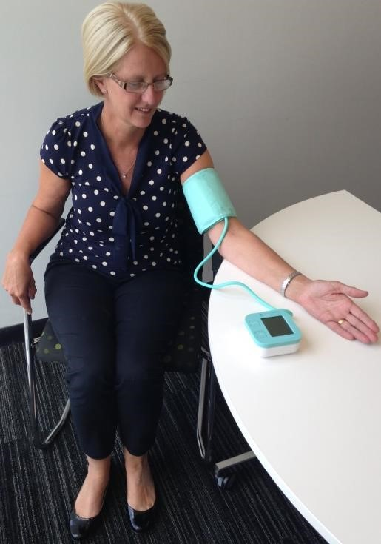
- Place the cuff on your arm, following the instructions that came with your monitor. The bottom of the cuff should be approximately 2cm above the bend in your elbow.
Comfortable, with no
distractions or talking

Arm supported at heart
level

Seated with back support

Feet flat on the floor

- Make sure that you are sitting down when taking your blood pressure readings and that you have both of your feet flat on the floor. You should not cross your legs as this can raise your blood pressure. The arm that you are measuring your blood pressure in should be supported on a firm surface (such as a table or desk) with your palm facing up and should be at the same level as your heart.

- Take a reading, following the instructions that came with your monitor. When taking your blood pressure readings, you should not talk and should try to relax.

- Take at least two readings, leaving at least a minute between each. After each measurement, you should write the reading down in your diary. Remember to write down the exact numbers that appear on the screen- do not round the numbers up or down. If the first two readings you take are very different, take 2 or 3 further readings. You should write all of your readings down in your blood pressure diary.
This resource is a joint production of the NIHR Collaboration for Leadership in Applied Health
Research and Care (CLAHRC) Greater Manchester and the British Hypertension Society

