
Hi,
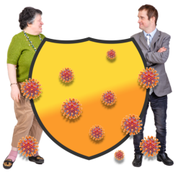
The coronavirus means we all are having to change our routines to keep ourselves and everyone else safe from becoming ill.


This can be very confusing, so we will send you emails with links to easyread information that the government and the NHS are giving to us.

Today I am sharing an easy read about the new rules for staying safe in June
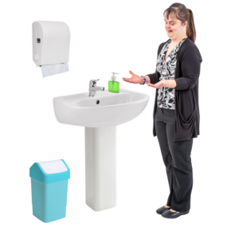
You can find out how to wash your hands properly from the Purple All Stars here


We have more easyread information about the coronavirus on our website.
www.hertfordshire.gov.uk/LDMyHealth

You can also find daily top tips on keeping healthy over on our Facebook page

 | Jessica Shingler  Senior Support Officer | Purple Star Strategy | Health Liaison Team  Adult Care Services, Hertfordshire County Council  SFAR015 Farnham House Six Hills Way Stevenage SG1 2FQ  E: Jessica.Shingler@hertfordshire.gov.uk  Find out about our learning disability nurses and how we can help with your health at  www.hertfordshire.gov.uk/LDmyhealth

