# Sharing the communication preferences and reasonable adjustment requirements of people with learning disabilities.

All people with learning disabilities should have their communication preferences recorded and used by health and social care professionals (Accessible Information Standard 2016) and reasonable adjustments made to help them accept health investigations (Equality Act 2010).

Please fill in this form that is created in line with the Accessible Information Standard 2016 and The Equality Act 2010. This information will be recorded and shared with any Health and Social Care Professional involved in your care.

|  |
| --- |
| Name: |

|  |
| --- |
| Preferred name & pronoun: |

|  |
| --- |
| Address: |

|  |
| --- |
| Level of support you have in life and who is significant in helping you (name, contact details and details of who they are to you): |

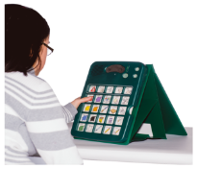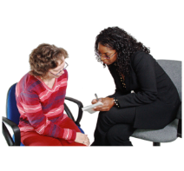

**I like to communicate using…**

(e.g. sign language, specific sounds that my care understands, speech but you may need my carer to interpret etc)

Notes:

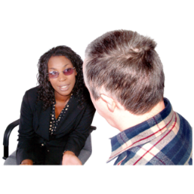

**To help me understand I need…**

(e.g. speak slowly, easy read, Makaton, tell my carers as well and they can help me understand etc.)

Notes:

**The best way to contact me is…**

(e.g. standard letters are fine, send me easyread, always telephone me don’t wend letters, I throw my letters away, text me to remind me, always send letters to me and to my carer as well I might not show them the letter you send me)

Notes:

## Reasonable Adjustments I may need to help me to accept health care I need.

## Think T.E.A.C.H.

**Time**

Are you likely to be more tolerant of health appointments at a certain time of day? Do you need extra time for you to feel relaxes so that you can accept treatment? Do you need extra time to explain things?

Notes:



**Environment**

Are you more likely to be relaxed and accept health treatment if you are in a place you know well? Do you hate noises, busy spaces or new places? What can be done to make this easier?

Notes:

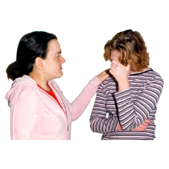**Attitude**

If you are anxious what can the person do to help you relax so that you are more likely to get the same treatment and not miss out on health care you need?

Notes:

**Communication**

How should the person talk to you? Are there things that you hate people saying or doing? Do you have favourite subjects you like to chat about that help you feel relaxed? Are there things you like to show people to help you settle? Do you need things written down or drawn to help you?

Notes:

**Help**

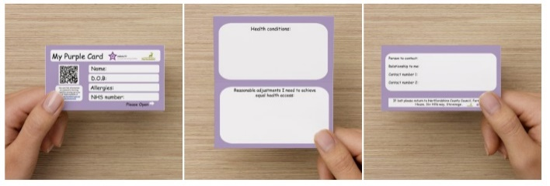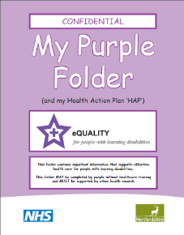

Who is the best person who knows you well who can help you at health appointments? [Name / relationship to you/ organisation they are from if applicable / contact details.] Do you need someone to be called after your appointment so they can help you understand what was been discussed? Do you have a Purple Folder or Purple Card that says what reasonable adjustments you need? Do you need a Community Learning Disability Nurse to help you understand the health treatment a doctor has recommended?

Notes:

### Consenting to sharing information about your communication preferences and reasonable adjustment requirements.

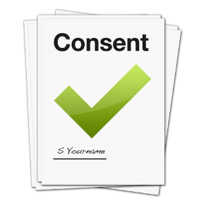

I understand that this information will be stored safely and that you will share with a health or social care professional that needs to contact me so that they know the best way to communicate with me.

|  |
| --- |
| Service user signature: |

|  |
| --- |
| Date: |

If this person does not have mental capacity to understand, remember and weigh up the decision to allow this information to be shared, then please record your best interest decision overleaf.

#### Mental Capacity Assessment for Sharing Preferred Communication Methods and Reasonable Adjustments (in line with Accessible Information Standard and Equality Act).

Record your evidence that the person was unable to Communicate, Understand, and Remember whether they agree to this information as being their communication method preference and for it to be shared with relevant health and social care professions.

**Best Interest Decision**

Record who was involved in this discussion (carers and/ or relatives) and record the decision reached - weighing up the risks and benefits of sharing/not sharing this information about the person with health and social care professionals

|  |
| --- |
| Name: |

|  |
| --- |
| Date: |

|  |
| --- |
| Position |