**Green Lane Surgery July 2019**

**Message to all Asthma Patients**

**Effective management of your Asthma, preventing exacerbations and acute asthma attacks**

Asthma remains a serious illness and if you are at all concerned that your asthma is getting worse you should ask for an emergency appointment with any of our doctors. Please make it clear to one of our receptionist that you are asthmatic and you have difficulty in managing your asthma or recently had an acute attack of Asthma.

Our receptionist will be able to book an emergency appointment for you.

**Asthma clinic at the practice**

Our practice does not have dedicated clinic session for asthma but will see as a routine appointment and your asthma will be assessed, advice offered, queries answered and correct management plan will be ensured.

Patients on asthma medication should be reviewed at least once a year but if your asthma is not controlled you must see doctor at least twice a year or soon after any acute attack. If you have not had your asthma review in the past year please contact one of our receptionists and book an appointment with either with nurse od a doctor.

**Useful information & advice**

**What is Asthma?**

Asthma is a condition which affects the airways, when a person with asthma comes into contact with a trigger (for example pollen, house dust mite or cold air) it causes their airways to tighten and narrow, which can make it difficult to breathe. Find out more at [**Patient UK**](http://www.patient.co.uk/health/asthma)**.**

**Self- management of Asthma**

Asthma is generally a chronic condition, although some people can grow out of it, therefore it is important that you are aware of things which can help to improve your asthma:

* Know your asthma triggers and preparing for them by having asthma relievers and preventers with you at all times
* [**Stop smoking**](http://www.nelsonmedicalpractice.co.uk/services/smoking-cessation-clinic/) – as smoking affects the airways and can worsen the condition LINK

[**Find your local Breath Easy Asthma Support Group.**](http://www.blf.org.uk/breatheeasy)

**Using your Asthma inhaler**

Inhaler technique is a vital part of managing asthma in order to get as much treatment ( medication) into your lungs as possible. See these websites for information and video on how to use your inhaler effectively:

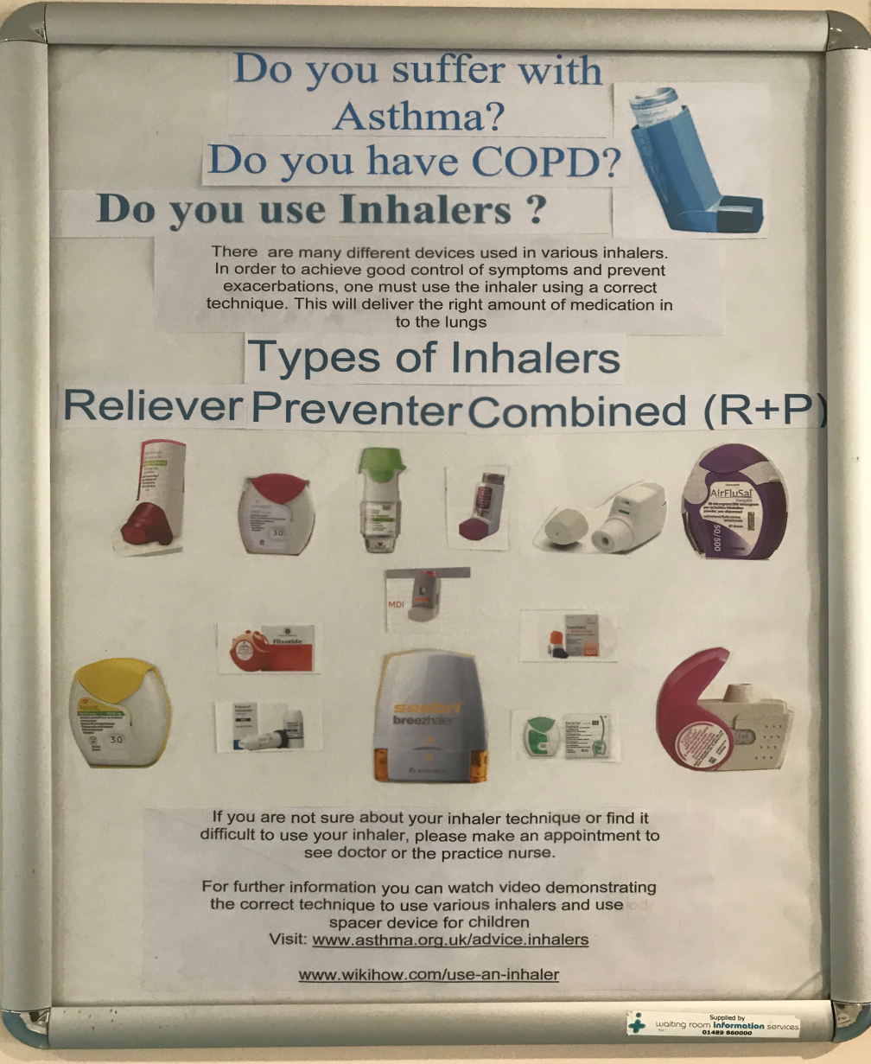

* [www.wikihow.com/use-an-inhaler](http://www.wikihow.com/use-an-inhaler)
* <https://www.asthma.org.uk/advice/inhaler-videos/>

**Asthma attacks – what to do**

It is important that you know what to do when you have an asthma attack so that you can immediately stop it from getting any worse. See these websites for more information on managing an asthma attack.

* [**Asthma first aid**](http://www.sja.org.uk/sja/first-aid-advice/breathing-problems/asthma.aspx)
* [**Asthma attack advice**](http://www.asthma.org.uk/advice-asthma-attacks)
* [**Asthma attack video**](http://www.mayoclinic.com/health/asthma/MM00001)
* [**Asthma attack prevention**](http://www.noattacks.org/)

**Useful websites:**

* [**NHS – Asthma**](http://www.nhs.uk/conditions/asthma/Pages/Introduction.aspx)
* [**Asthma UK**](http://www.asthma.org.uk/)
* [**British Lung Foundation**](http://www.blf.org.uk/conditions/detail/asthma)
* [**Global Initiative for Asthma**](http://ginasthma.org/)
* [**NHS – Travelling with Asthma**](http://www.nhs.uk/Livewell/travelhealth/Pages/travelling-with-asthma.aspx)
* [**Asthma UK – Living with Occupational Asthma**](http://www.asthma.org.uk/knowledge-bank-living-with-asthma-occupational-asthma)

Personalised Asthma Plan:

You must have your own personalized Asthma Management Plan ( children and Adults). Please print a copy from the link below and complete it as much as you can and take it with you to discuss at the time of your asthma review. It will give you an important information about your you maintenance asthma treatment and emergency action plan at the time of an acute attack or exacerbation.

Action Plan for Children:

<https://www.asthma.org.uk/32326f44/globalassets/health-advice/resources/children/myasthmaplan-trifold-final-interactive.pdf>

**Action plan for children over 12 and adults**

<https://www.asthma.org.uk/18e901c2/globalassets/health-advice/resources/adults/adult-asthma-action-plan.pdf>

***Your 10-point action plan to manage asthma***

* 1. **You should have your own personal asthma action plan**
  2. **Know and avoid your trigger factors for asthma**
  3. **Take your medications as directed by your doctor or a nurse.**
  4. **If you are using your reliever inhaler( Blue Inhaler) more than twice a day , make an appointment to see the doctor.**
  5. **If your asthma is well controlled ,you should have a regular annual review and if asthma is not well controlled, you must have more frequent reviews by the doctor.**
  6. **If you had an acute exacerbation of your asthma or attended emergency department at hospital, you must see a doctor as soon as possible to review your asthma management.**
  7. **You must use your inhalers properly to be effective. Use a spacer device and visit websites( stated above) for correct inhaler techniques.**
  8. **Use Peak Flow Meter to monitor your asthma**
  9. **For more in-depth understanding of asthma visit websites as stated above.**
  10. **Asthma deaths are preventable**